

**BSc (Hons) in Information Technology**

**Software Engineering – Year 3**

**Lab sheet 04**

**LL**

**Lab sheet 04**

**IT3050 – User Experience Engineering**

**Semester 2, 2021**



**User Experience Engineering**

**Sketches, Wireframes and prototypes**

**Group ID: 2021S1_JUNE_WD_11**

|  |  |
| --- | --- |
| Registration Number | Member |
| IT19974774 | N.A.C.H Dasanayake |
| IT19047720 | B.N.V Mendis |
| IT19953984 | Y.N Sajani |
| IT19953052 | K.A.S.S Rupasinghe |

**Group Member Details**



**Contents**

**IT19974774 – Dasanayake N.A.C.H – User Management and Feedback Management** 3

**Interface 1 – Sign In** 3

**Interface 2 – Registration** 4

**Interface 3 – Profile** 5

**Interface 4 – Feedback** 6

**IT19047720 – Mendis B.N.V – Cake and Category Management** 10

**Interface 1 – Add a Cake - Admin** 10

**Interface 2 – Home - Admin** 11

**Interface 3 – Edit Cake - Admin** 11

**Interface 4 – Cake List - Admin** 12

**Interface 5 – Category List - Admin** 13

**Interface 6 – Side Navigation** 13

**Interface 7 – Category List** 14

**Interface 8 – Single Category** 14

**Interface 9 – Cake List** 16

**Interface 10 – Single View of a Cake** 17

**IT19953984 – Sajani Y.N – Cart, Wishlist and Order management** 25

**Interface 1 – Landing Page** 25

**Interface 2 – Wishlist** 26

**Interface 3 – Shopping Cart** 27

**Interface 4 – Payment - Shipping Details** 28

**Interface 5 – Payment – Card Details** 29

**Interface 6 – Order History** 30

**Interface 7 – Payment Success** 31

**IT19953052 – Rupasinghe K.A.S.S – Customized Cake Management** 37

**Interface 1 – Welcome Page – Customized Cake** 37

**Interface 2 – Place Customized Cake Order** 38

**Interface 3 – Place Customized Cake Order – Upload Image** 39

**Interface 4 – Place Customized Cake Order Confirmation** 40

**Interface 5 – Customized Cake Order History** 41

**User Feedback for the Prototype** 45

# **IT19974774 – Dasanayake N.A.C.H – User Management and Feedback Management**

## **Interface 1 – Sign In**

**Design Suggestions**

|  |  |  |
| --- | --- | --- |
| Screenshot of the GUI | Proposed sketch | Proposed wireframe |
|  |  |  |
| Failure points of the UI   * Login screen is complicated and hard to use because of too much information | Suggested solutions  Create a simple UI with minimal information with easy navigation | |

**Sketches Wireframes**

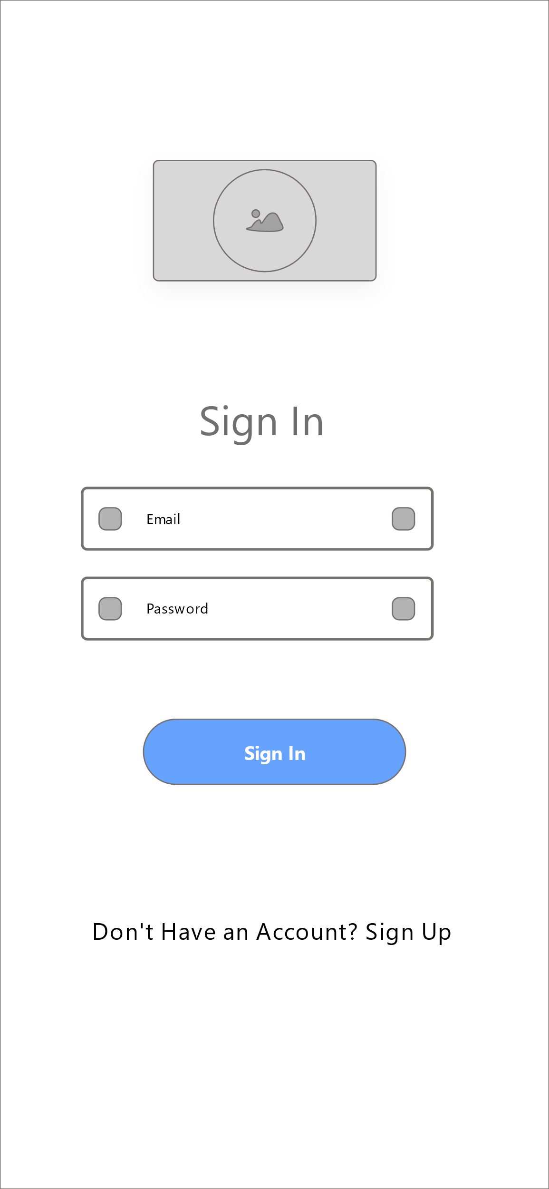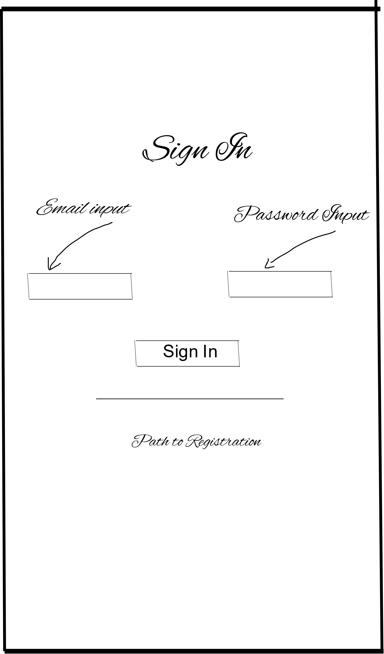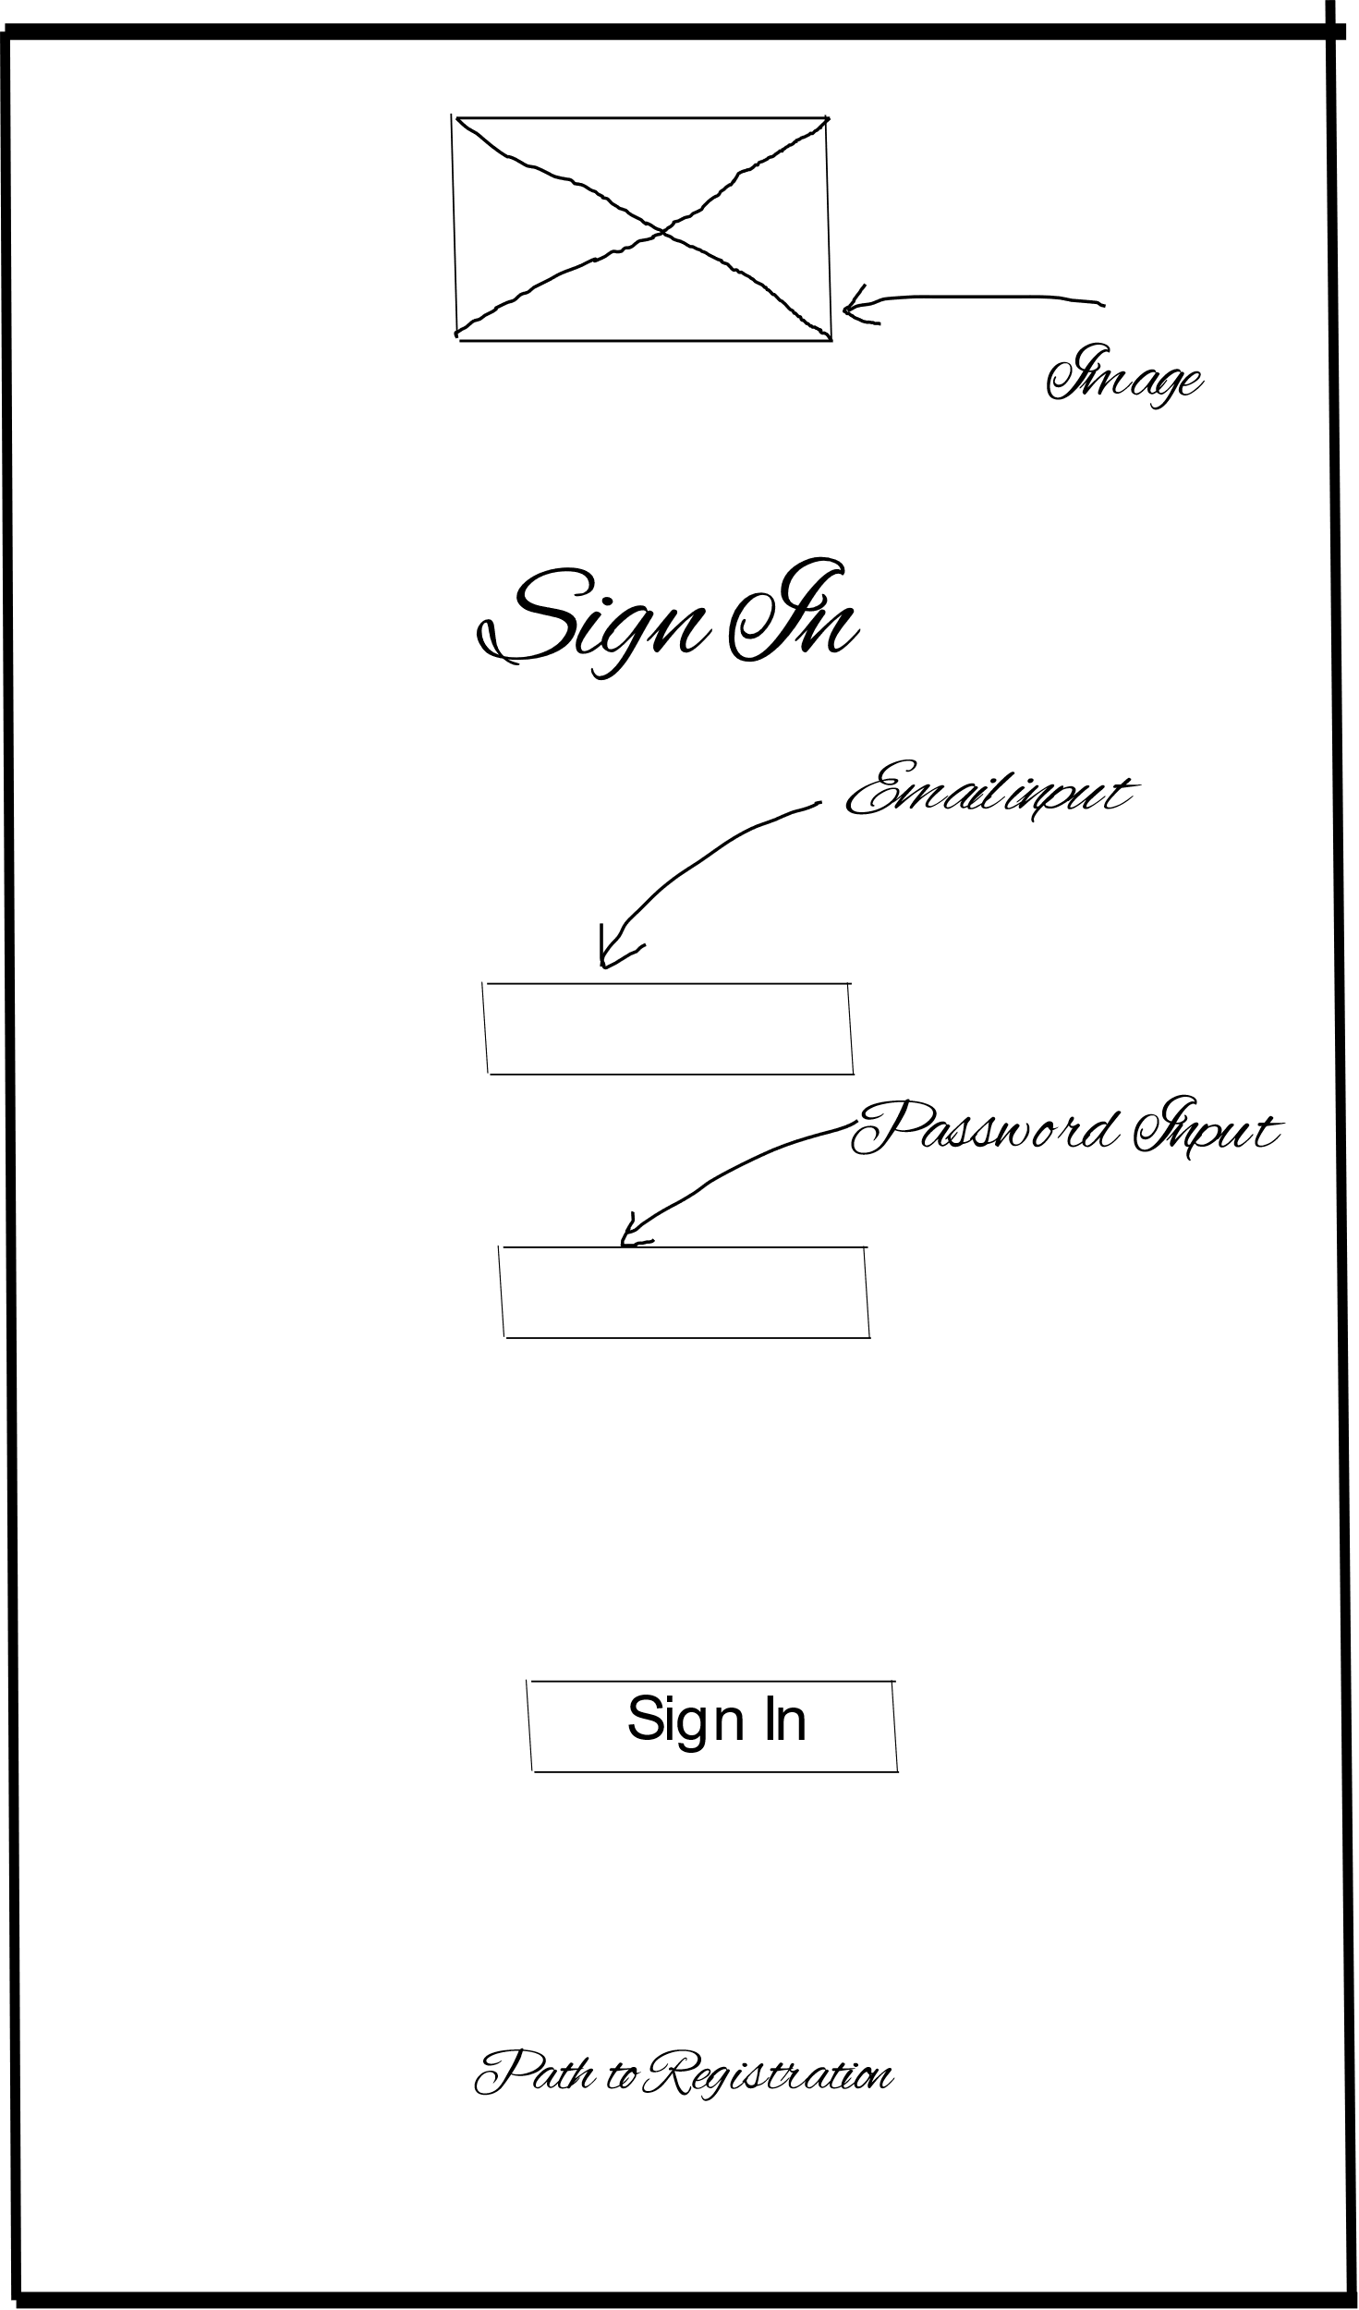

## **Interface 2 – Registration**

**Design Suggestions**

|  |  |  |
| --- | --- | --- |
| Screenshot of the GUI | Proposed sketch | Proposed wireframe |
|  |  |  |
| Failure points of the UI   * Registration form has too many steps to go through. | Suggested solutions  Create a simple UI with minimal information with easy navigation | |

**Sketches Wireframes**

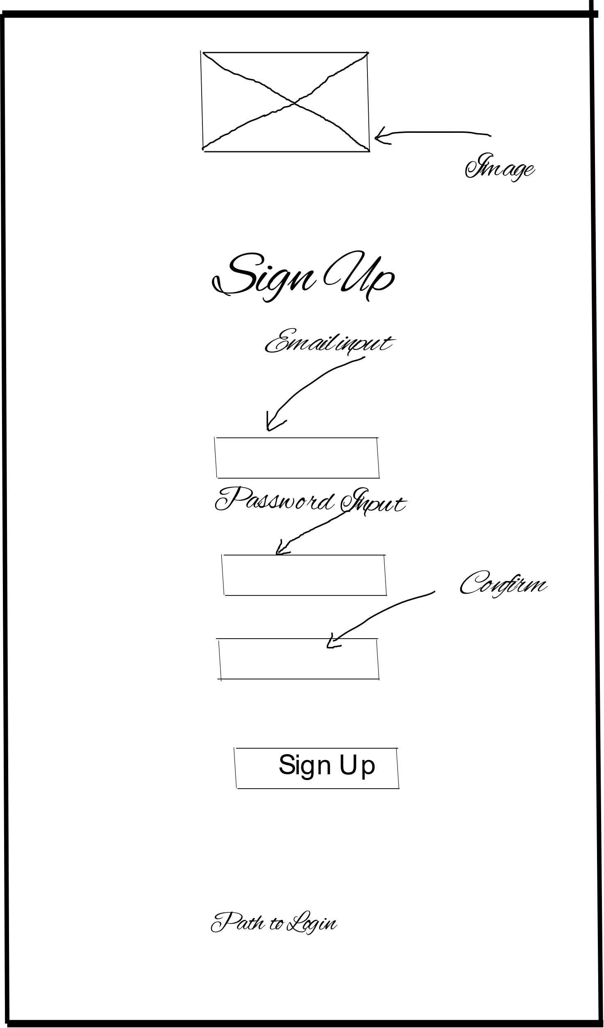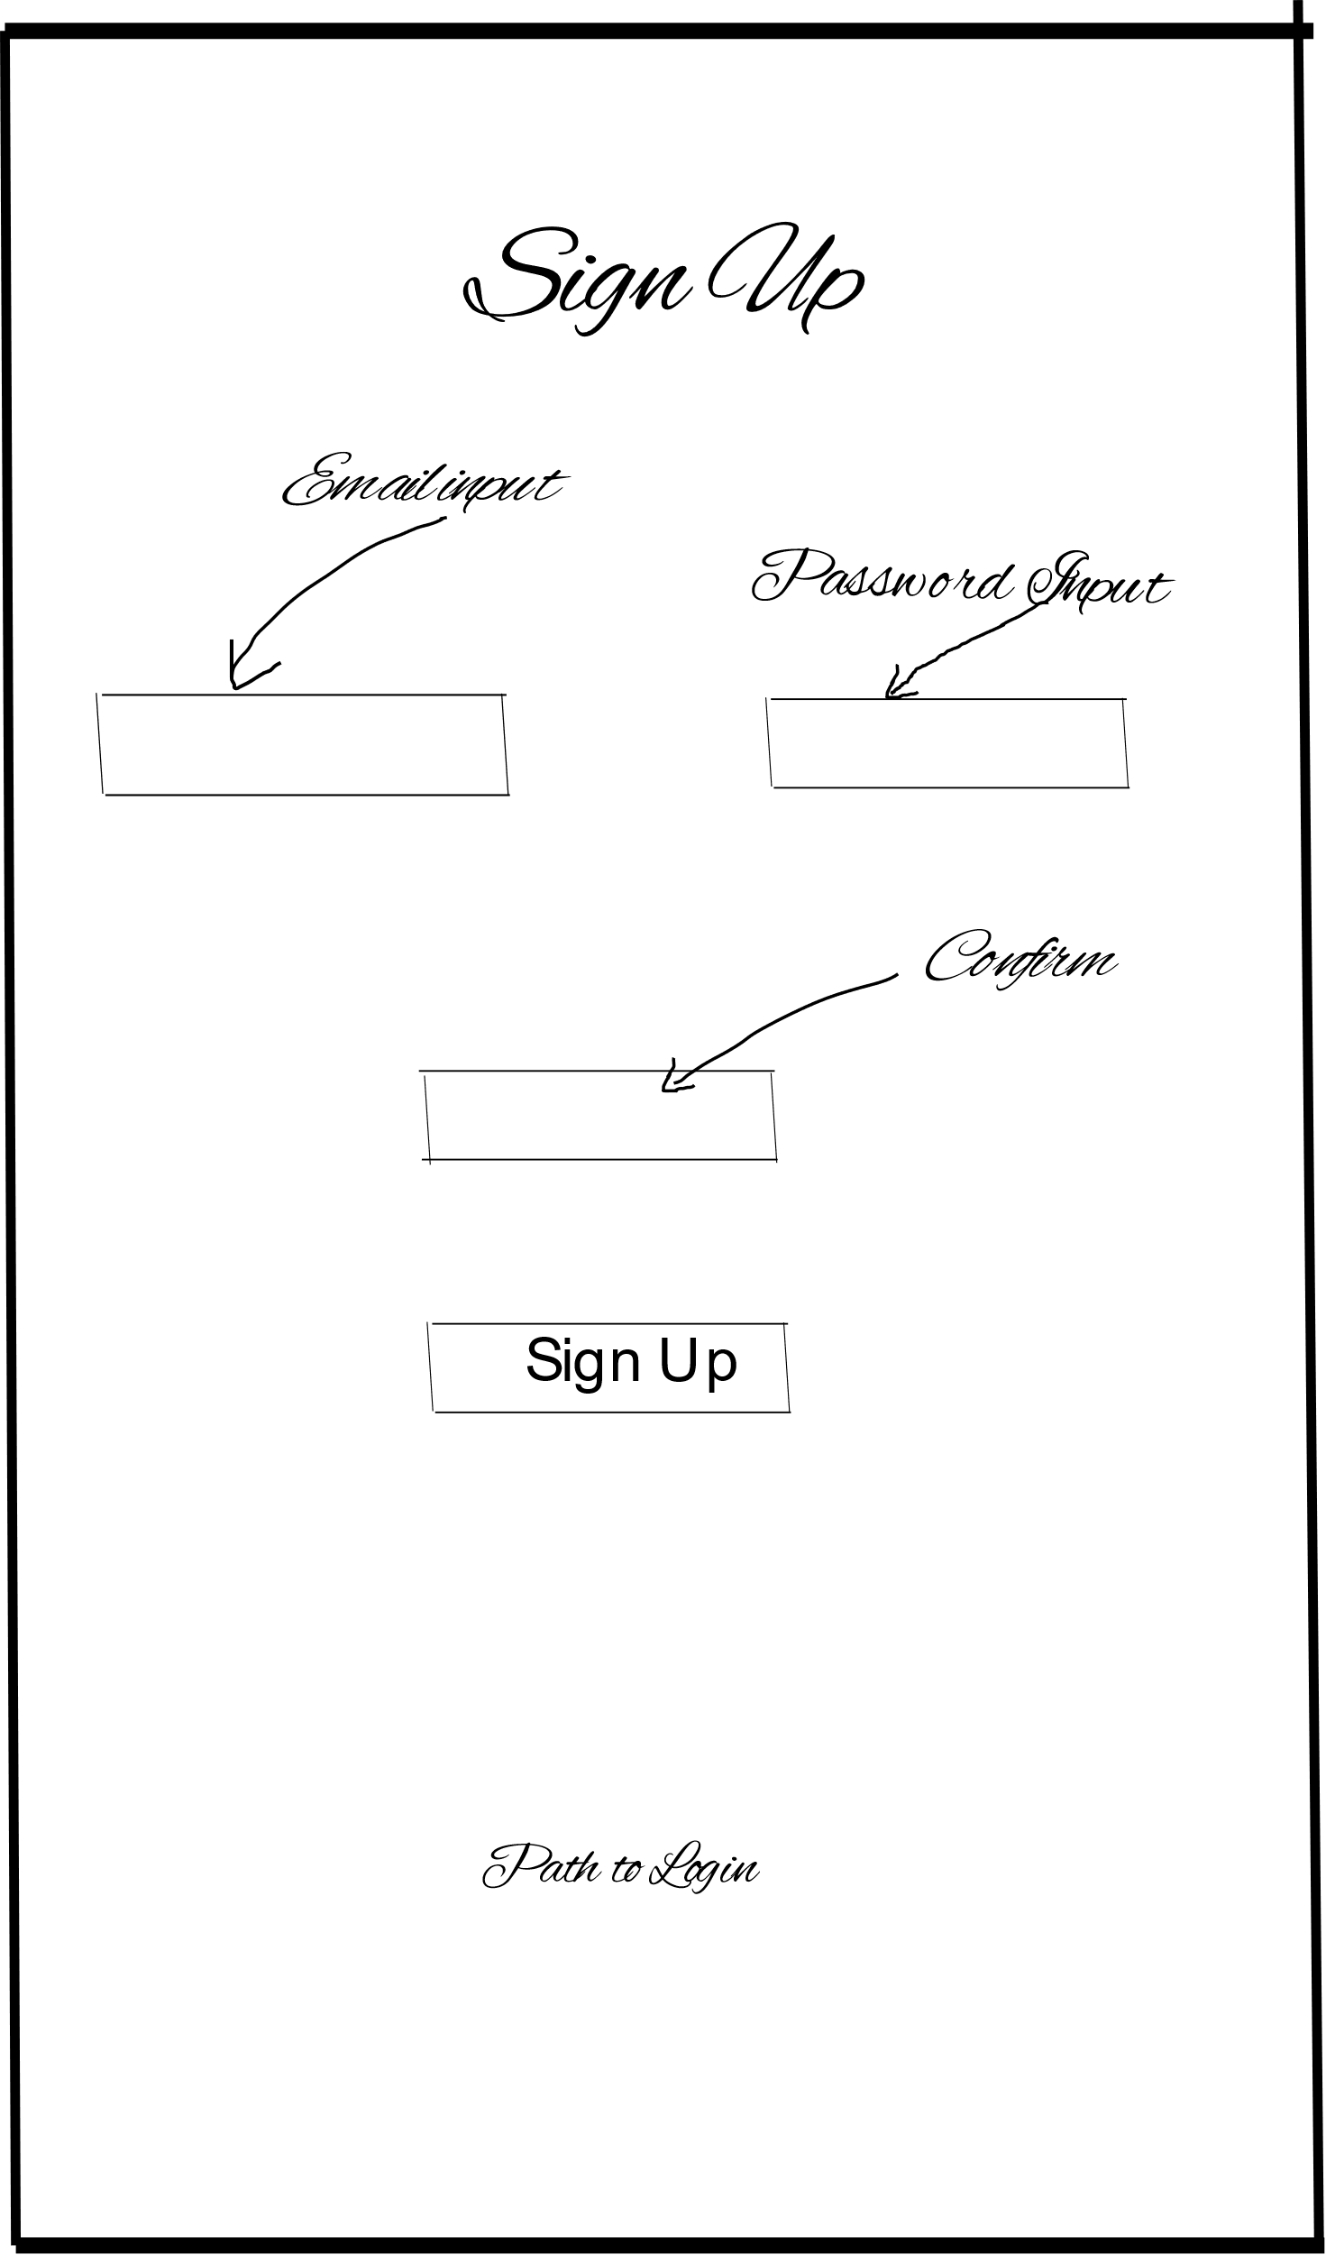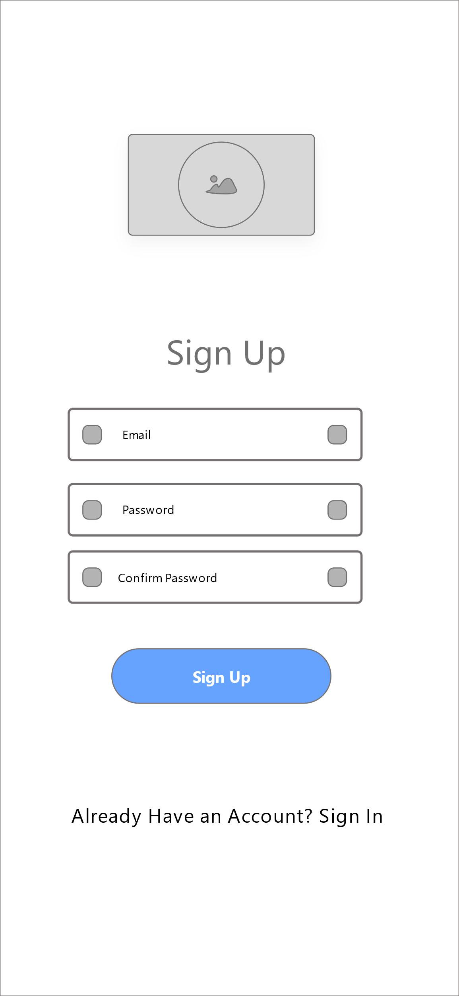

## **Interface 3 – Profile**

**Design Suggestions**

|  |  |  |
| --- | --- | --- |
| Screenshot of the GUI | Proposed sketch | Proposed wireframe |
|  |  |  |
| Failure points of the UI   * No profile page | Suggested solutions  Create a page for profile details | |

**Sketches Wireframes**

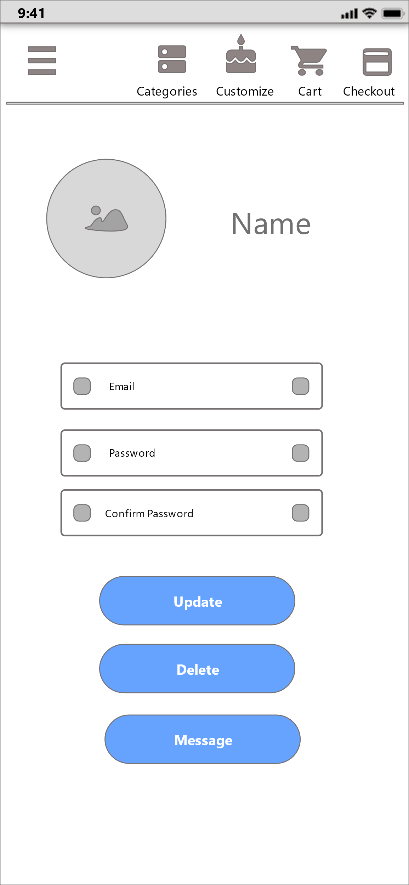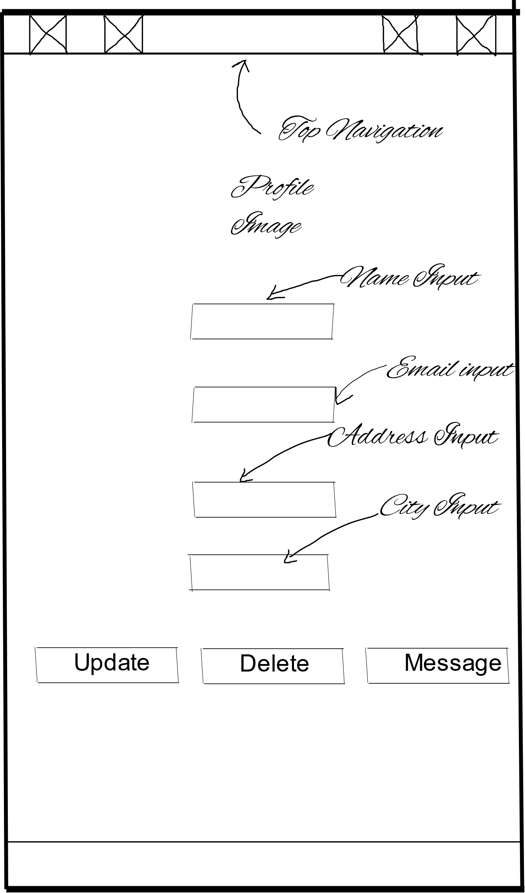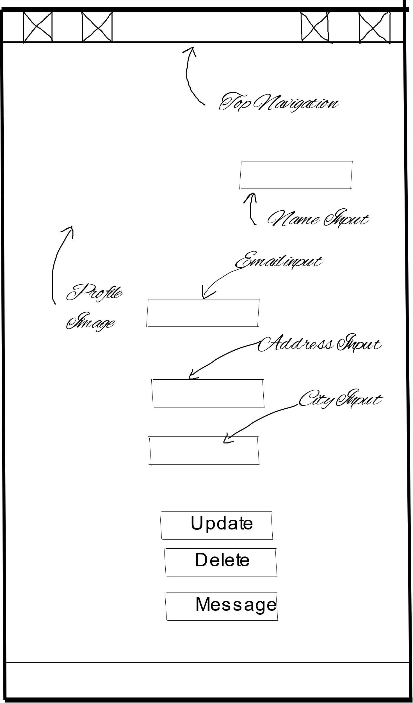

## **Interface 4 – Feedback**

**Design Suggestions**

|  |  |  |
| --- | --- | --- |
| Screenshot of the GUI | Proposed sketch | Proposed wireframe |
|  |  |  |
| Failure points of the UI   * Footer has covered half of an interface as a barrier to viewing other information clearly and footer contain message box which is not a suitable place to locate. | Suggested solutions  Remove footer with proper navigation and create new page for message box | |

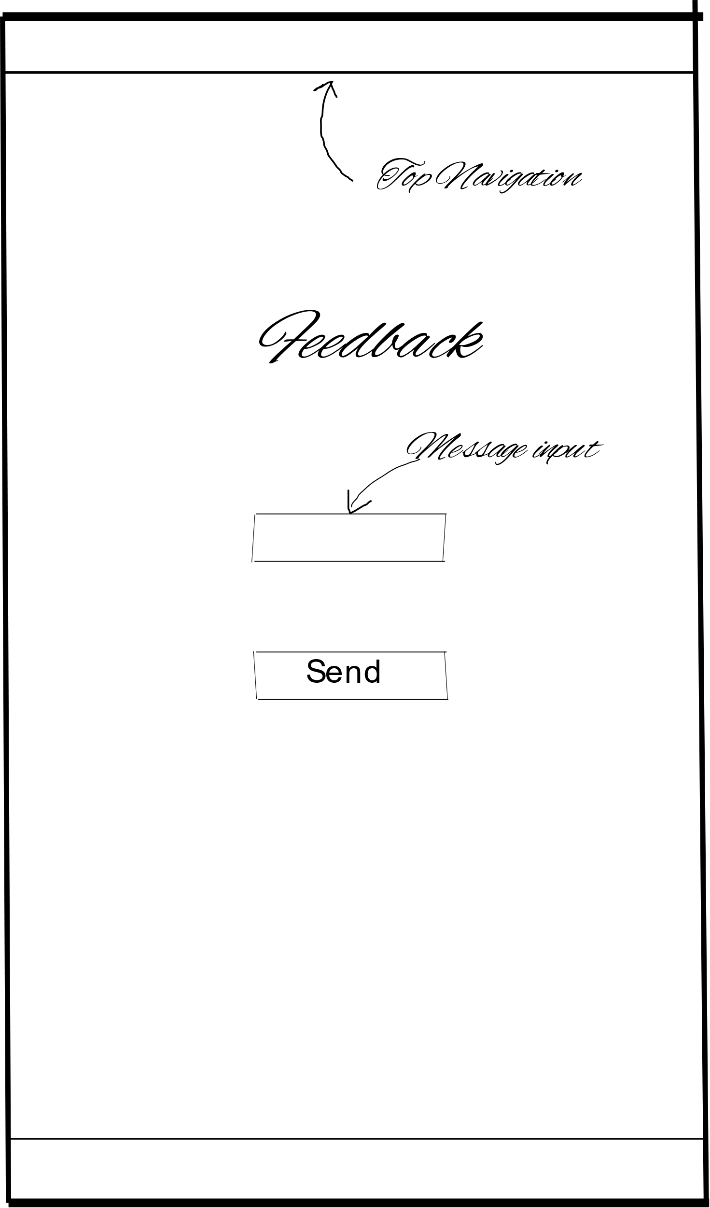**Sketches Wireframes**

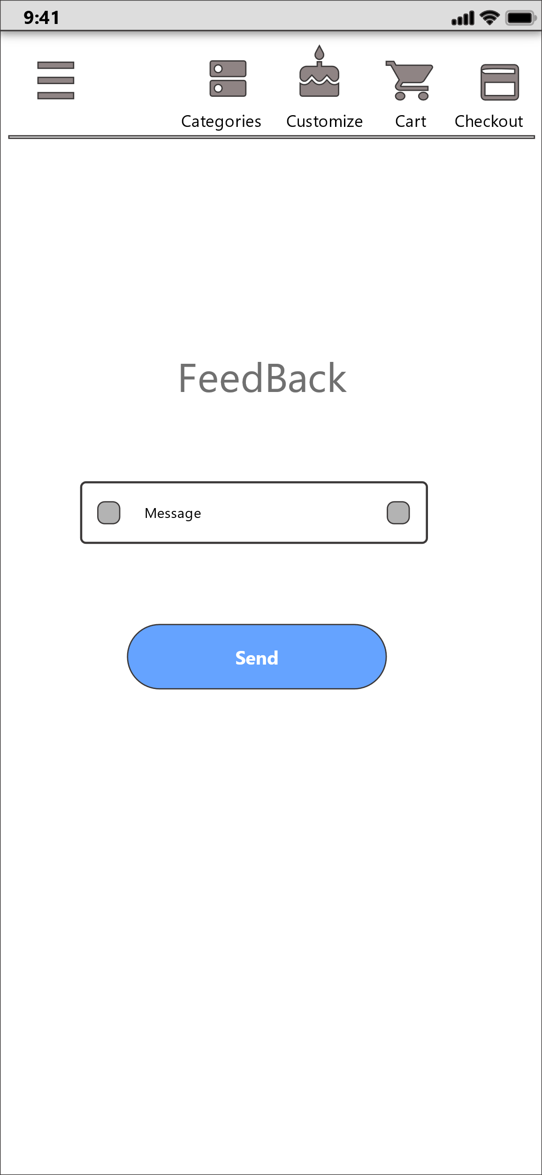

**Connection between UIs**



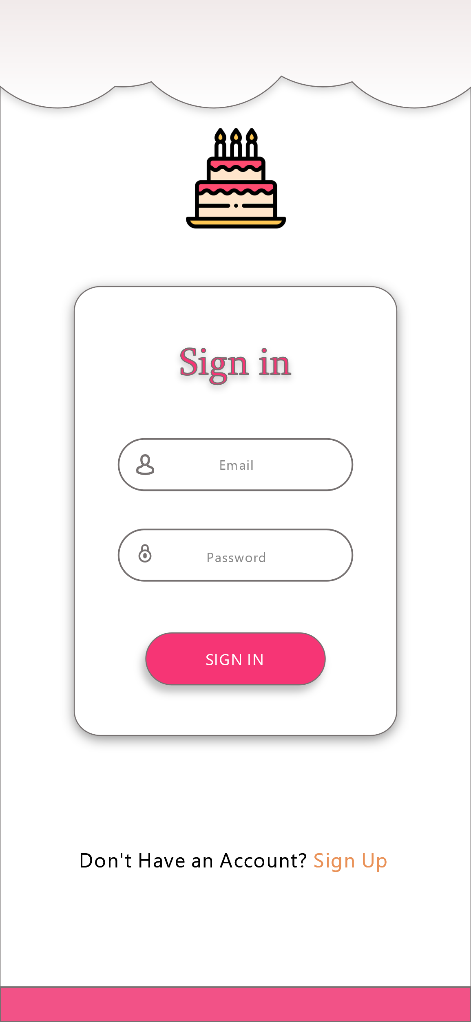**Prototype version 1**

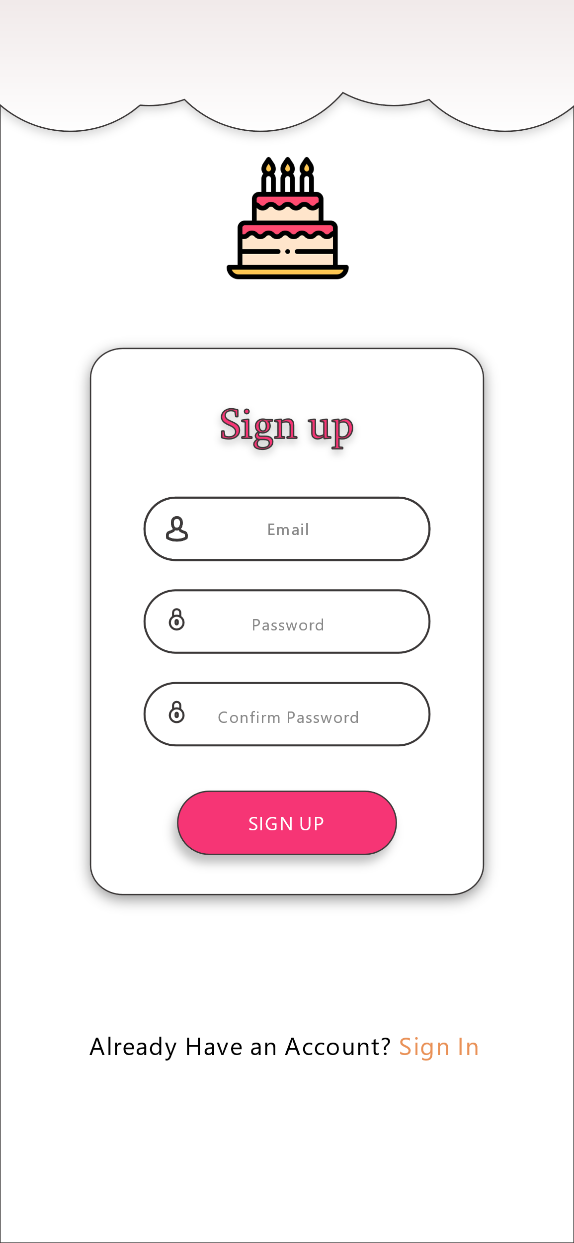

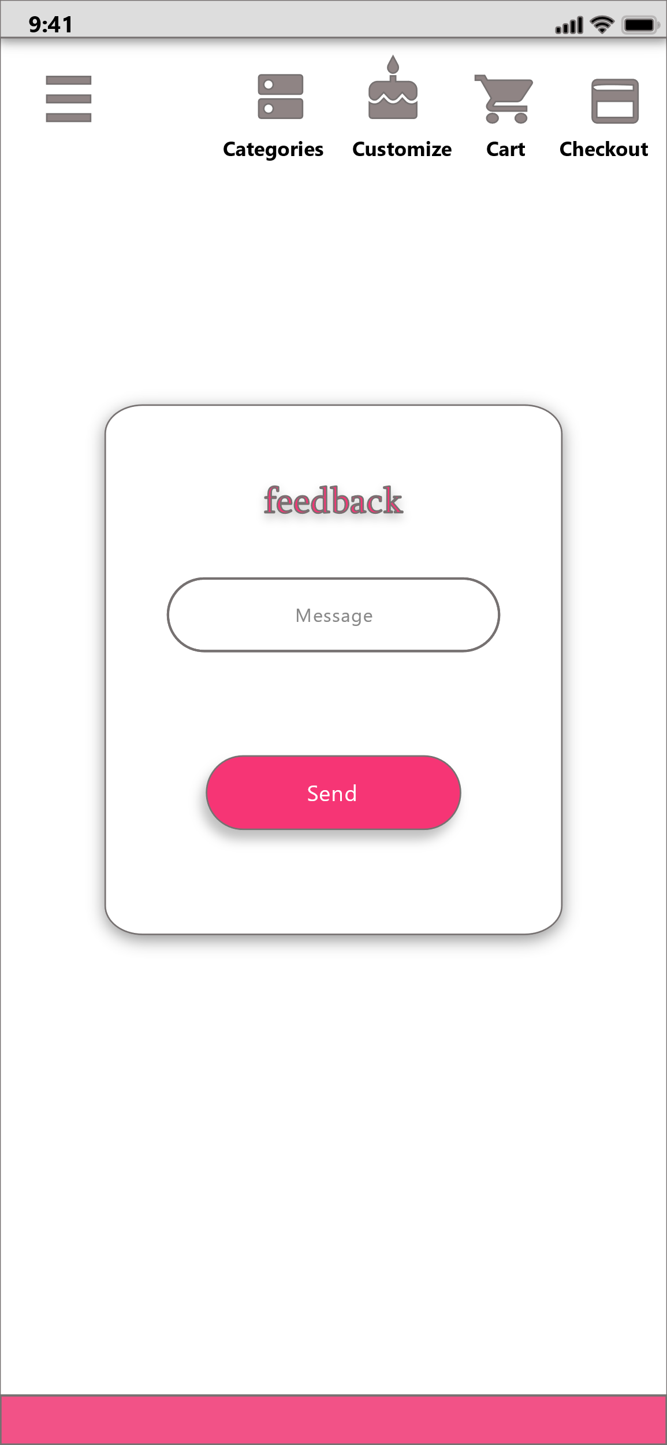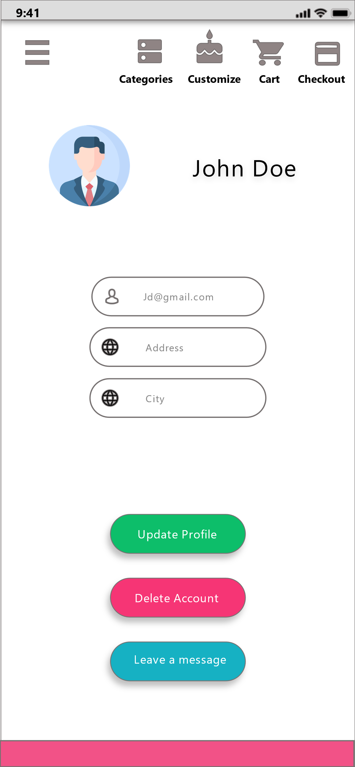**Sign In Registration**

## 

**Feedback Profile**

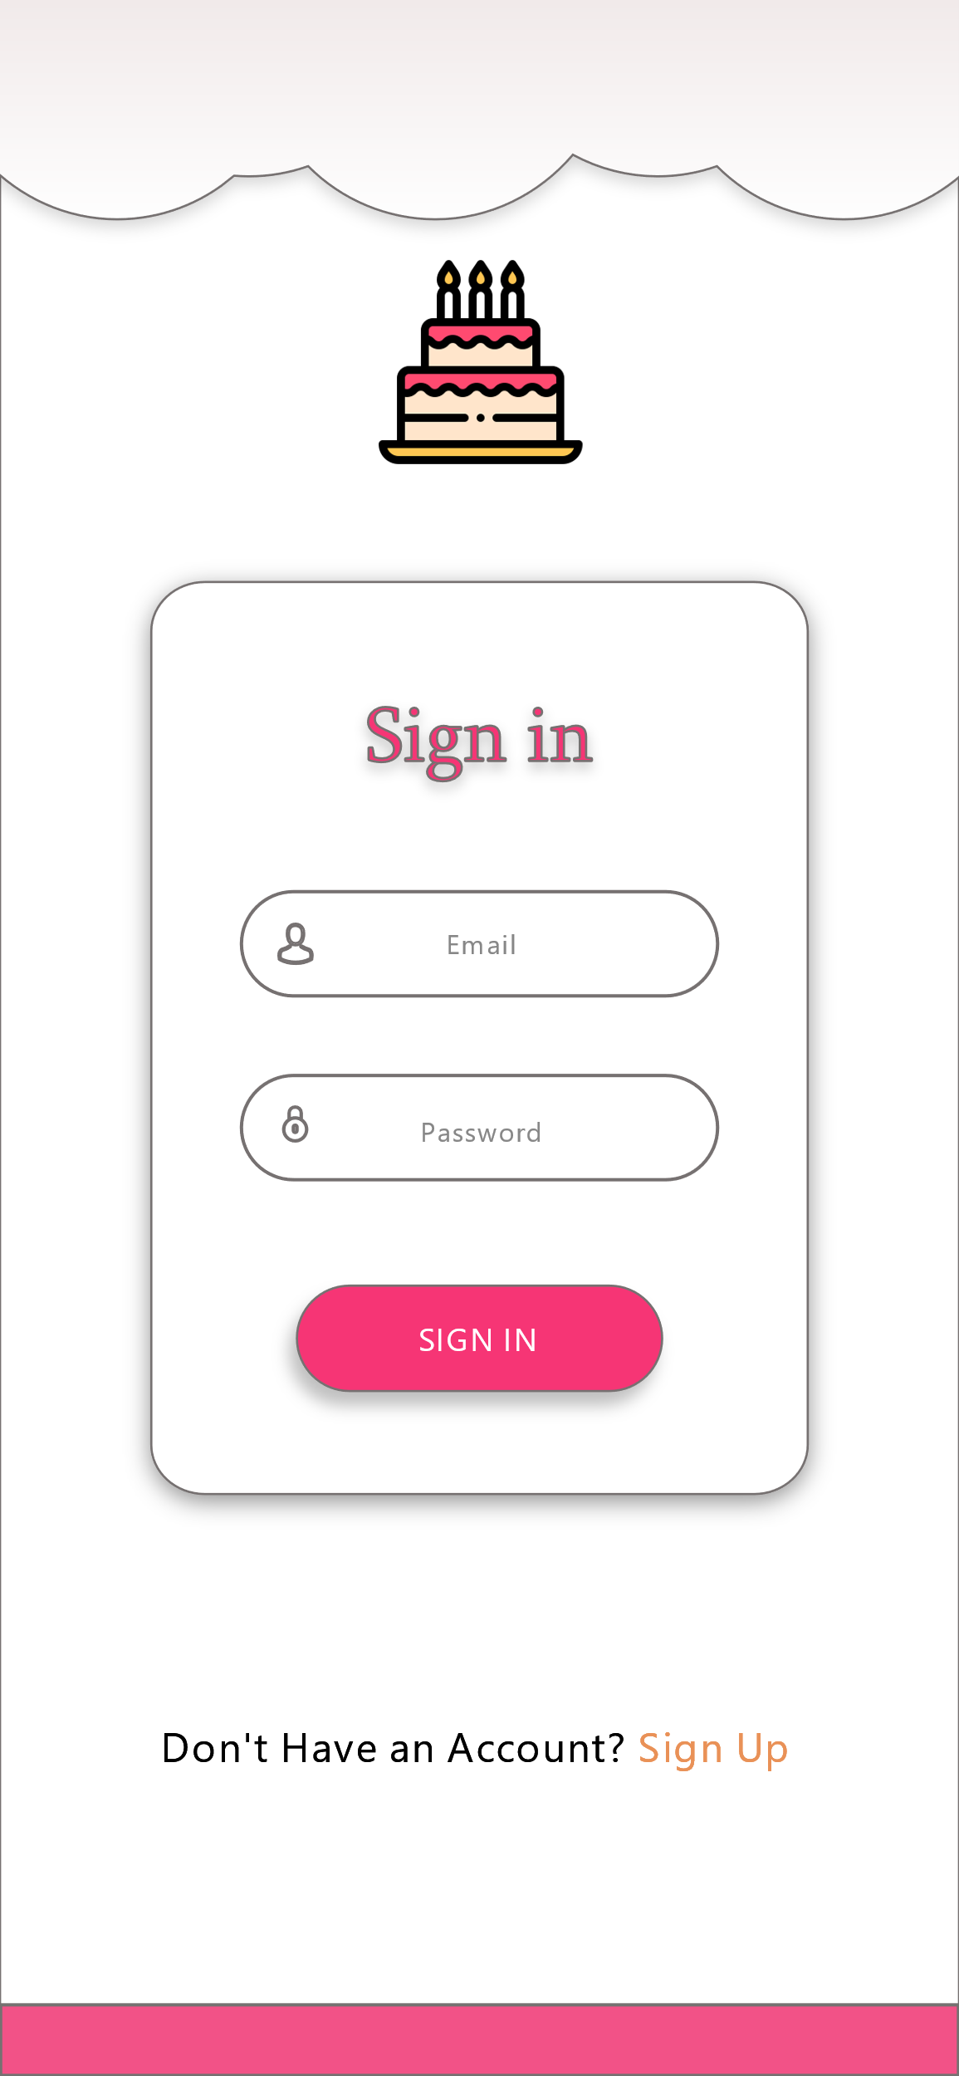 **Prototype version 2**

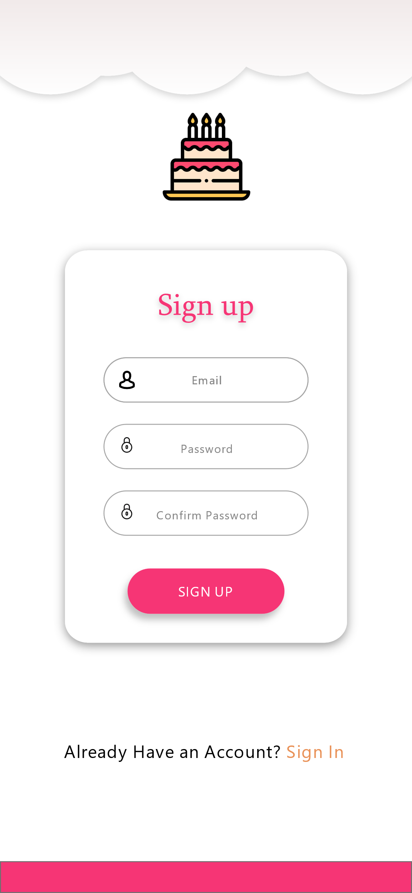

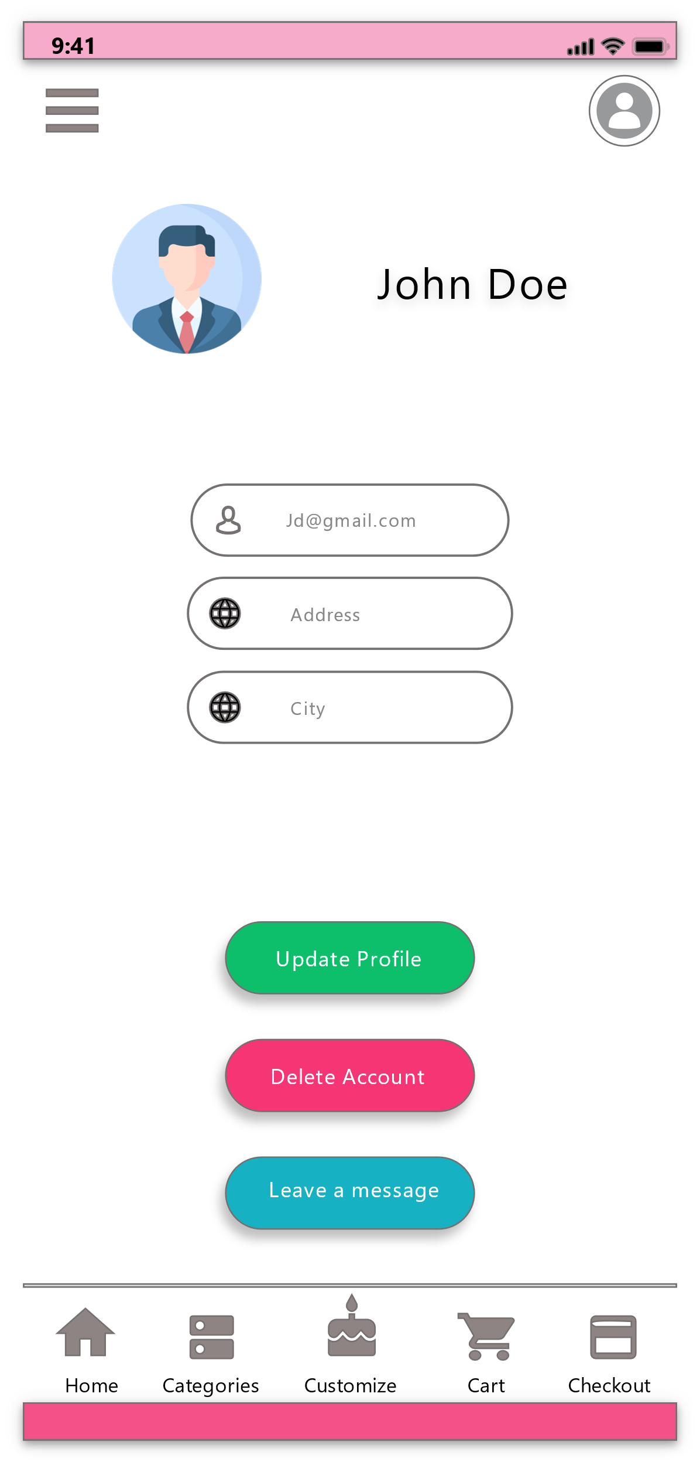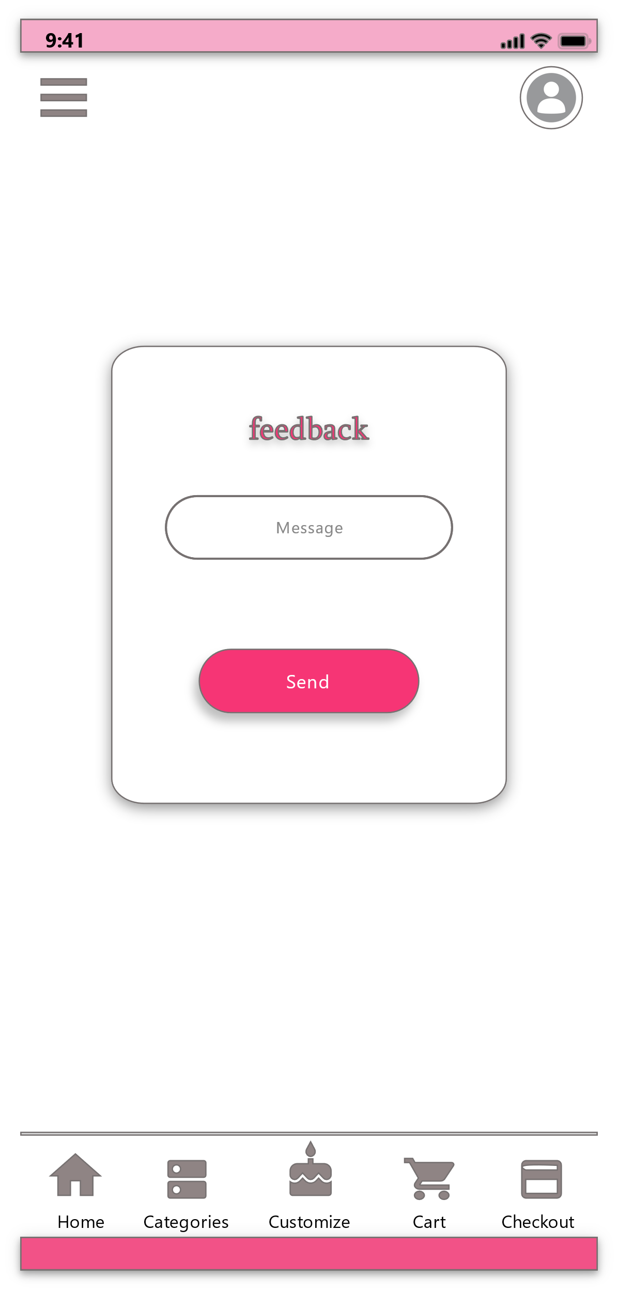**Sign In Registration**

**Feedback Profile**

# **IT19047720 – Mendis B.N.V – Cake and Category Management**

## **Interface 1 – Add a Cake - Admin**

**Design Suggestions**

|  |  |  |
| --- | --- | --- |
| Screenshot of the GUI | Proposed sketch | Proposed wireframe |
|  |  |  |

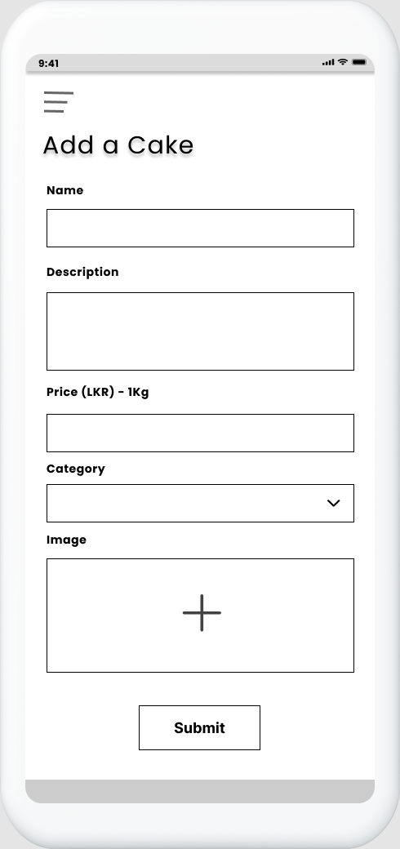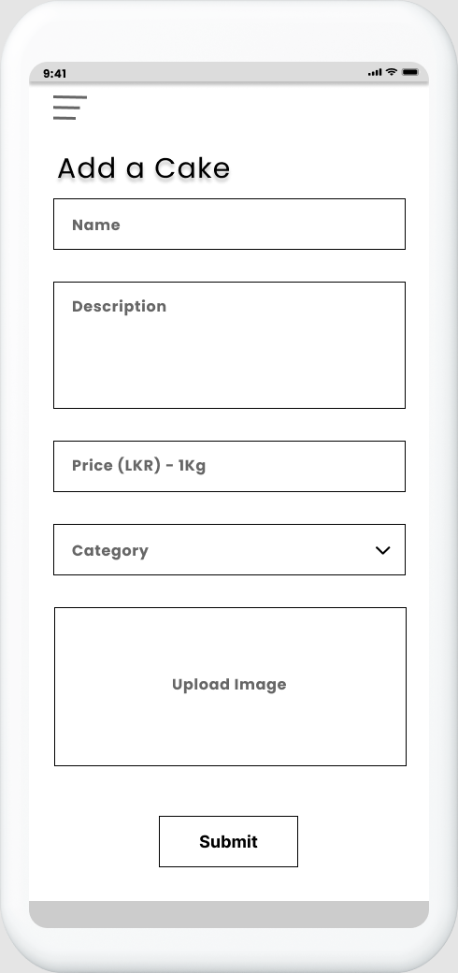**Sketches Wireframes**

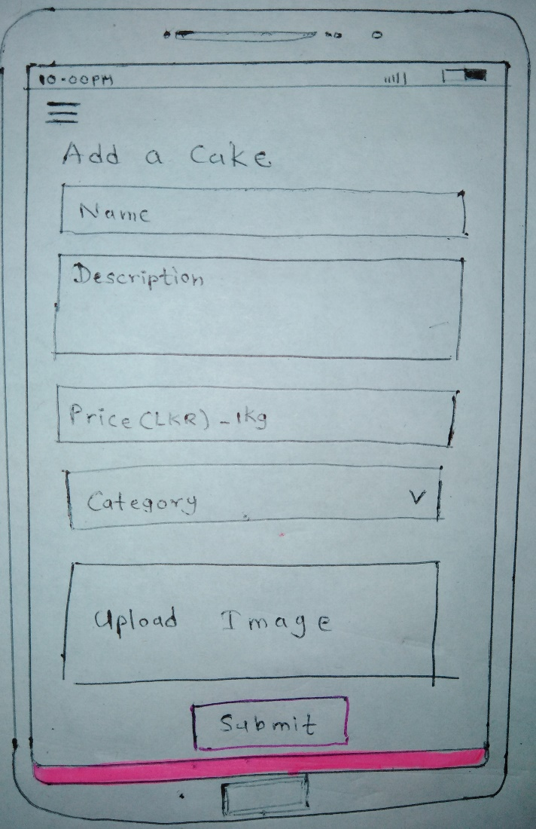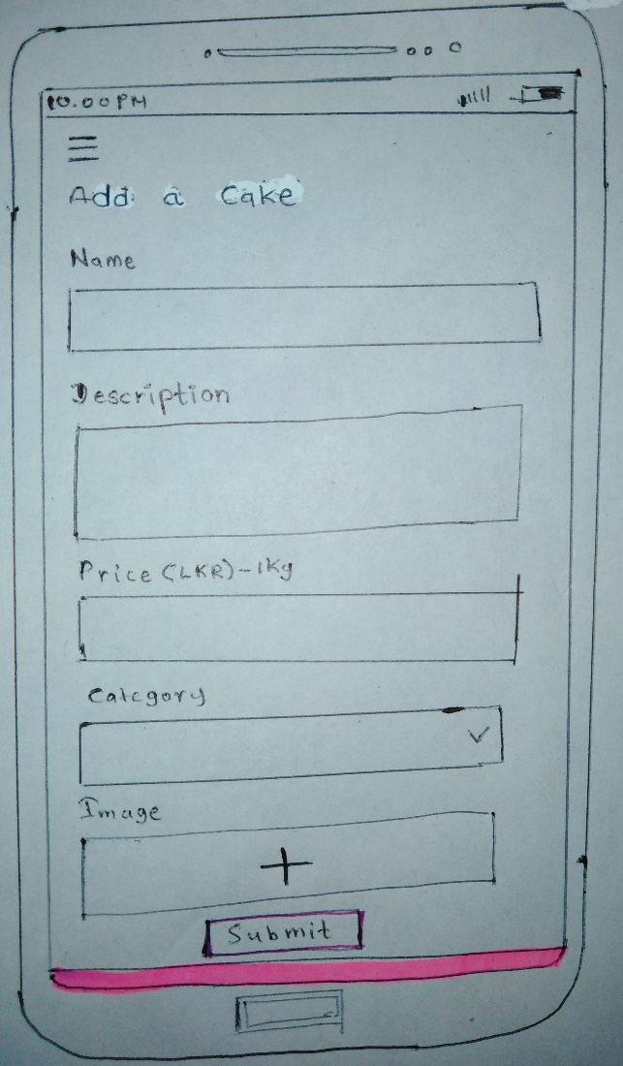

## **Interface 2 – Home - Admin**

**Design Suggestions**

|  |  |  |
| --- | --- | --- |
| Screenshot of the GUI | Proposed sketch | Proposed wireframe |
|  |  |  |

## **Interface 3 – Edit Cake - Admin**

|  |  |  |
| --- | --- | --- |
| Screenshot of the GUI | Proposed sketch | Proposed wireframe |
|  |  |  |

**Design Suggestions**

## **Interface 4 – Cake List - Admin**

**Design Suggestions**

|  |  |  |
| --- | --- | --- |
| Screenshot of the GUI | Proposed sketch | Proposed wireframe |
|  |  |  |

**Sketches Wireframes**

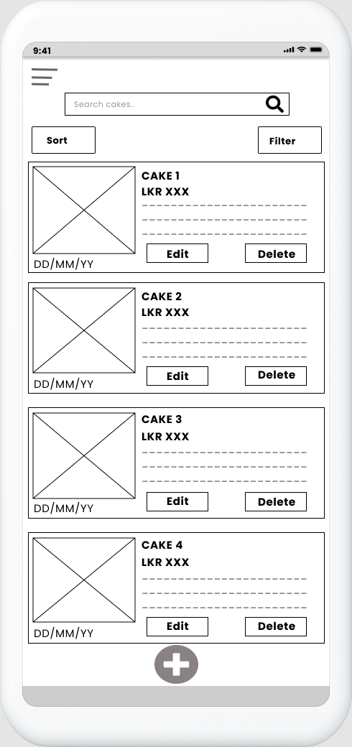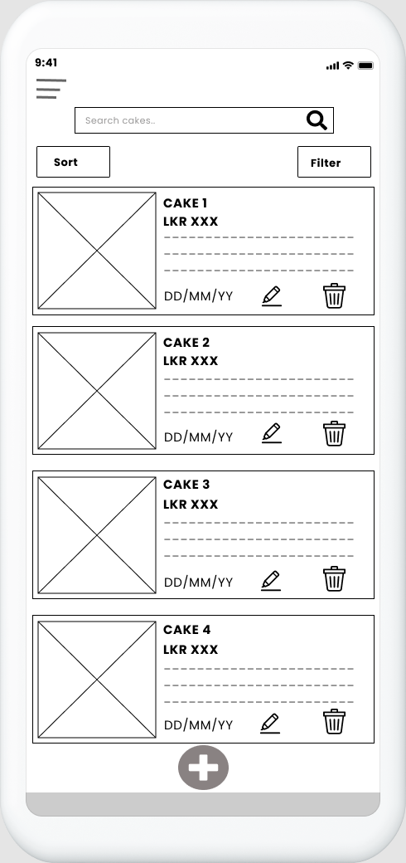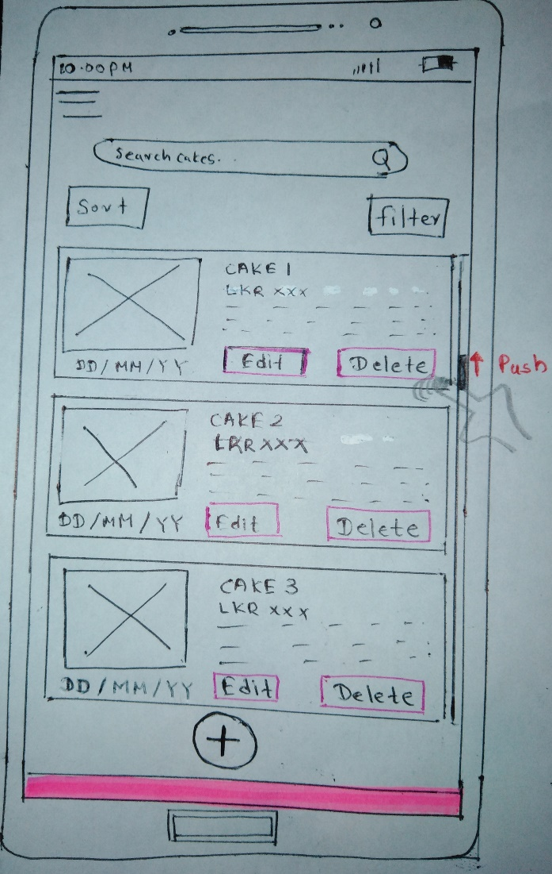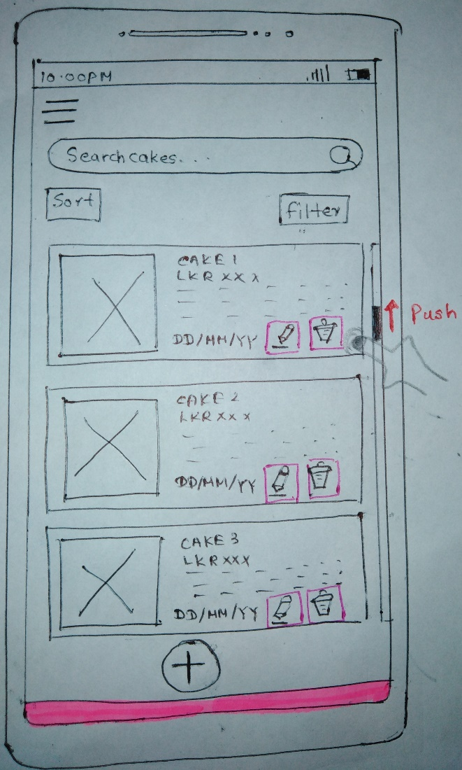

## **Interface 5 – Category List - Admin**

**Design Suggestions**

|  |  |  |
| --- | --- | --- |
| Screenshot of the GUI | Proposed sketch | Proposed wireframe |
|  |  |  |

## **Interface 6 – Side Navigation**

**Design Suggestions**

|  |  |  |
| --- | --- | --- |
| Screenshot of the GUI | Proposed sketch | Proposed wireframe |
|  |  |  |

## **Interface 7 – Category List**

**Design Suggestions**

|  |  |  |
| --- | --- | --- |
| Screenshot of the GUI | Proposed sketch | Proposed wireframe |
|  |  |  |
| Failure points of the UI:   * Category list is just like a dropdown list. Not an attractive UI | Suggested solutions   * Create a list of categories by adding a related picture to recognize easily | |

## **Interface 8 – Single Category**

**Wireframes**

**Sketches**

**Design Suggestions**

|  |  |  |
| --- | --- | --- |
| Screenshot of the GUI | Proposed sketch | Proposed wireframe |
|  |  |  |
| Failure points of UI   * No search option to search cakes | Suggested solution   * Add a search bar to search cakes * Add a filter option to filter cakes | |

**Sketches Wireframes**

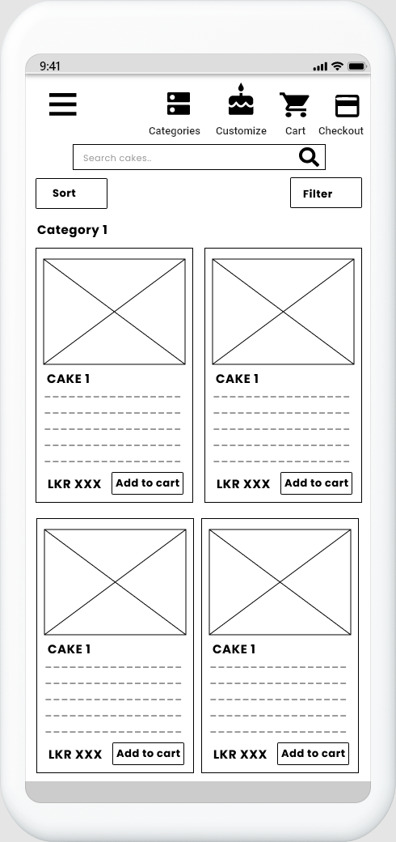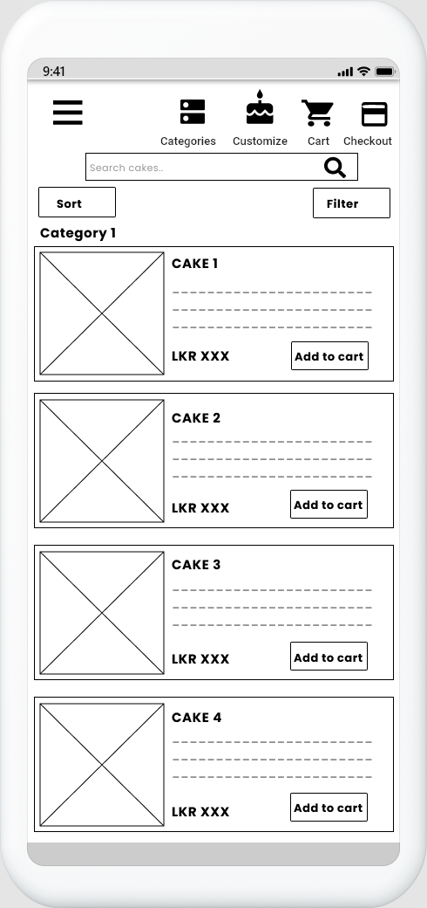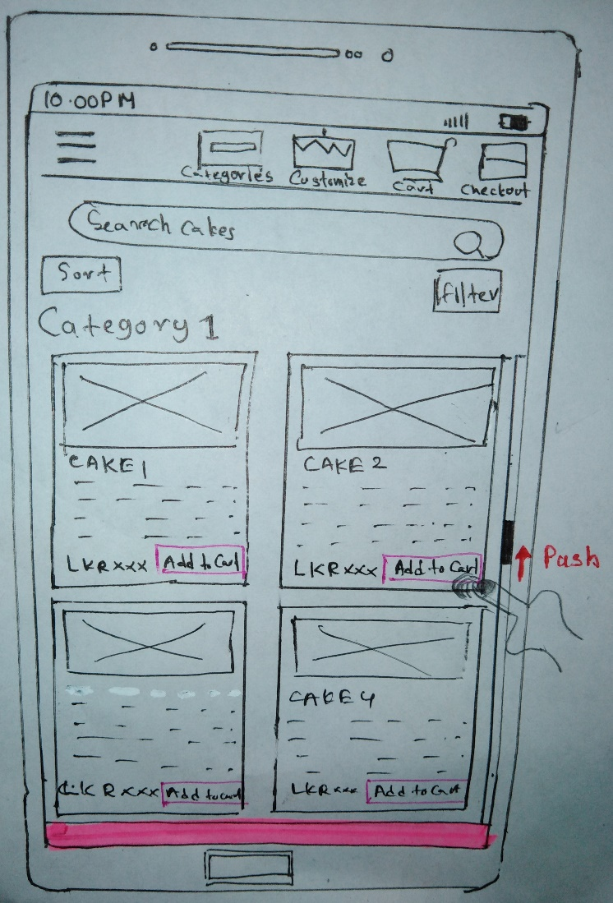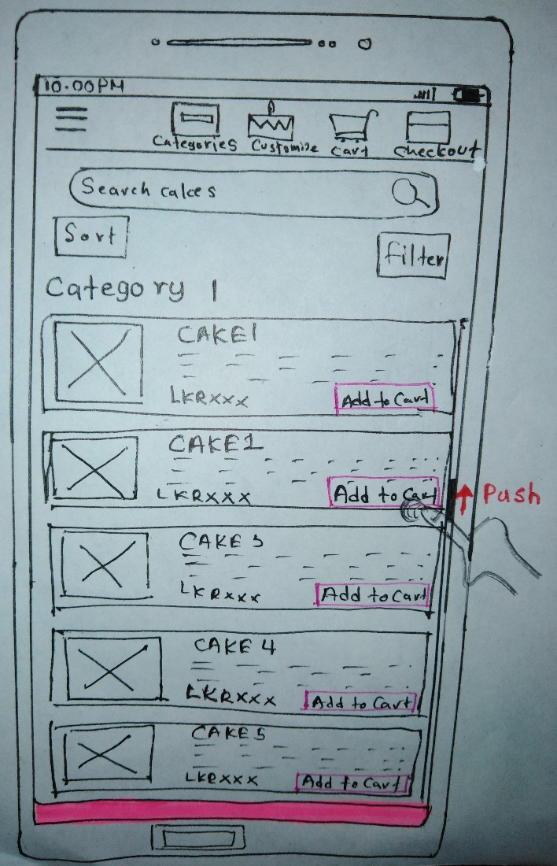

## **Interface 9 – Cake List**

**Design Suggestions**

|  |  |  |
| --- | --- | --- |
| Screenshot of the GUI | Proposed sketch | Proposed wireframe |
|  |  |  |
| Failure points of UI   * No search, sort and filter options to find cakes | Suggested solutions   * Add search bar to search cakes * Add sort options to sort cakes according to preference of the customer * Add filter option to filter cakes | |

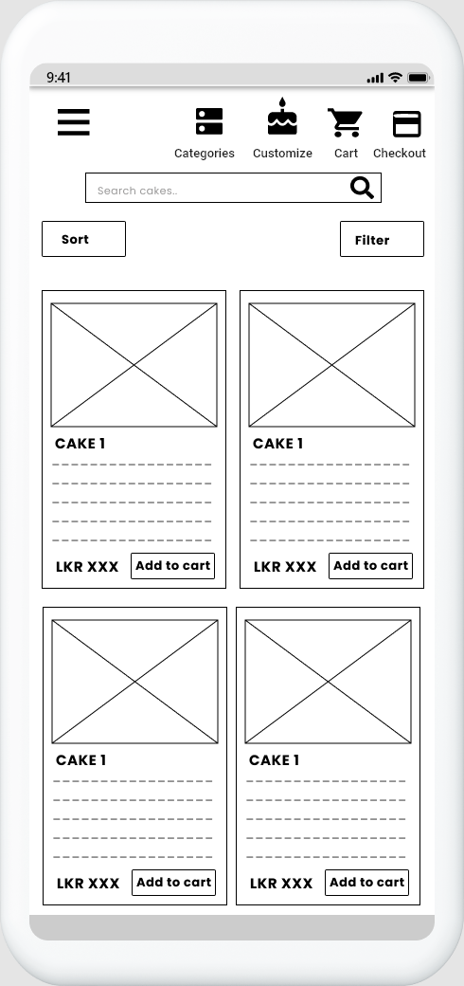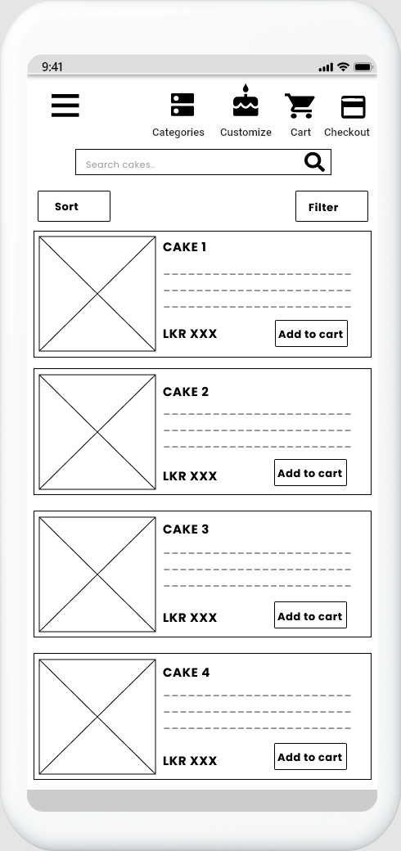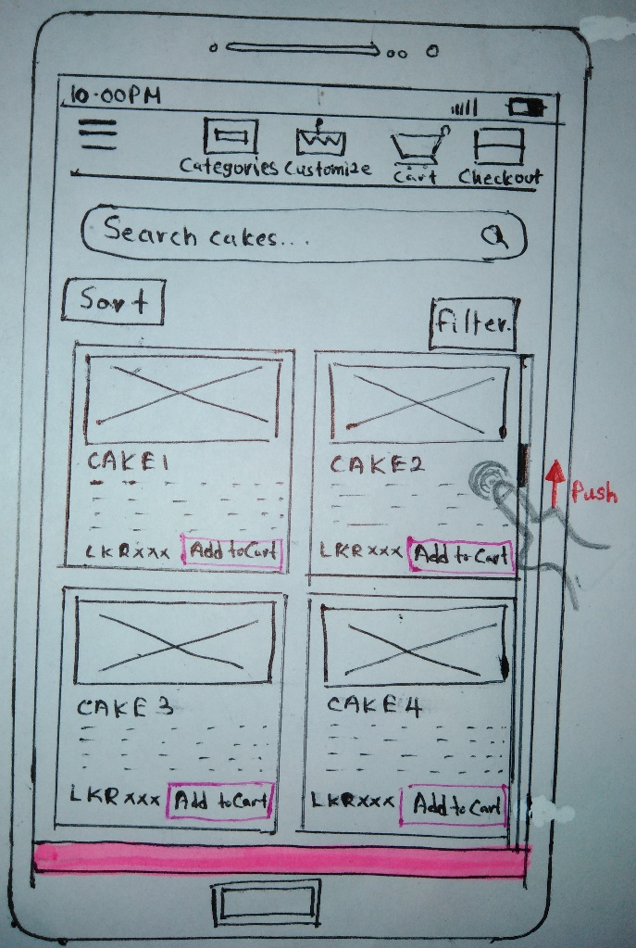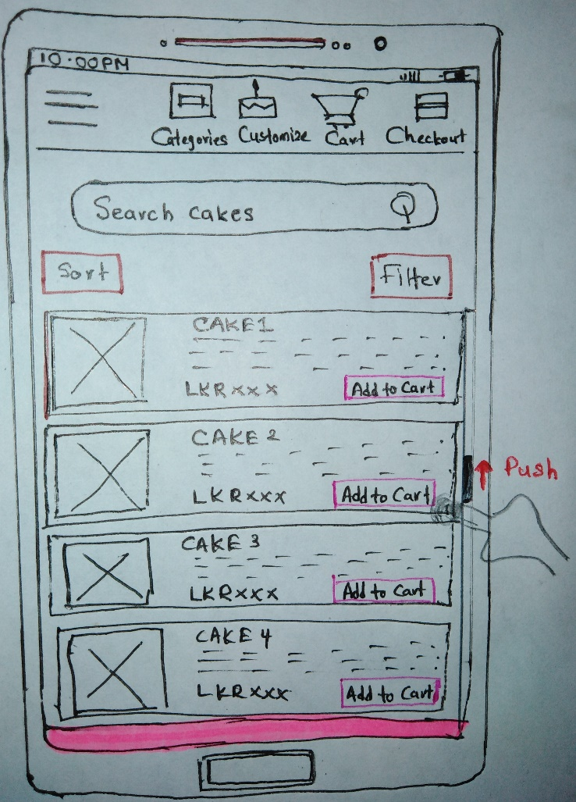**Sketches Wireframes**

## **Interface 10 – Single View of a Cake**

**Design Suggestions**

|  |  |  |
| --- | --- | --- |
| Screenshot of the GUI | Proposed sketch | Proposed wireframe |
|  |  |  |
| Failure points of UI   * Small image of the cake * Input fields are too small. * Too much information in this UI * Changing the quantity is little bit difficult. | Suggested solutions   * Add a clear large image of the cake to recognize easily * Increase the size of the input fields * Reduce unwanted information * Add + and – buttons to increase and decrease the quantity of the item. | |

**Sketches Wireframes**

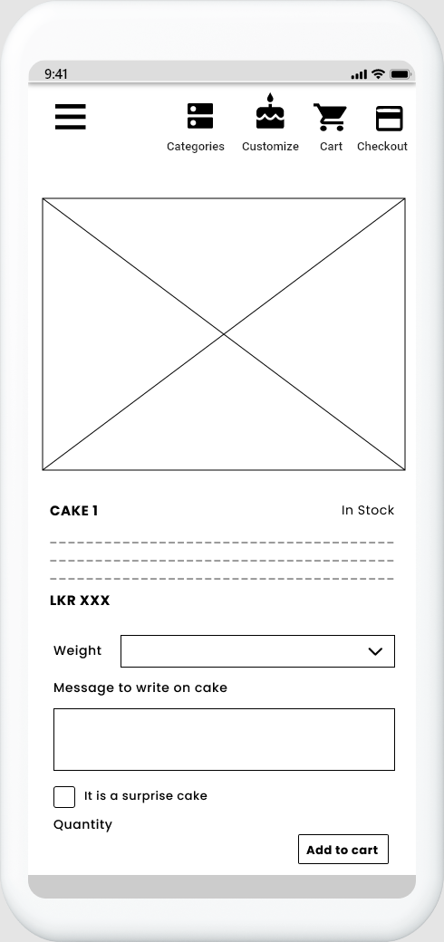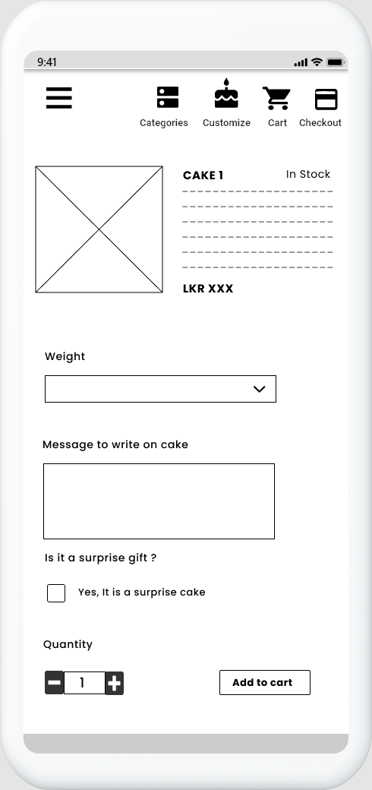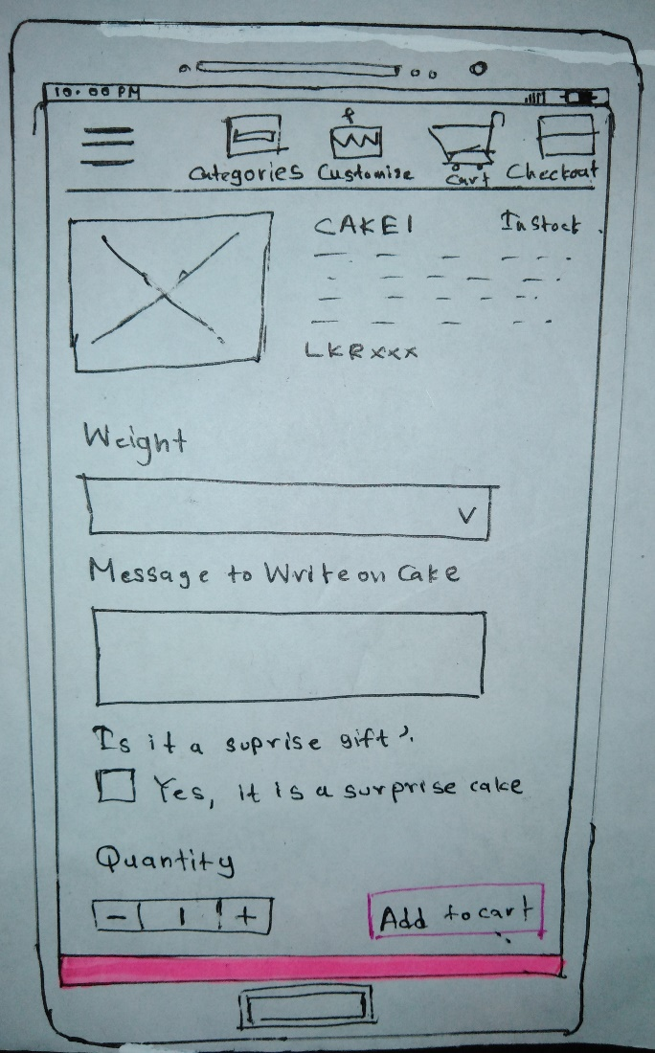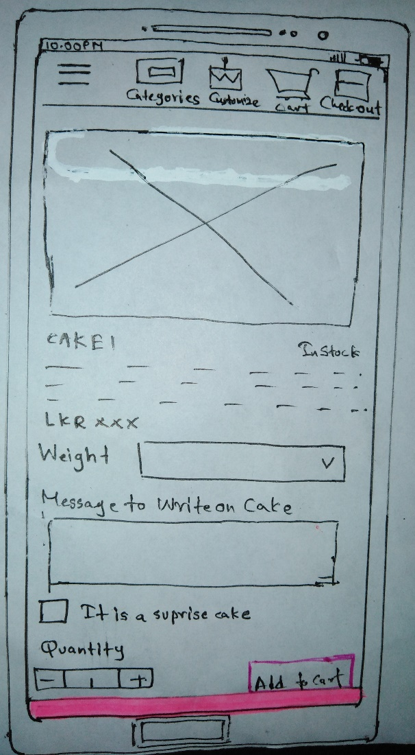

**Connection between UIs**

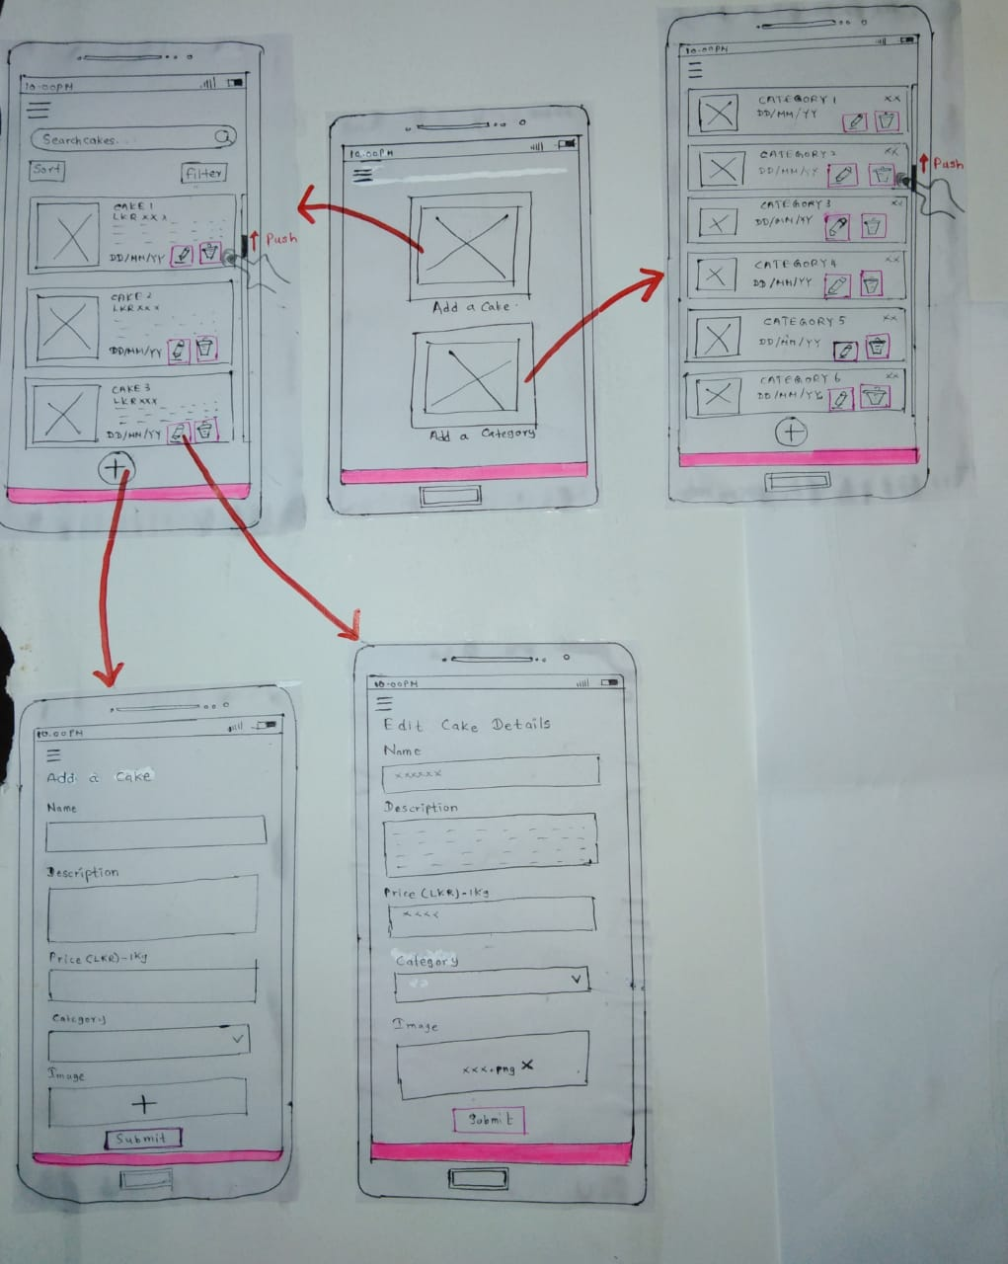

**Admin**

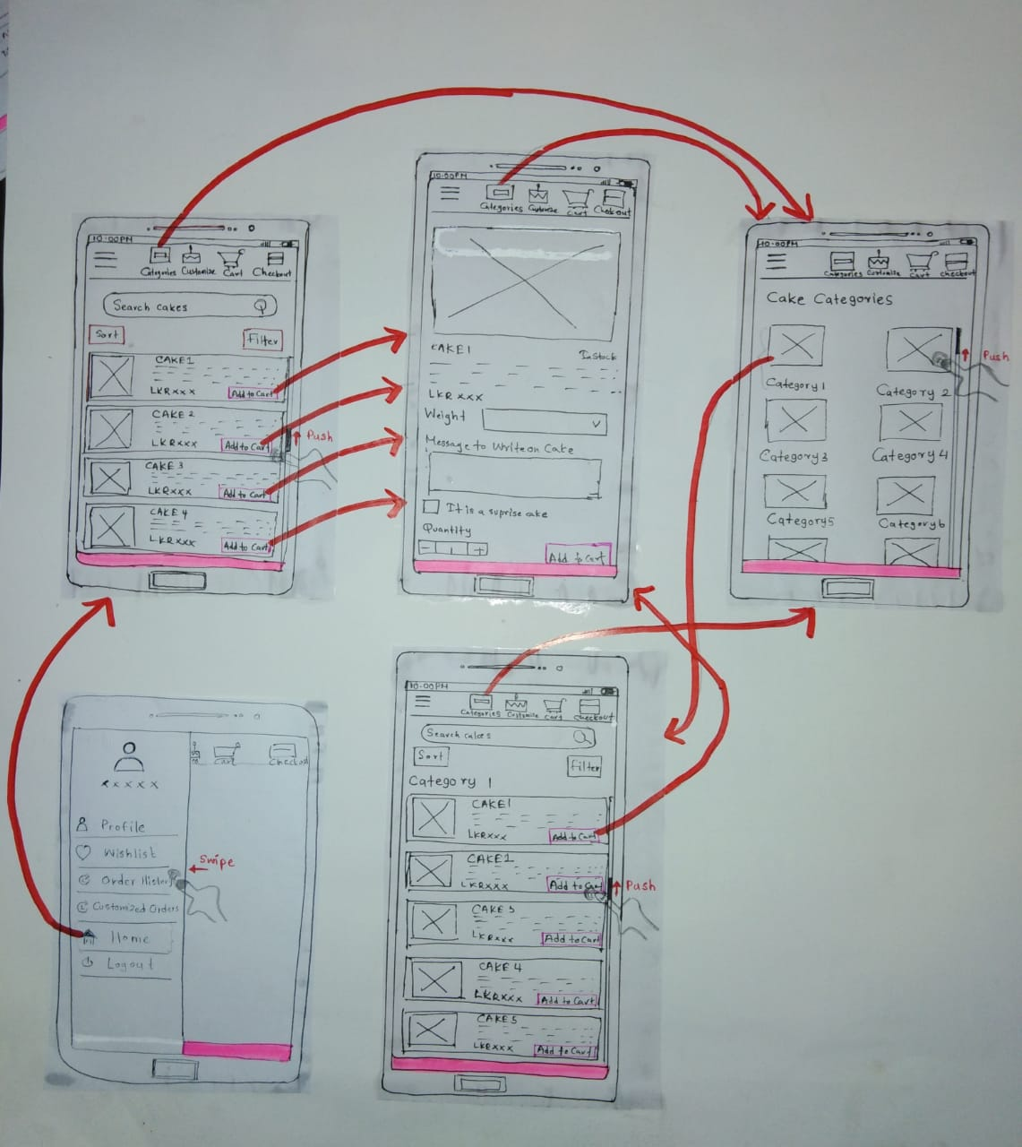

**Customer UIs**

**Connection between UIs – Admin UIs**

  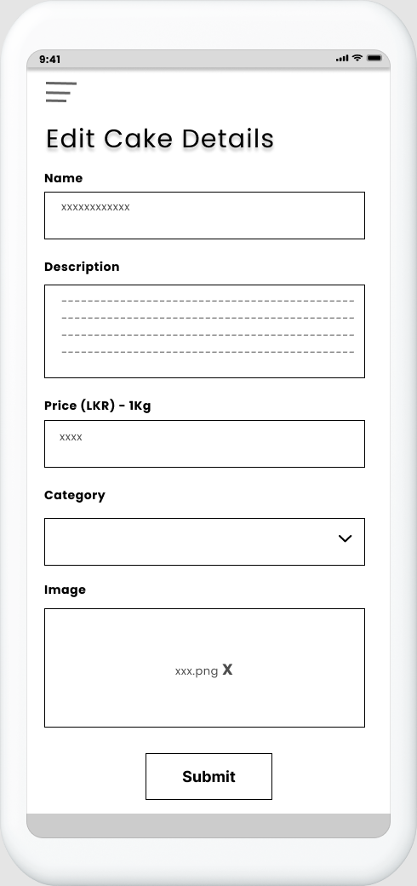

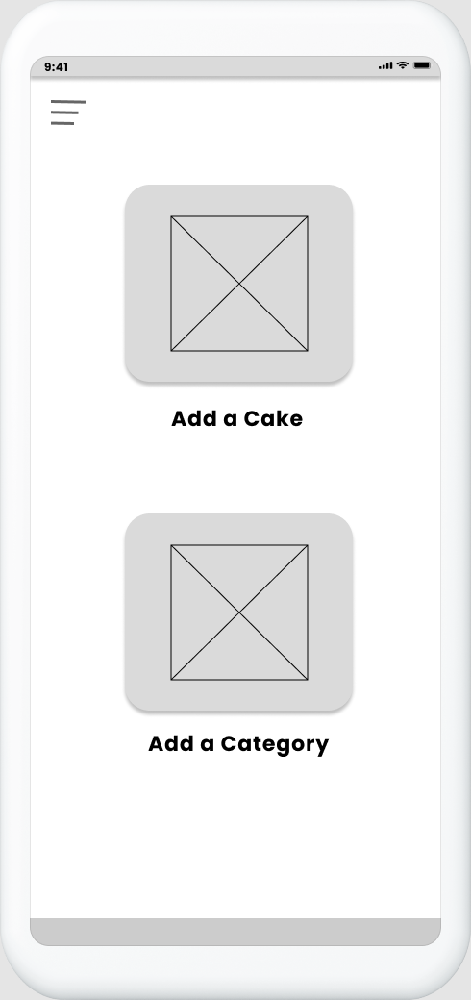

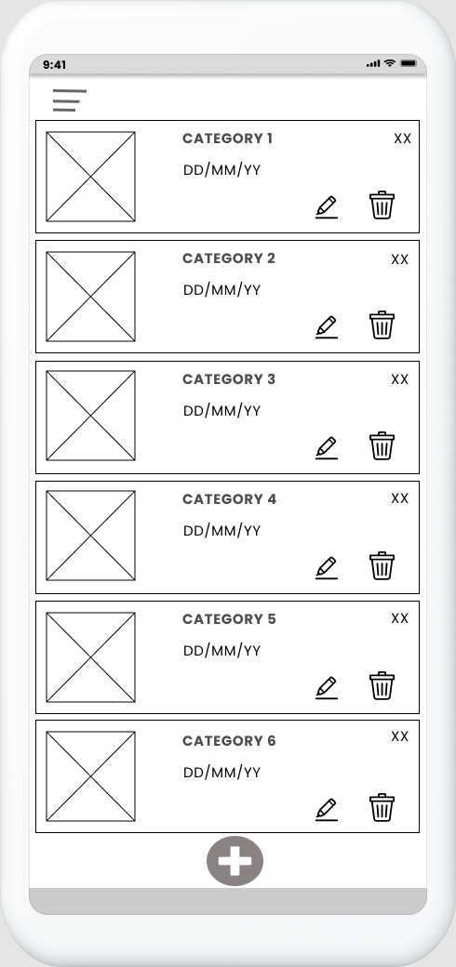

**Connection between UIs – Customer UIs**

  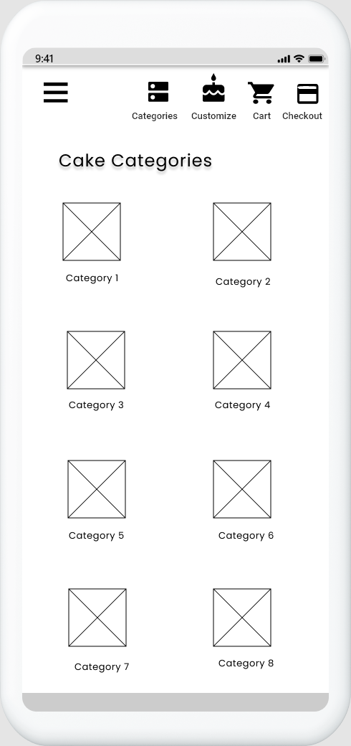

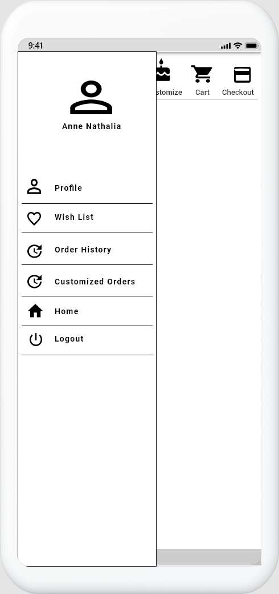 

**Prototype Version 1**

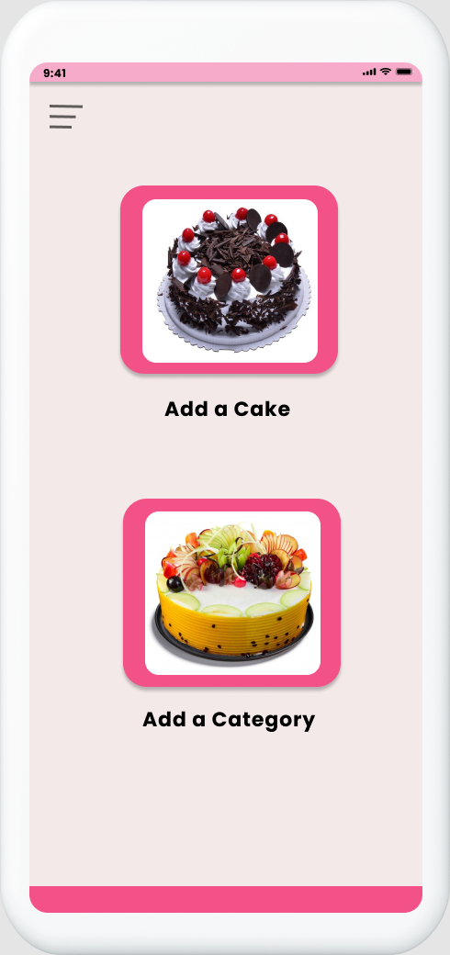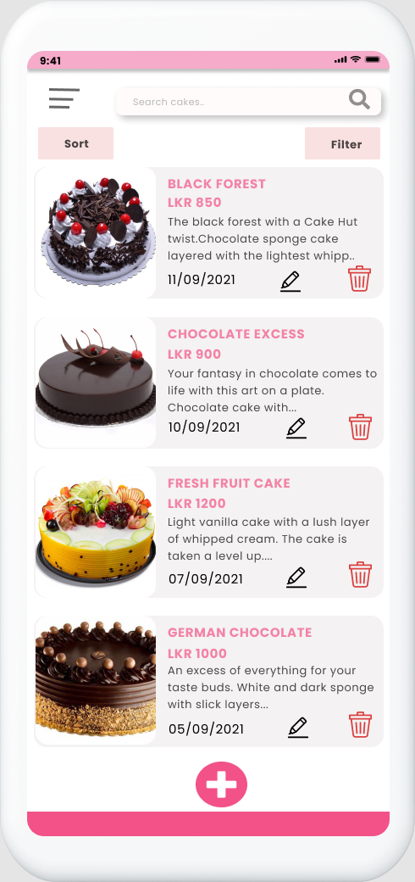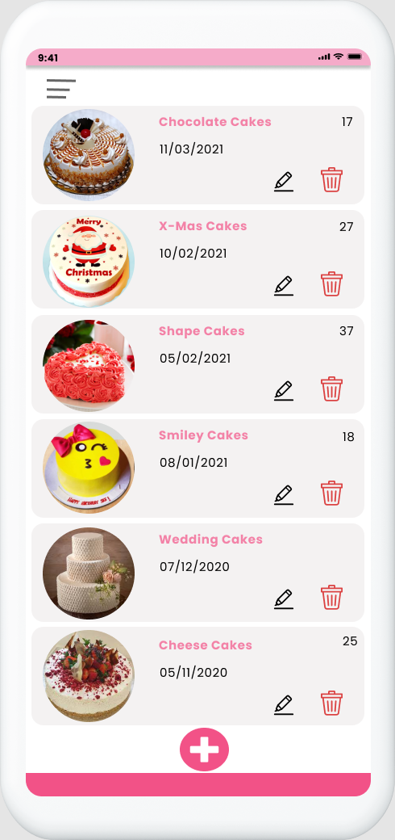

**–**

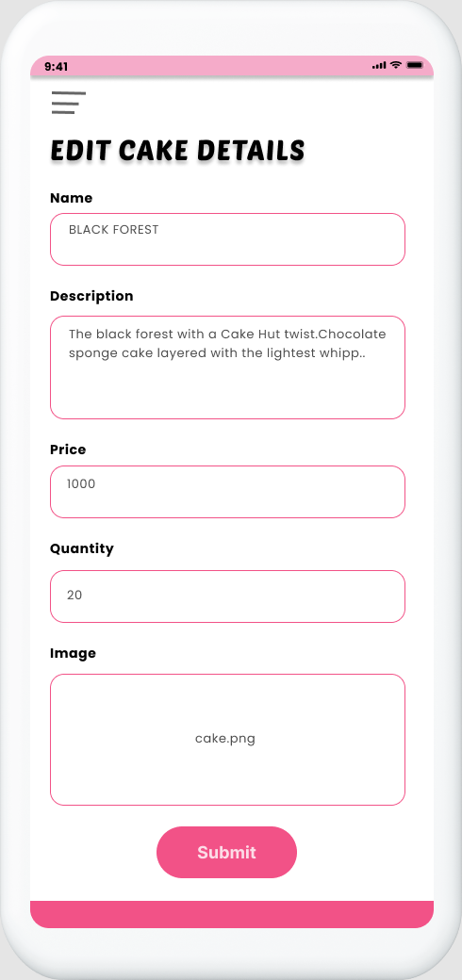

**Edit Cake - Admin**

**Home - Admin**

**Cake List - Admin**

**Category List - Admin**

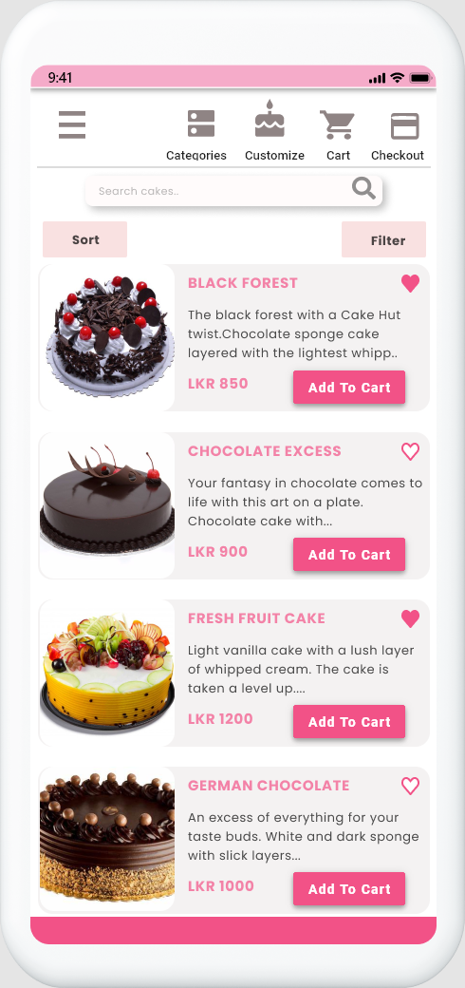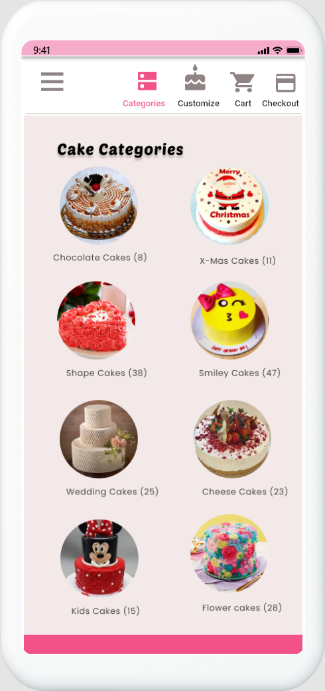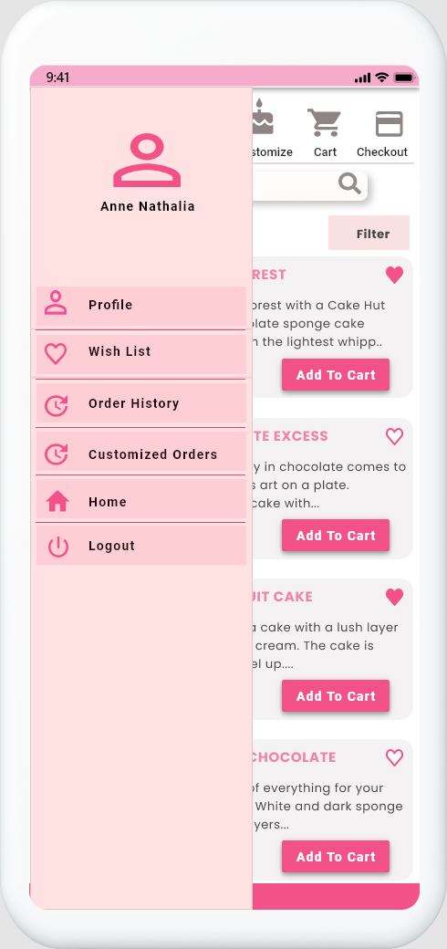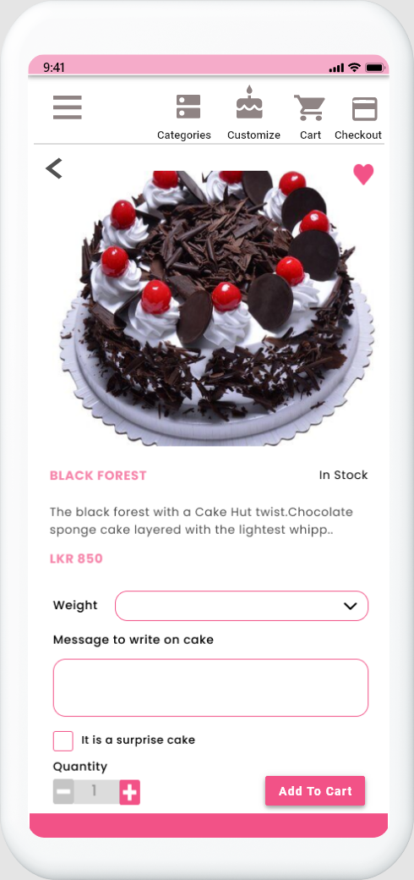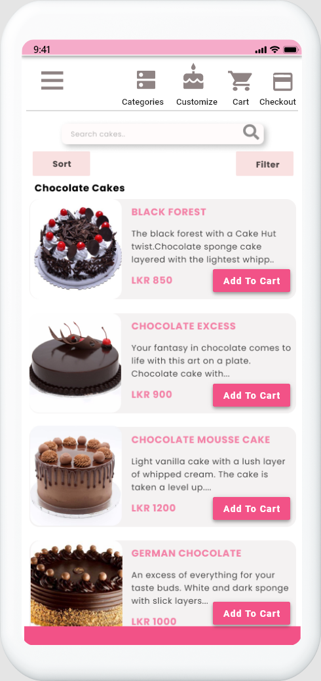

**Single View of a Cake**

**Single Category**

**Category List**

**Cake List**

**Side Navigation**

**Prototype Version 2**

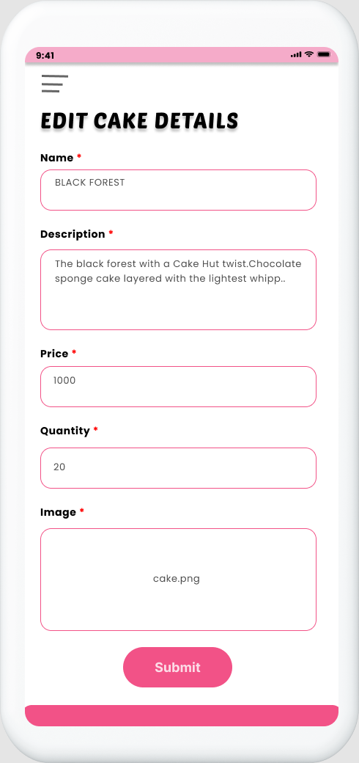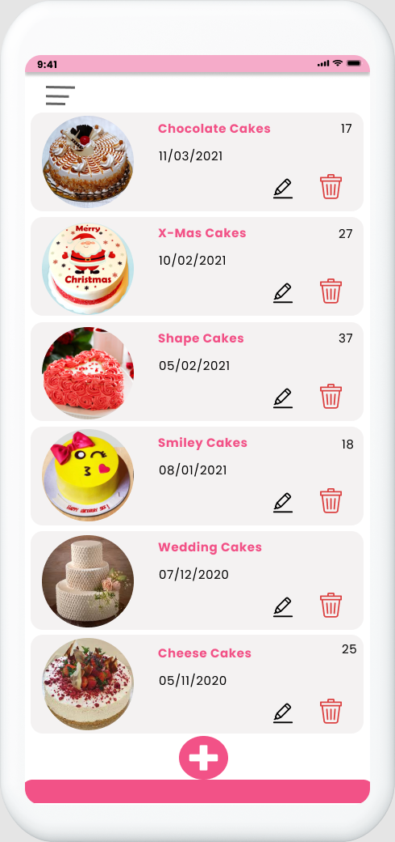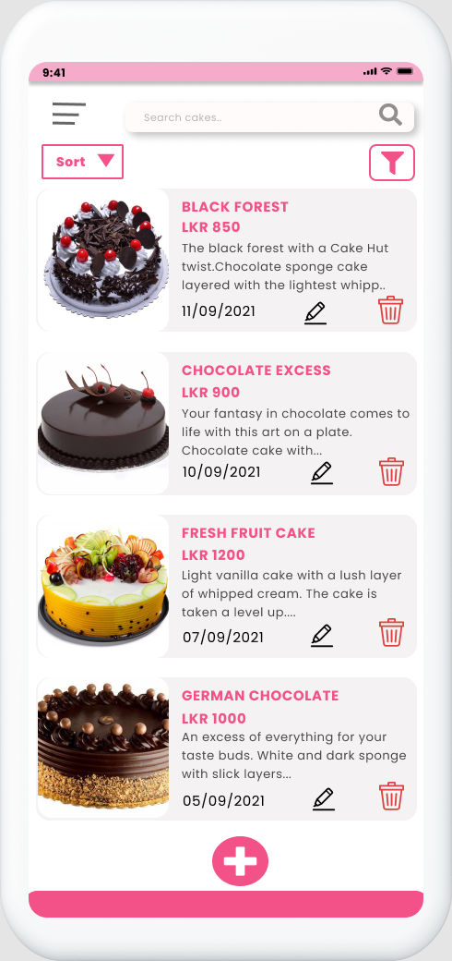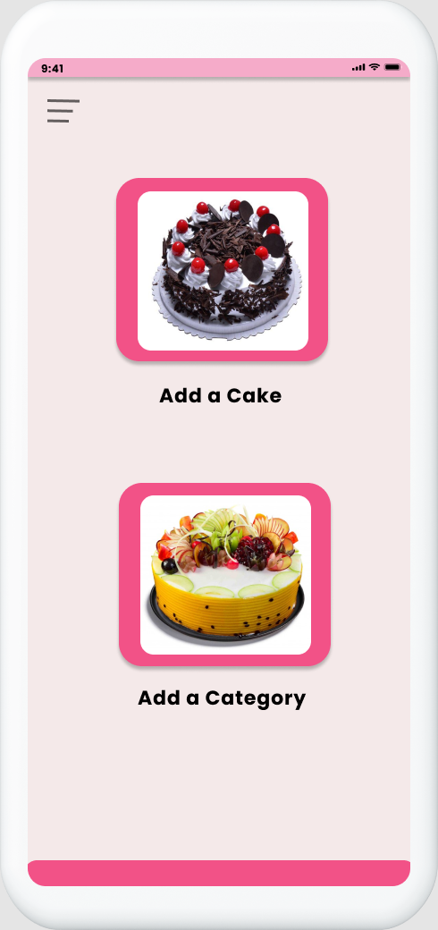

**Edit Cake - Admin**

**Category List - Admin**

**Cake List - Admin**

**Home - Admin**

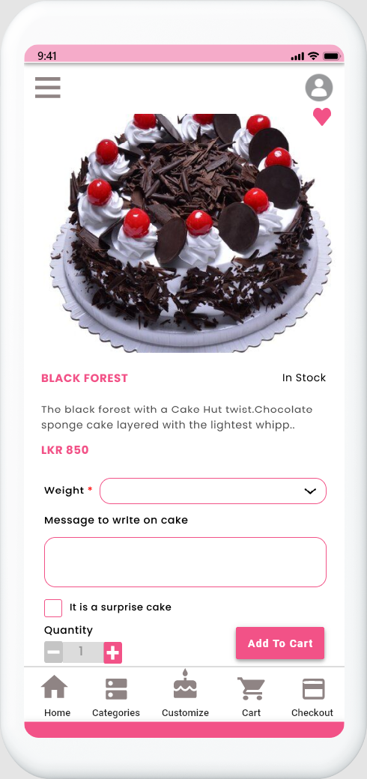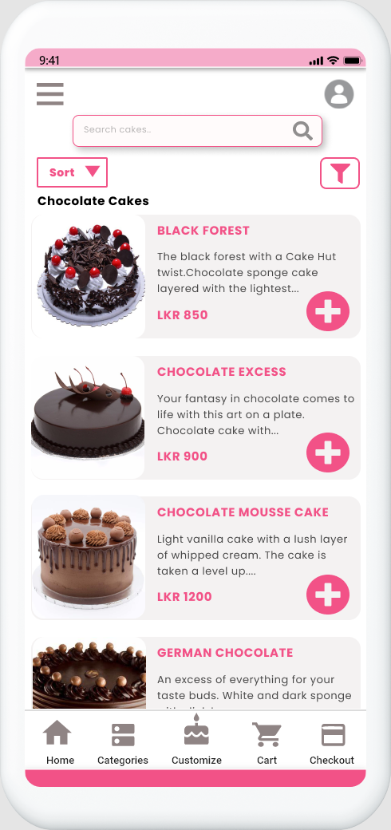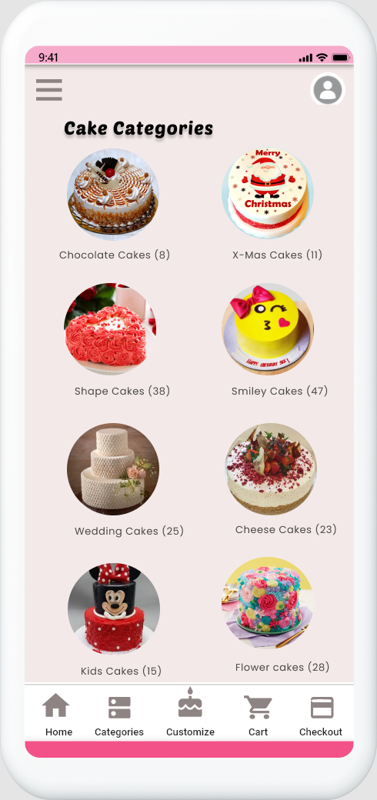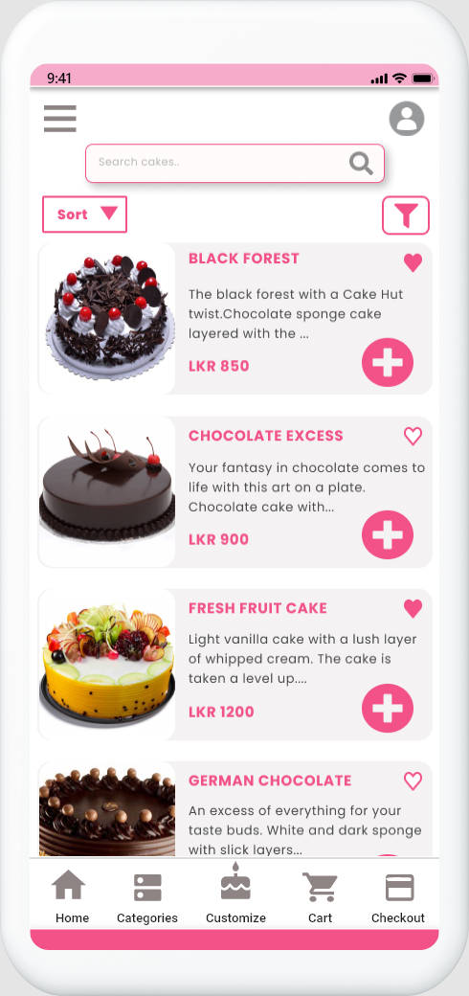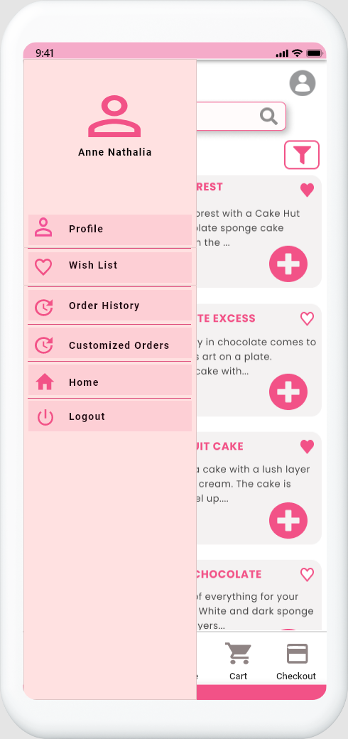

**Single View of a Cake**

**Single Category**

**Category List**

**Cake List**

**Side Navigation**

# **IT19953984 – Sajani Y.N – Cart, Wishlist and Order management**

## **Interface 1 – Landing Page**

**Design Suggestions**

|  |  |  |
| --- | --- | --- |
| Screenshot of the GUI | Proposed sketch | Proposed wireframe |
|  |  |  |
| * There is no landing page | * Add a loading screen to increase the usability of the app | |

## 

## **Interface 2 – Wishlist**

**Design Suggestions**

|  |  |  |
| --- | --- | --- |
| Screenshot of the GUI | Proposed sketch | Proposed wireframe |
|  |  |  |
| * There is no wishlist | * Add a wishlist to the app and users can add their desired items to wishlist to view them later | |

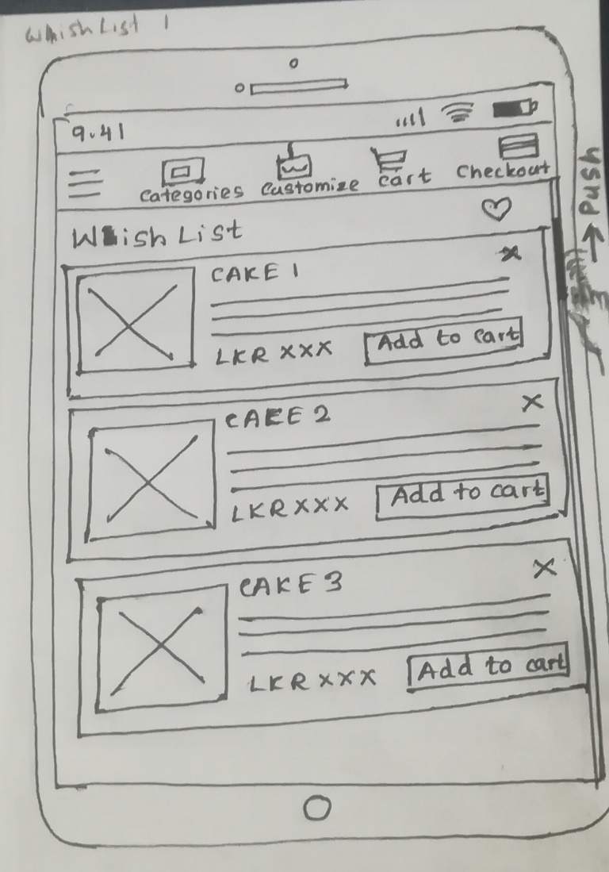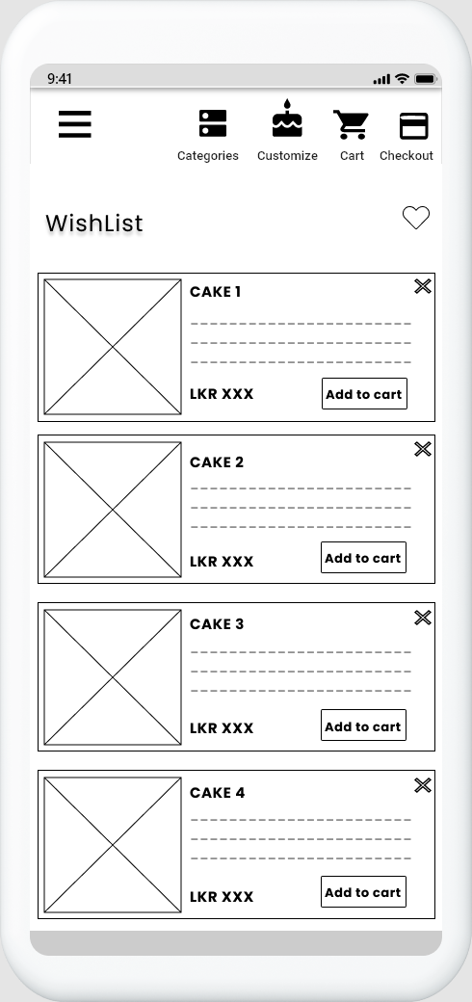**Sketches Wireframes**

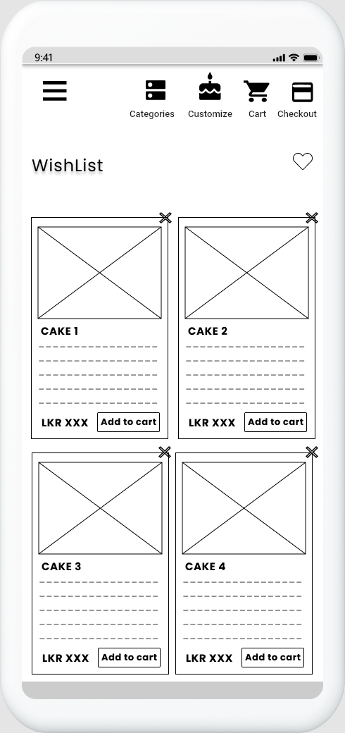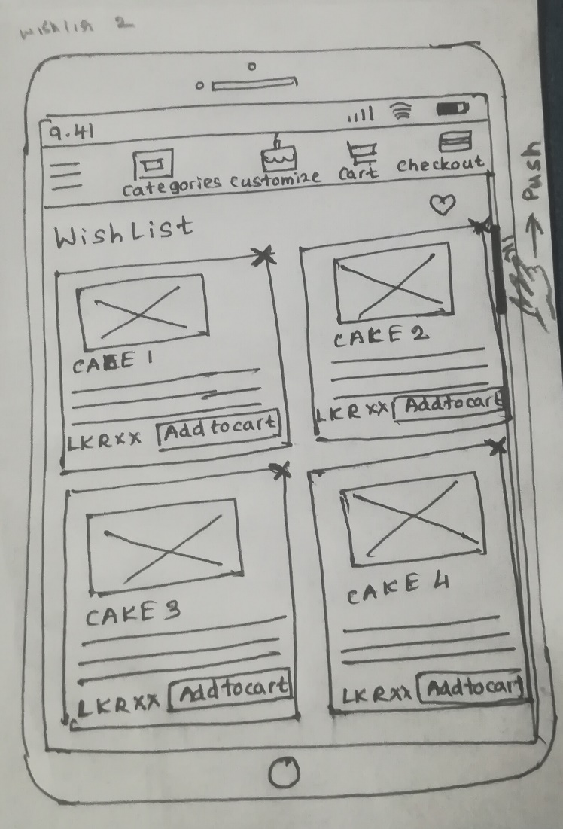

## **Interface 3 – Shopping Cart**

**Design Suggestions**

|  |  |  |
| --- | --- | --- |
| Screenshot of the GUI | Proposed sketch | Proposed wireframe |
|  |  |  |
| Failure points of the UI   * No image to recognize the added item to the cart * Font sizes are too small * Changing the quantity of added item is little bit difficult | Suggested solution   * Add a clear image to recognize the added item * Increase the font size * Add + and – buttons to change the quantity easily. | |

**Sketches Wireframes**

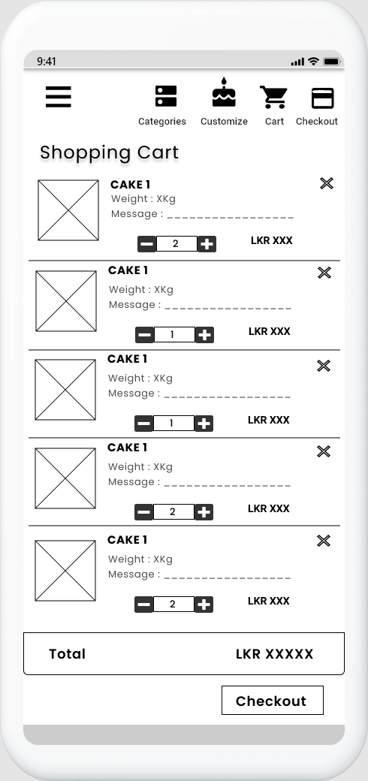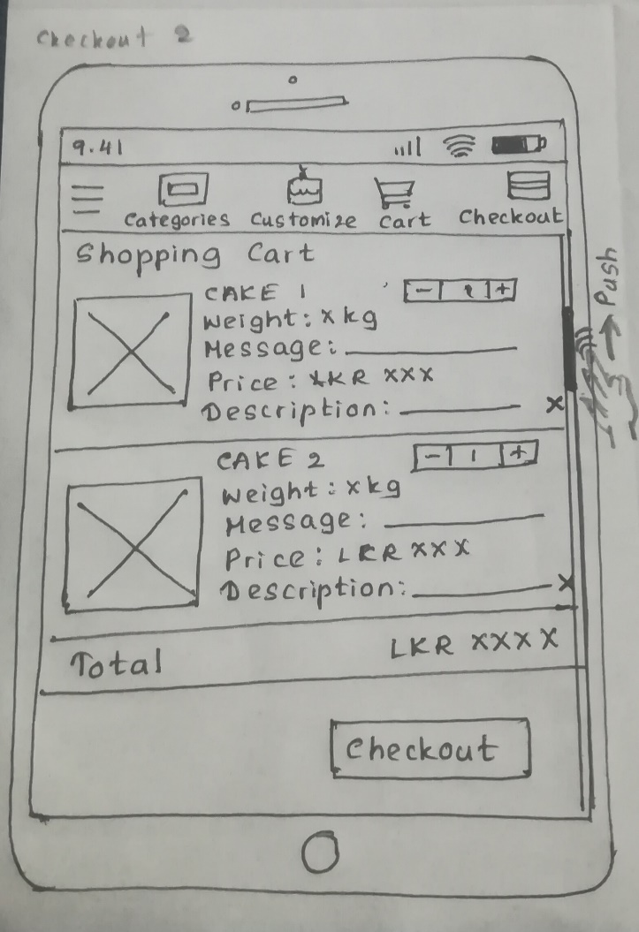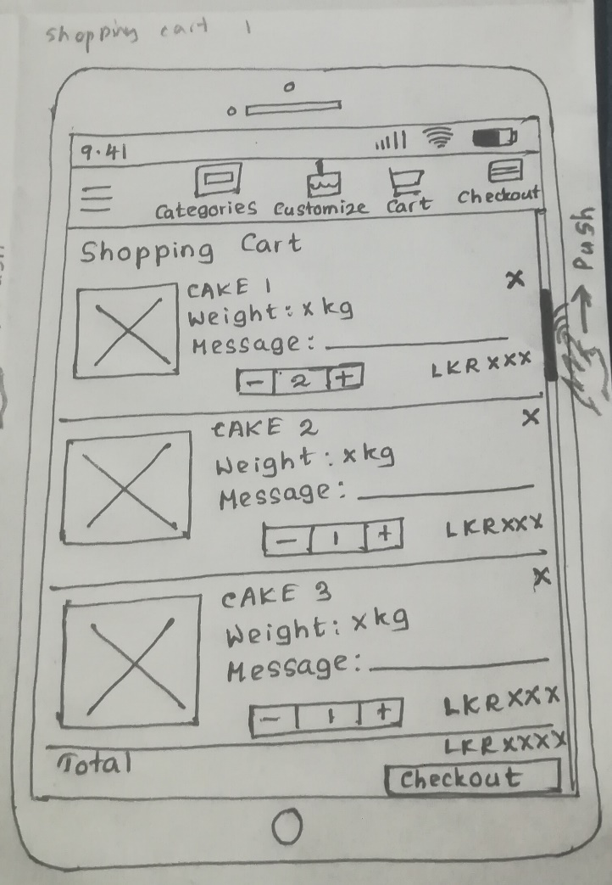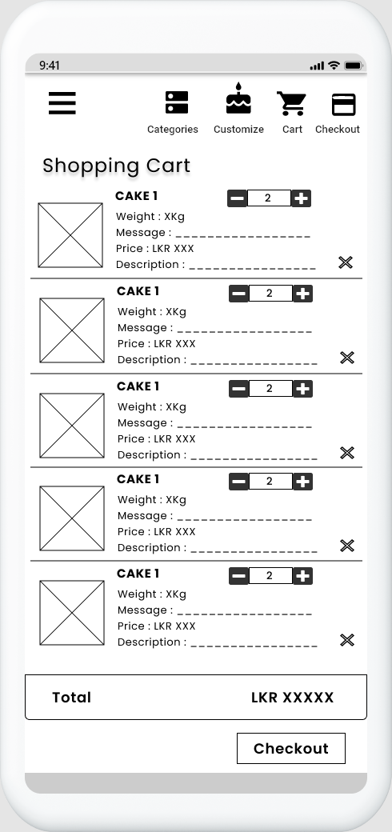

## **Interface 4 – Payment - Shipping Details**

**Design Suggestions**

|  |  |  |
| --- | --- | --- |
| Screenshot of the GUI | Proposed sketch | Proposed wireframe |
|  |  |  |
| Failure points of the UI   * No clear order summary before making payments * Six steps to make the payments * Inputs fields are too small * Asking much information to fill out | Suggested solutions   * Add a clear order summary to recognize the items which are going to be buy * Only two steps for payment * Increase the size of the input fields * Ask to fill only required information | |

**Sketches Wireframe**

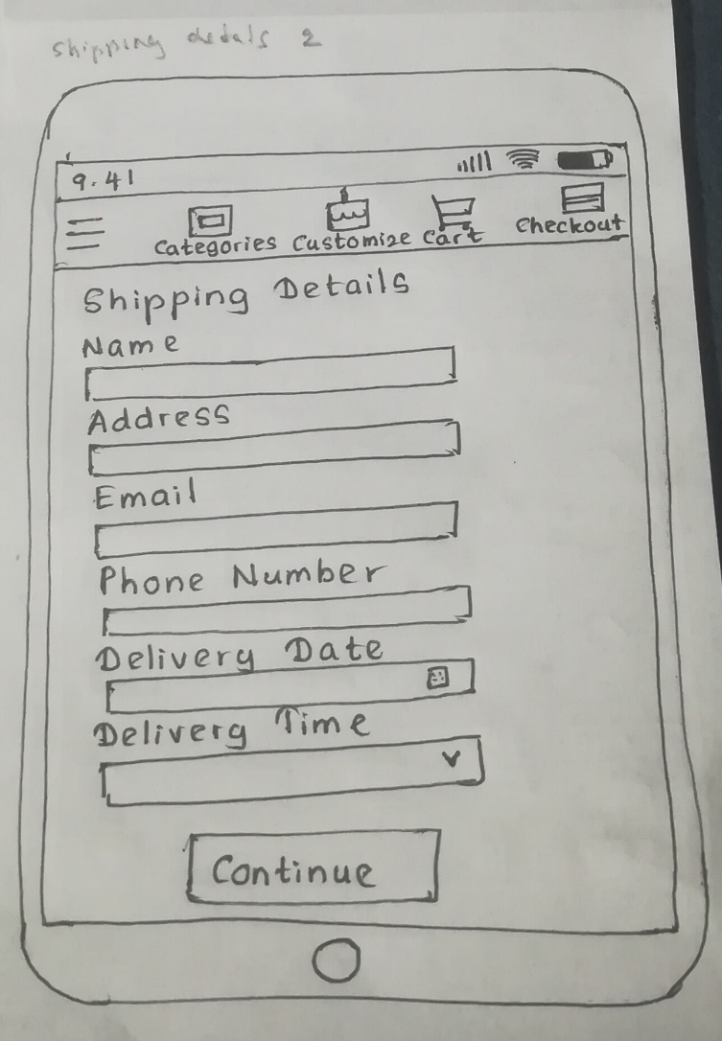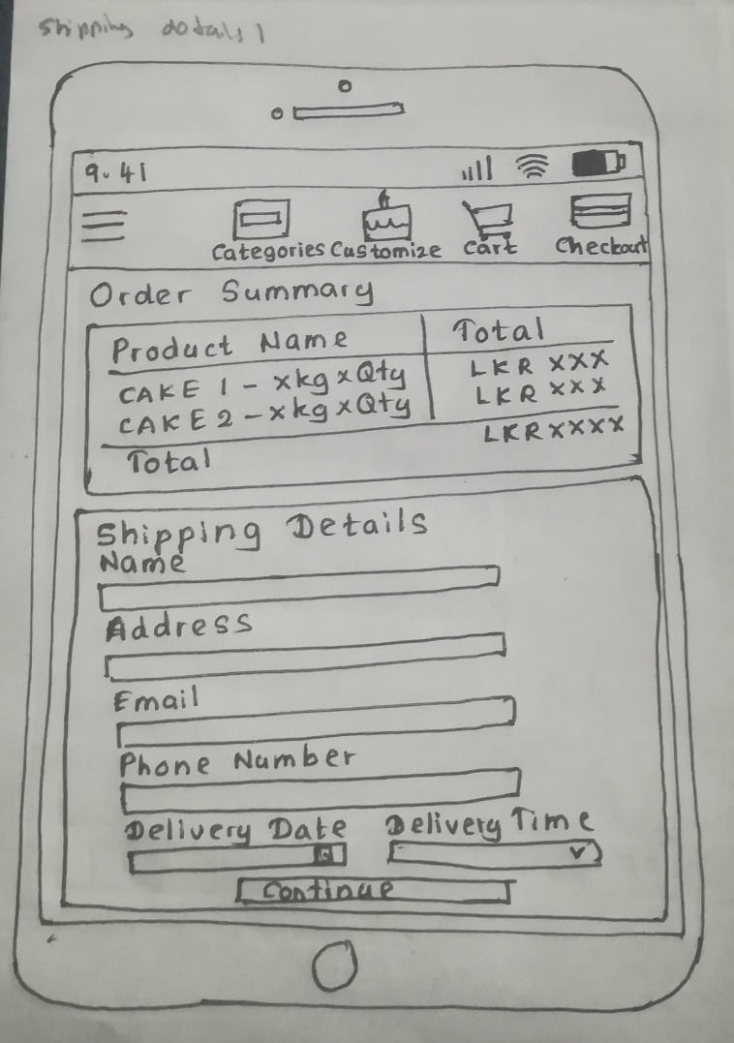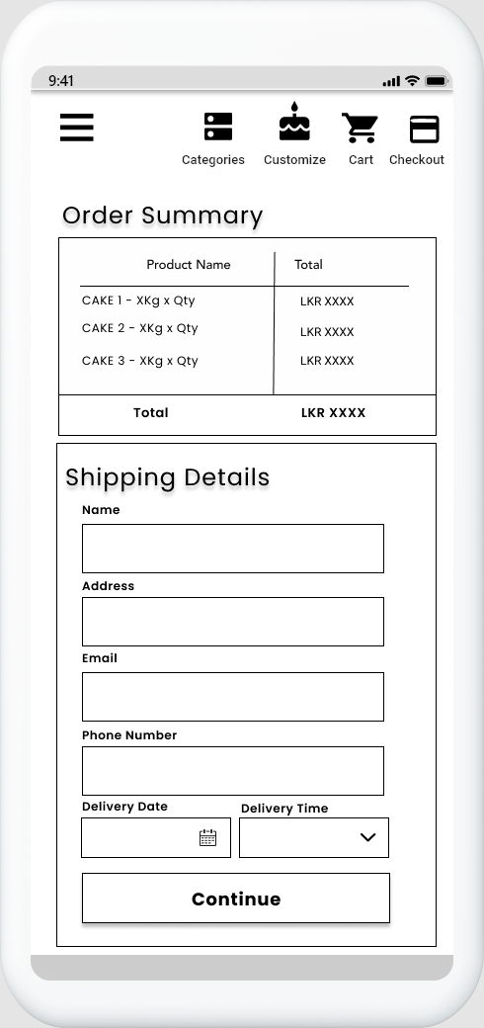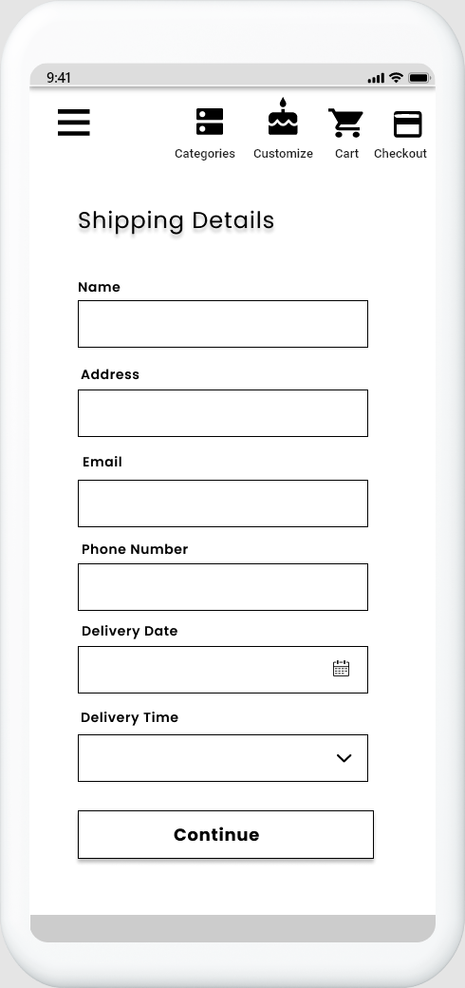

## **Interface 5 – Payment – Card Details**

**Design Suggestions**

|  |  |  |
| --- | --- | --- |
| Screenshot of the GUI | Proposed sketch | Proposed wireframe |
|  |  |  |
| Failure points of the UI   * Six steps to make the payments * Inputs fields are too small * Asking much information to fill out | Suggested solutions   * Only two steps for payment * Increase the size of the input fields * Ask to fill only required information | |

**Sketches Wireframe**

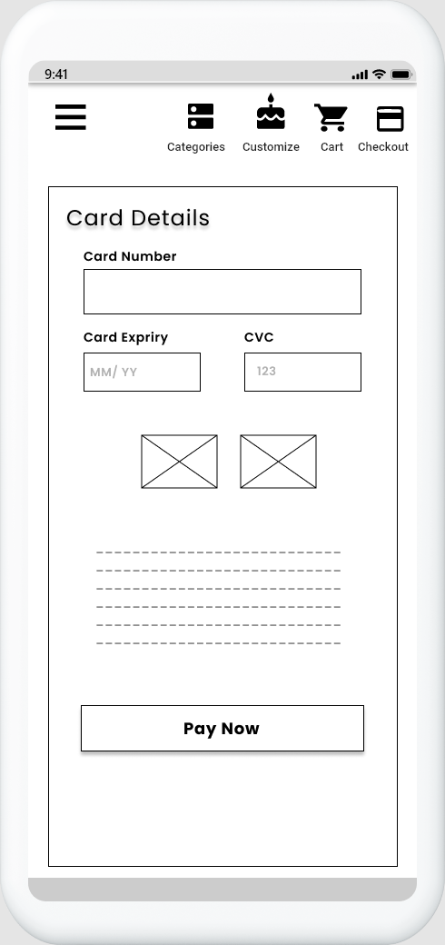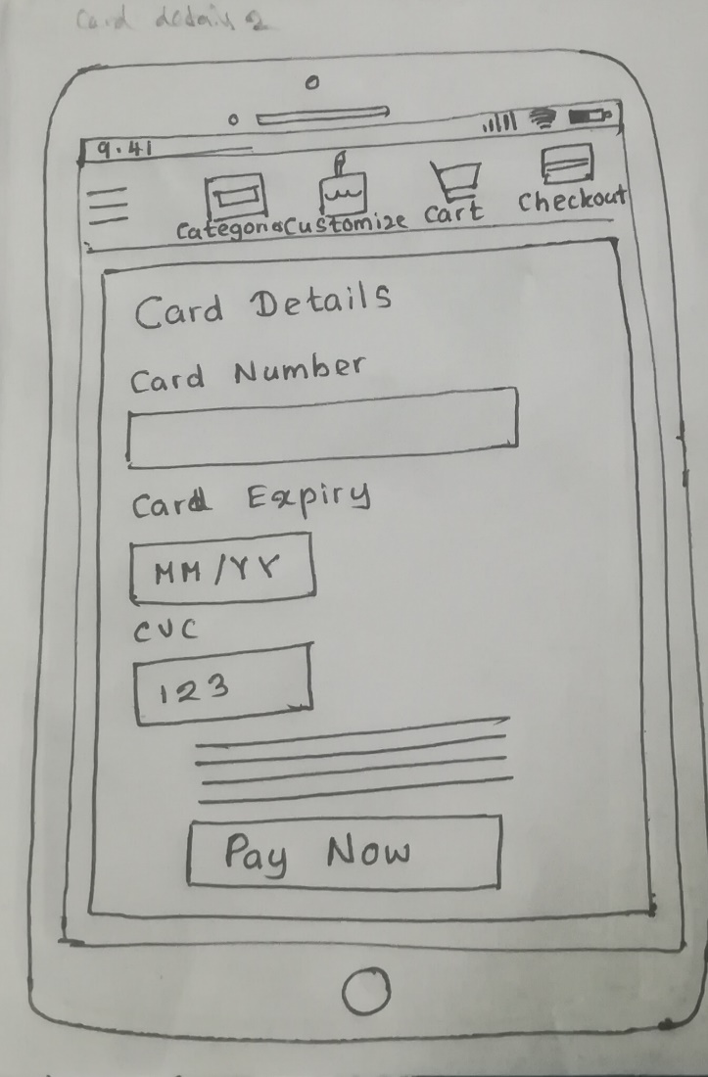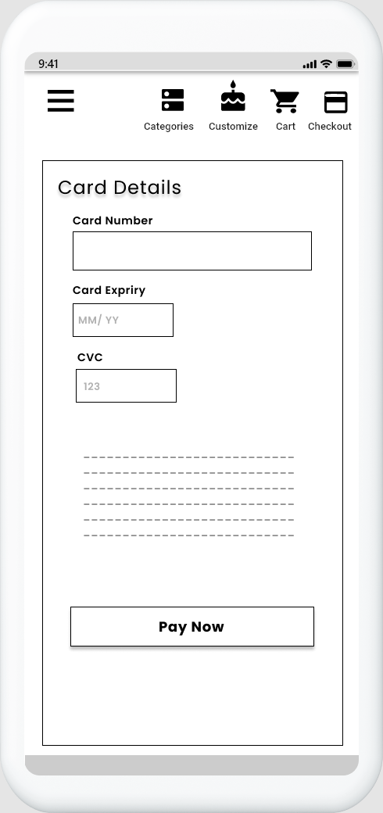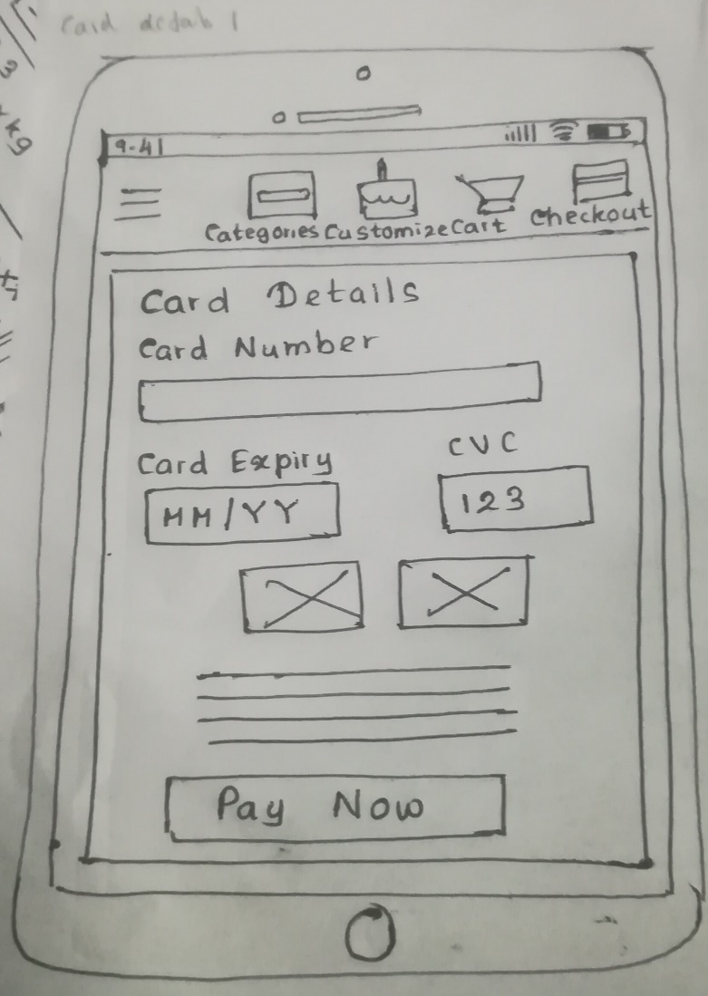

## **Interface 6 – Order History**

**Design Suggestions**

|  |  |  |
| --- | --- | --- |
| Screenshot of the GUI | Proposed sketch | Proposed wireframe |
|  |  |  |
| * There is no order history in the app | * Add a order history to view ordered items | |

**Sketches Wireframes**

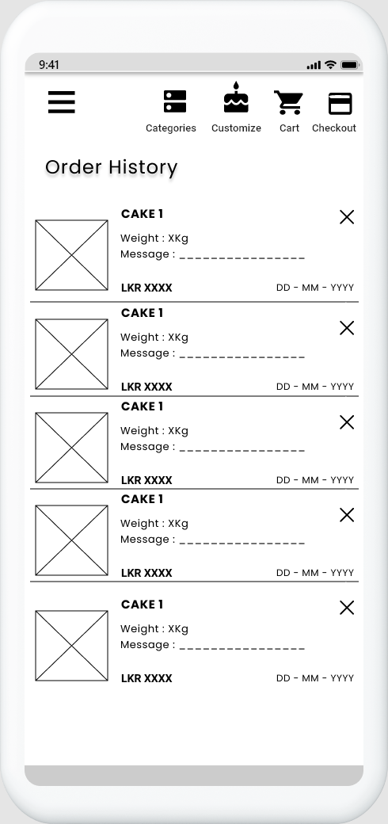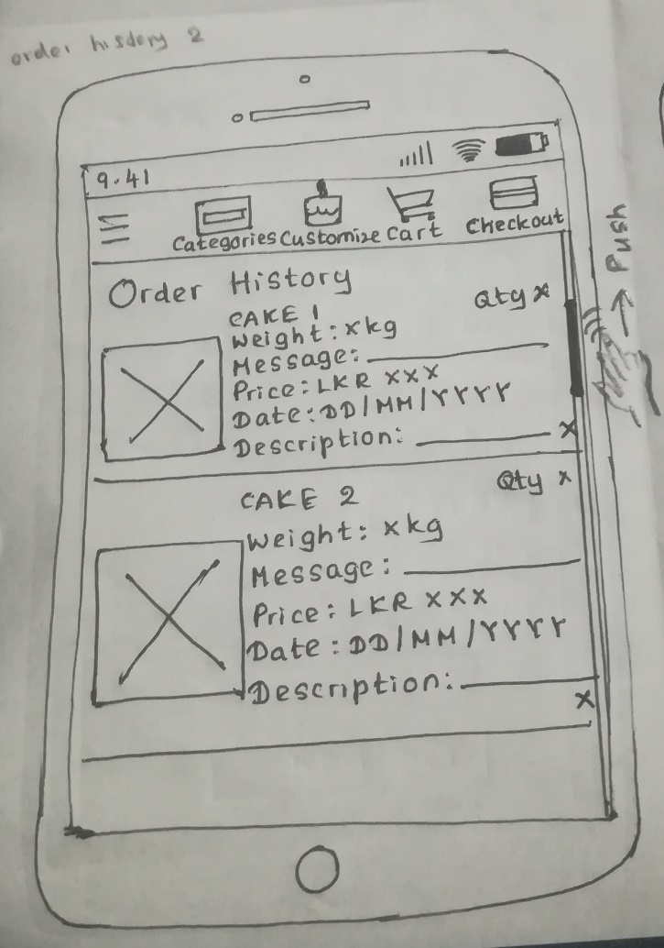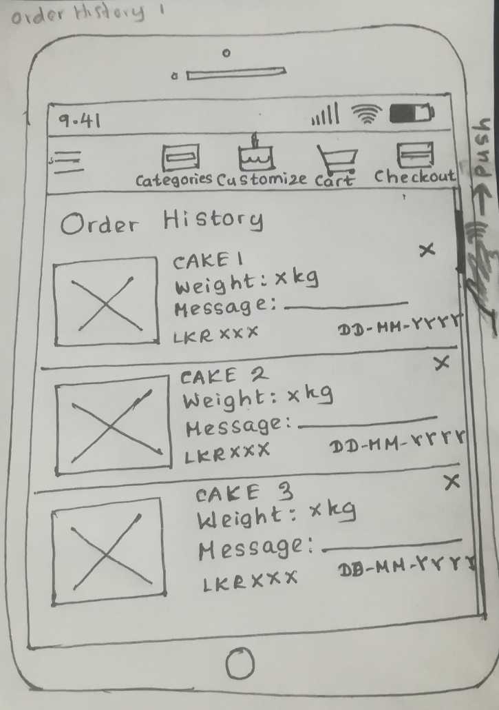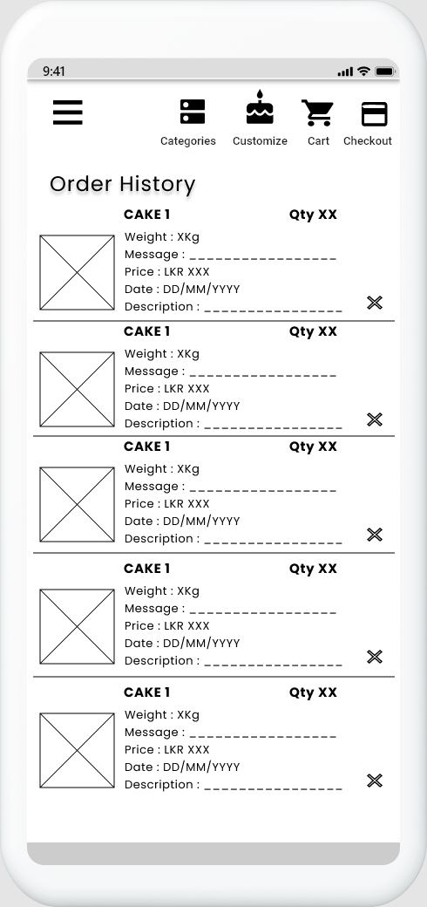

## **Interface 7 – Payment Success**

**Design Suggestions**

|  |  |  |
| --- | --- | --- |
| Screenshot of the GUI | Proposed sketch | Proposed wireframe |
|  |  |  |
| * There is no payment successful page | * Add a message to notify the user that their payment was successful. * User can go to the home page easily by clicking on Back to Home button | |

**Connection Between UIs**

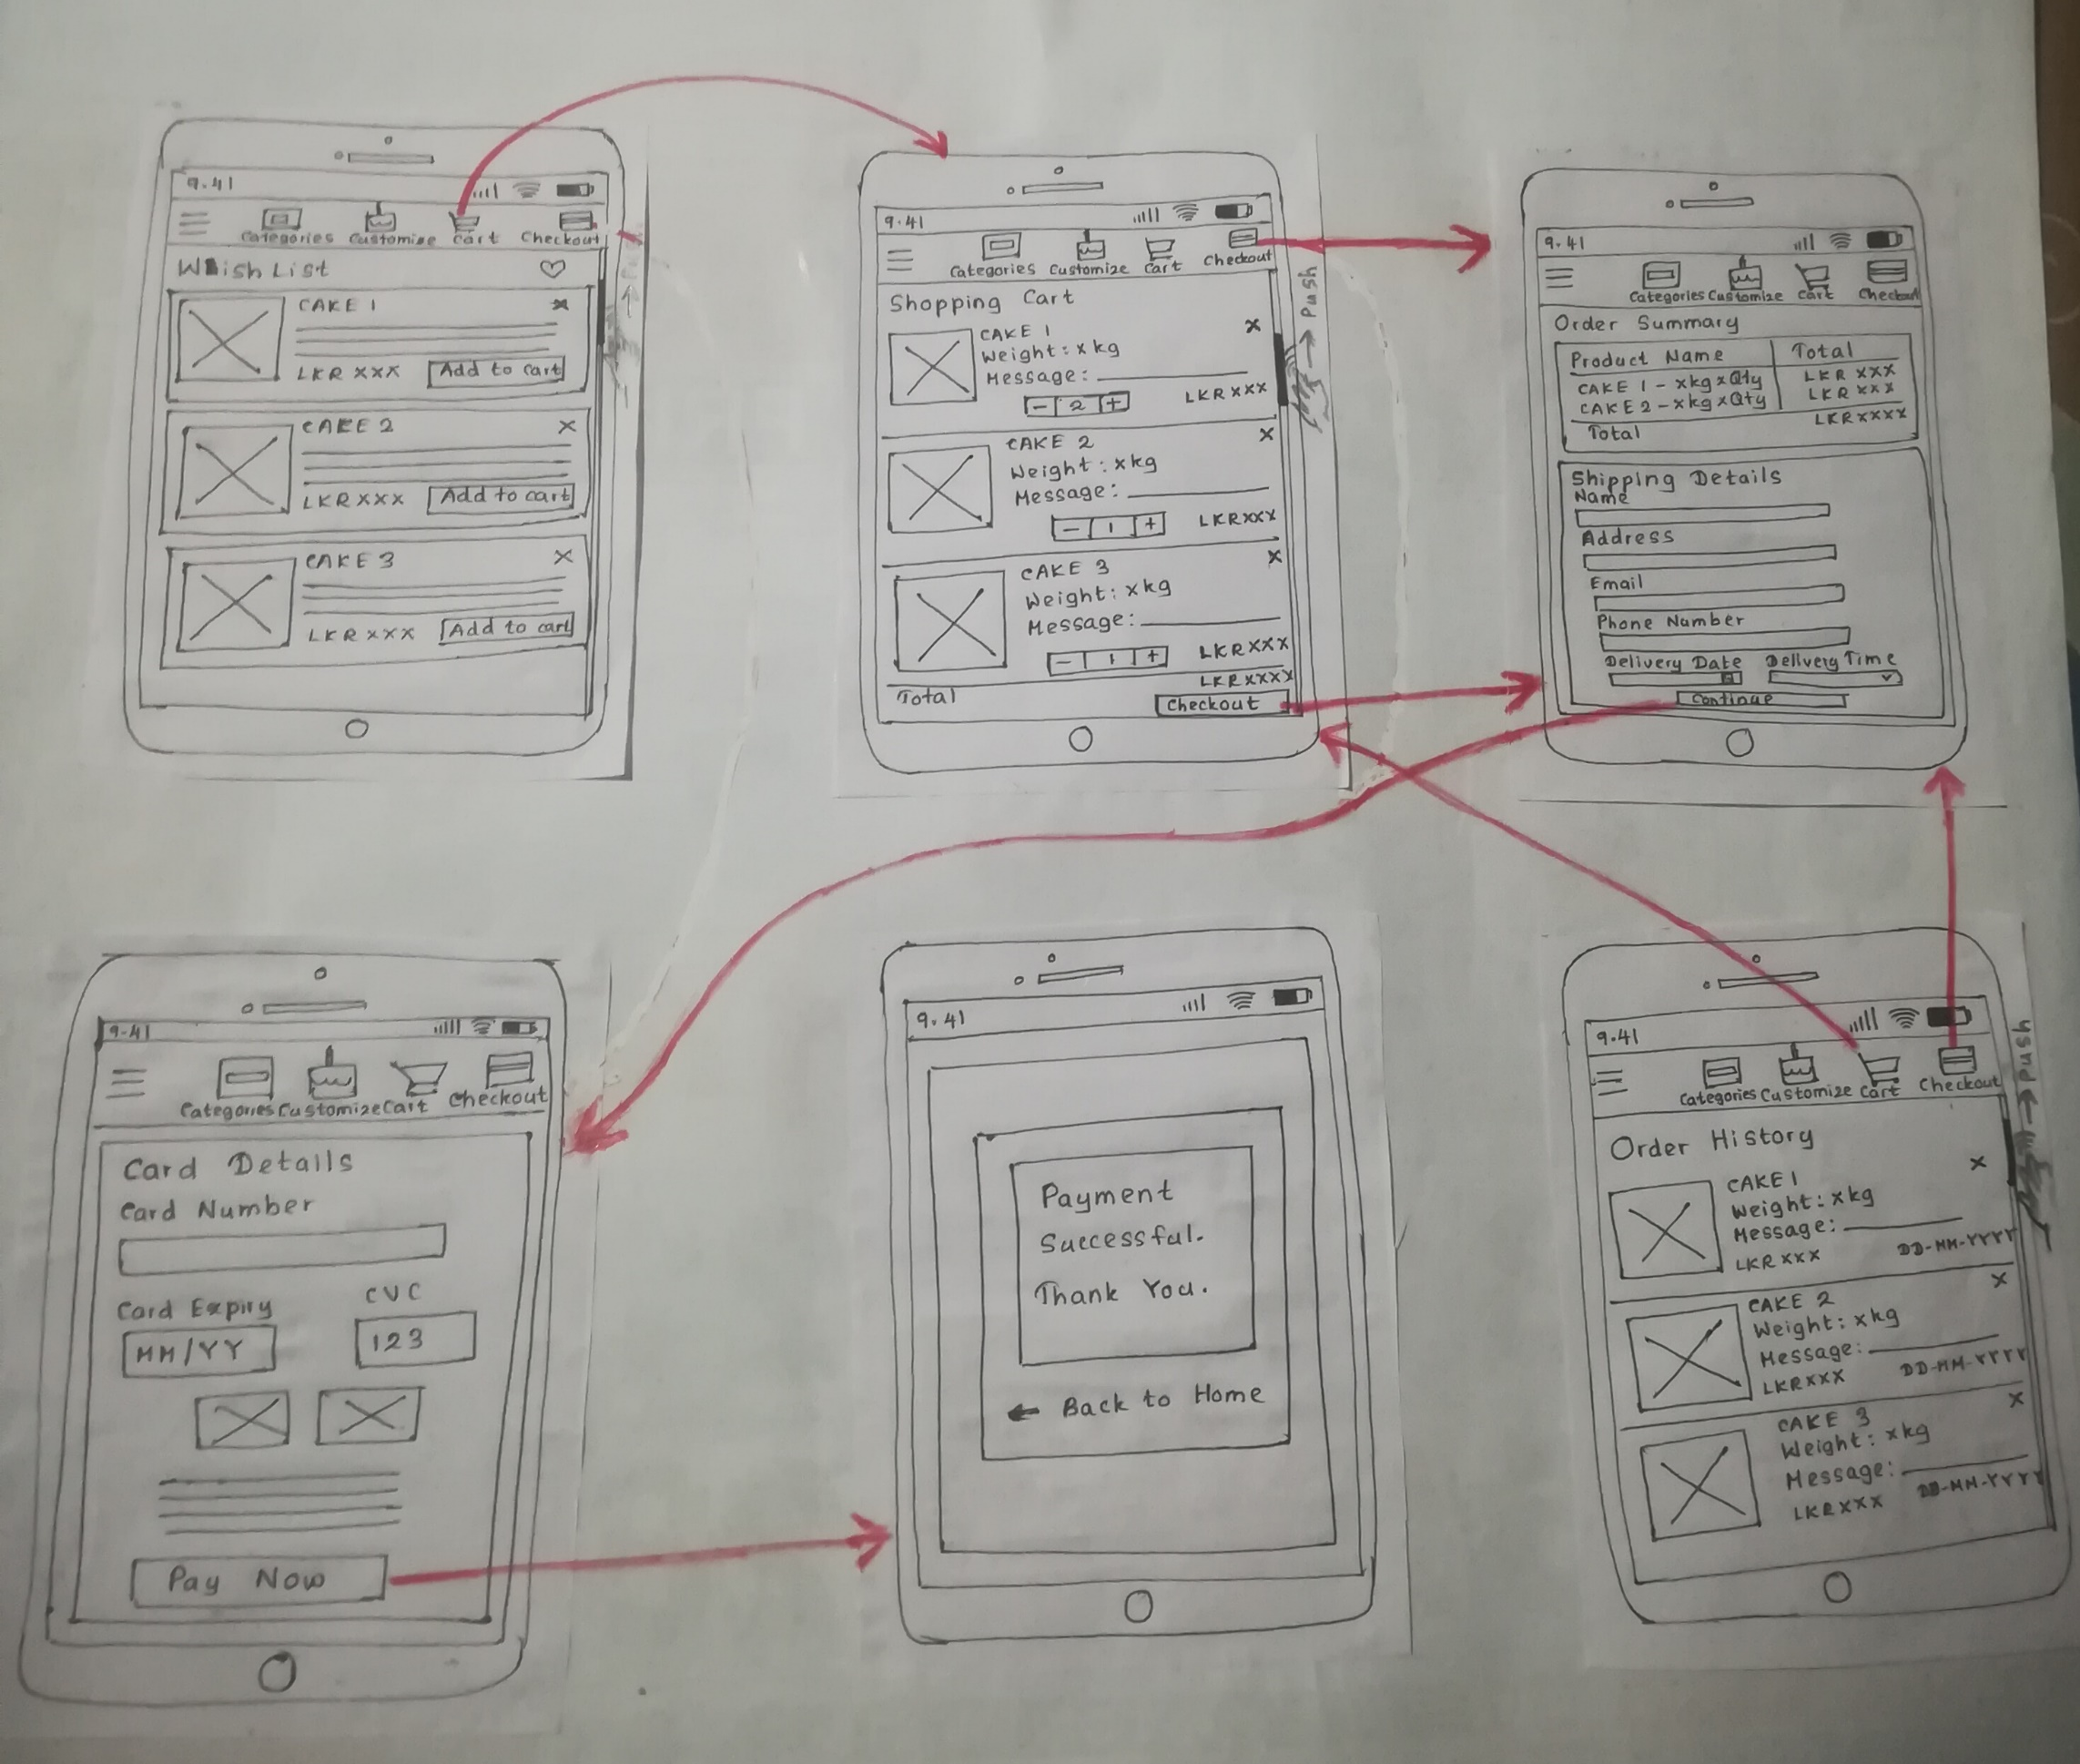

**Connection Between UIs**



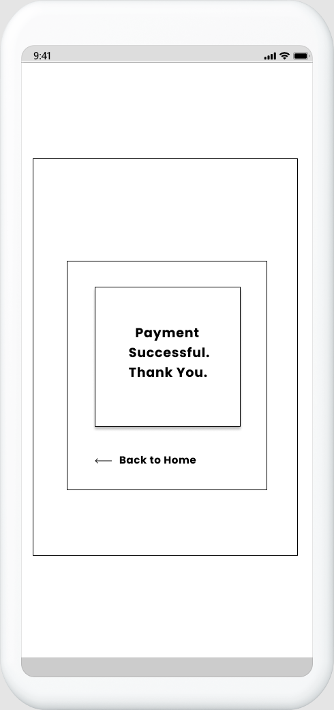

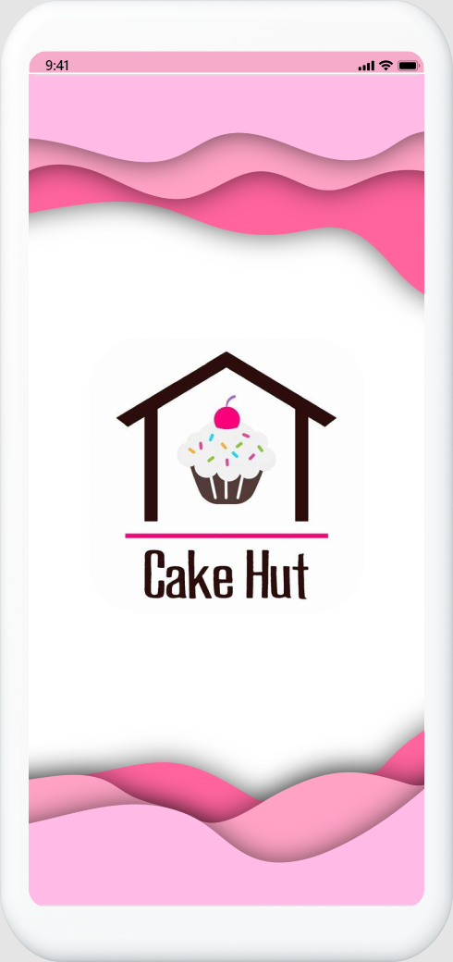**Prototype Version 1**

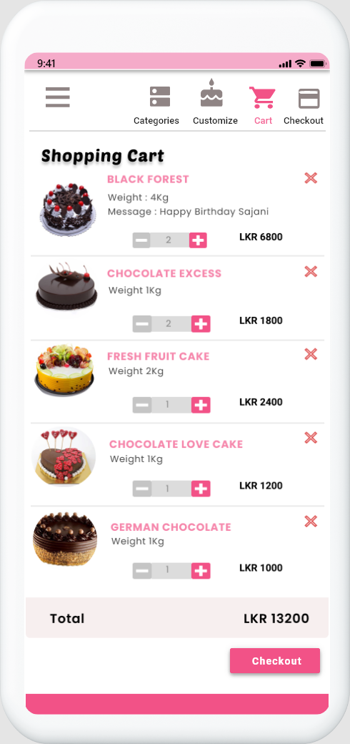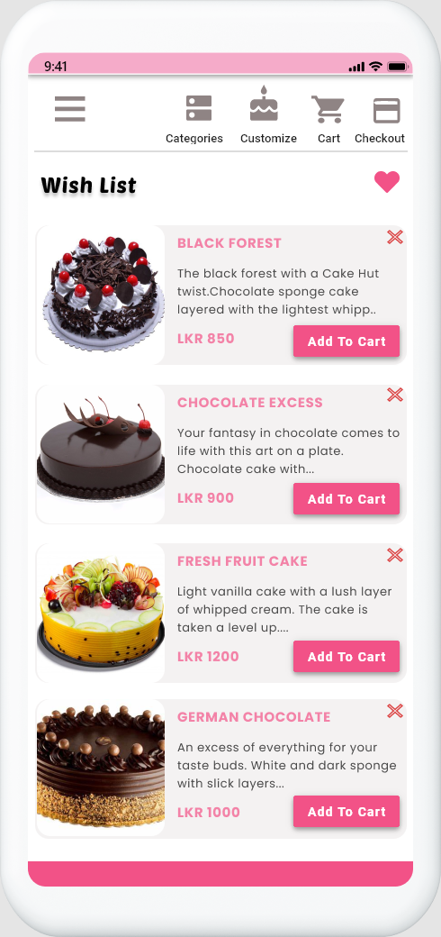

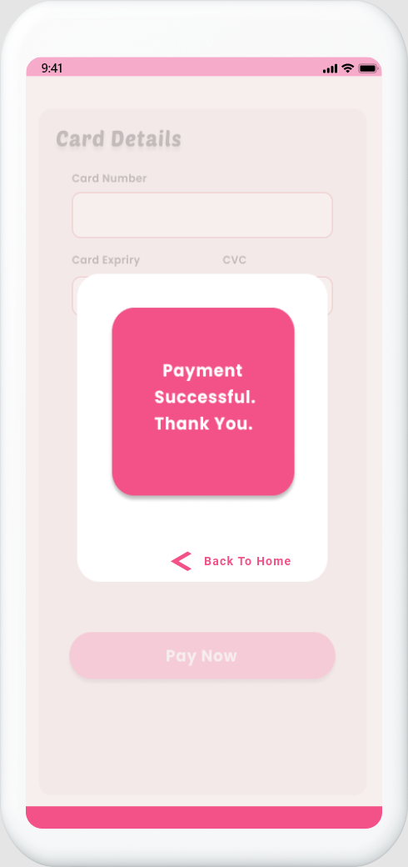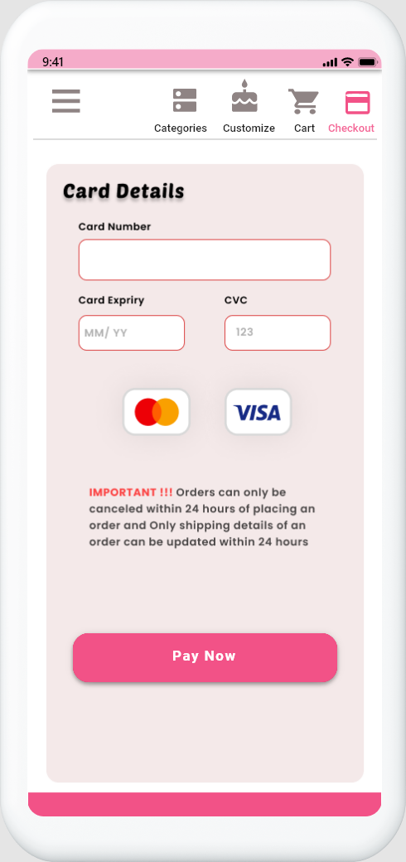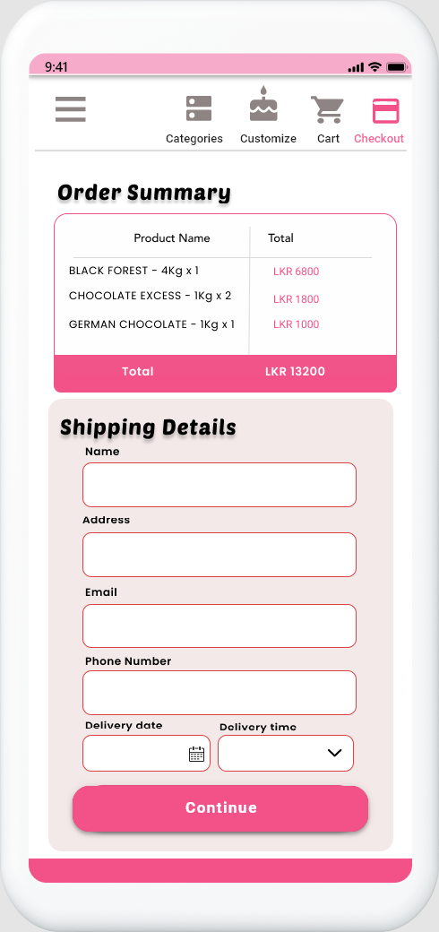

**Payment Successful**

**Payment – Shipping Details**

**Landing Page**

**Payment – Card Details**

**Shopping Cart**

**Wishlist**

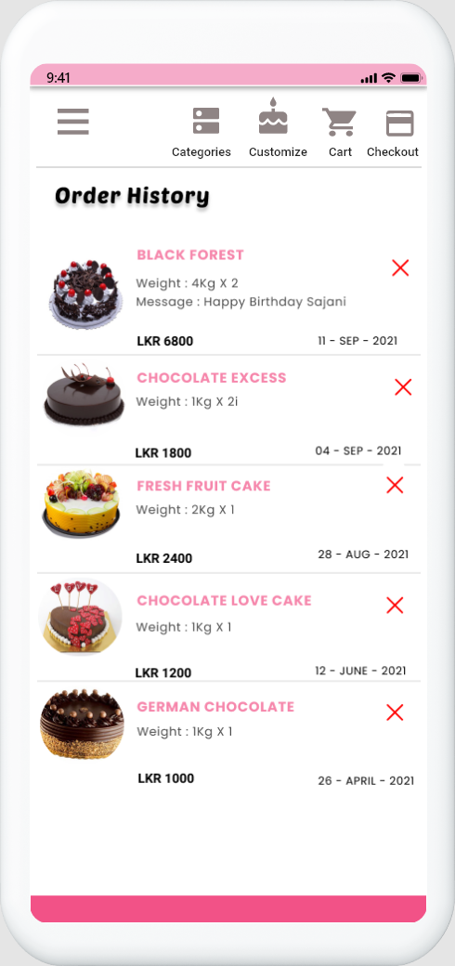

**Order History**

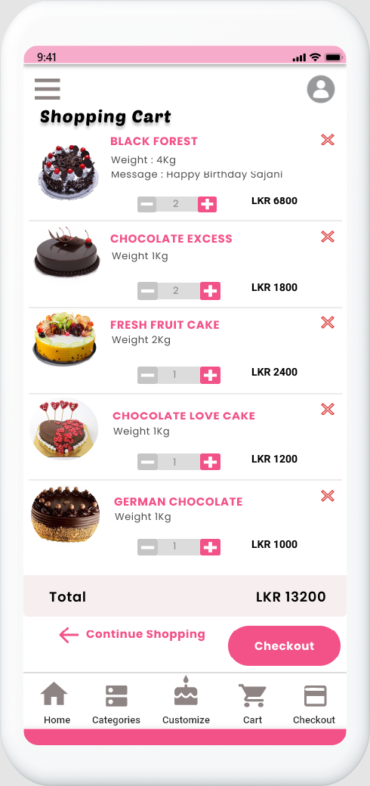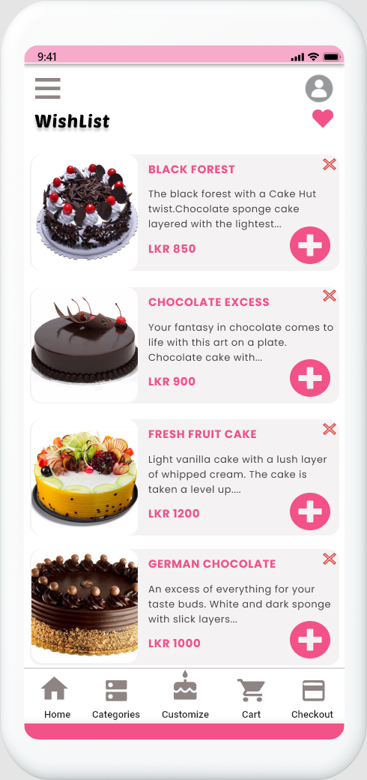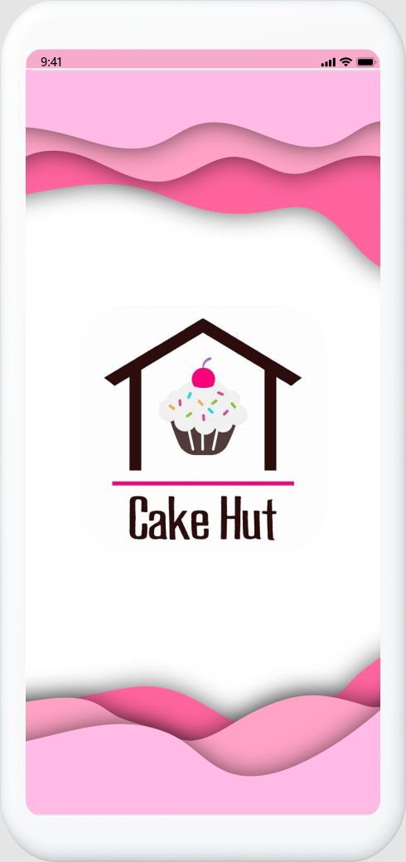**Prototype Version 2**

**Shopping Cart**

**Wishlist**

**Landing Page**

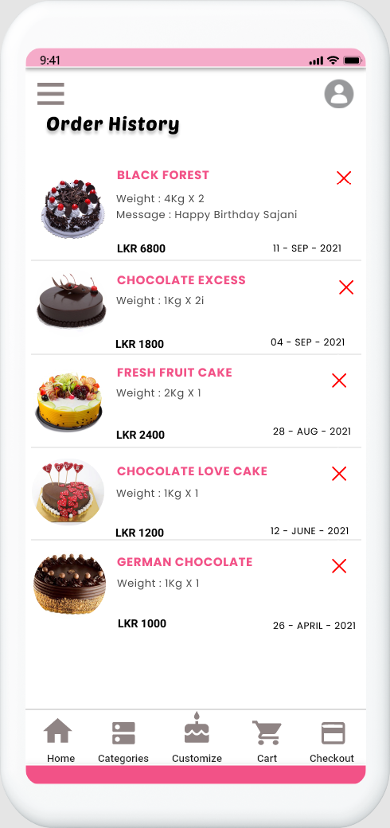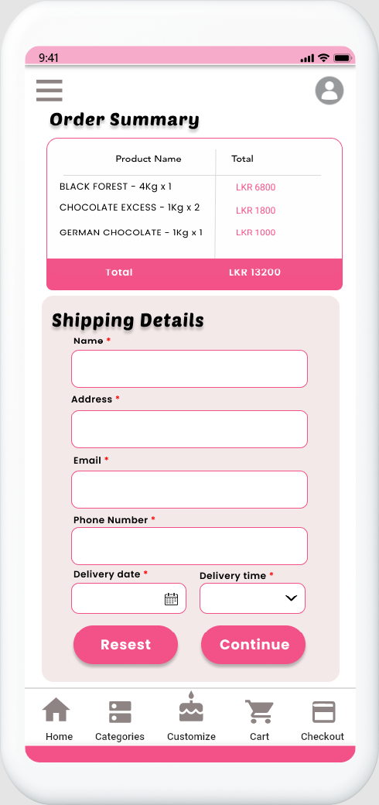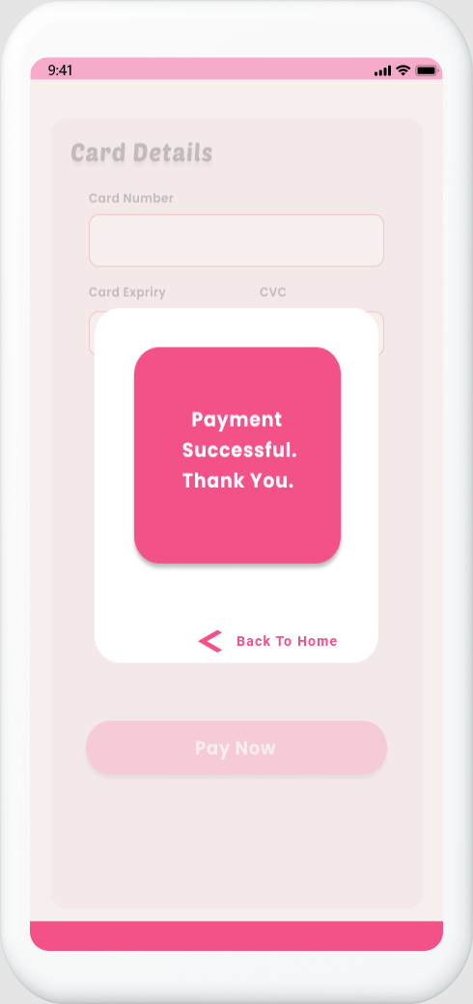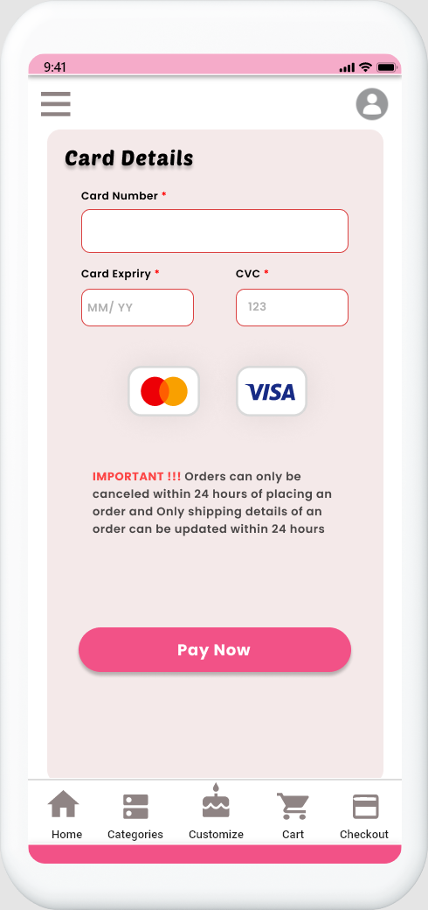

**Order History**

**Payment – Shipping Details**

**Payment – Card Details**

**Payment Successful**

# **IT19953052 – Rupasinghe K.A.S.S – Customized Cake Management**

## **Interface 1 – Welcome Page – Customized Cake**

**Design Suggestions**

|  |  |  |
| --- | --- | --- |
| Screenshot of the GUI | Proposed sketch | Proposed wireframe |
|  |  |  |
| Failure points of the UI:   * There is no customize cake function | Suggested solutions:   * According to user feedback they need to get a feature for   Customize their order | |

**Sketches Wireframes**

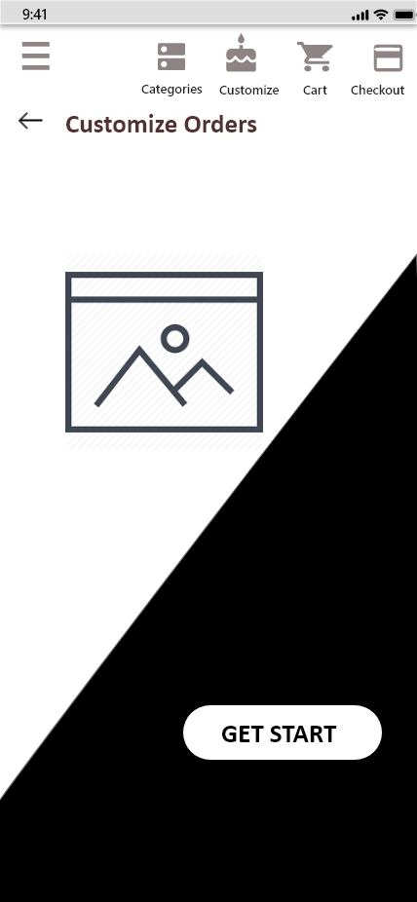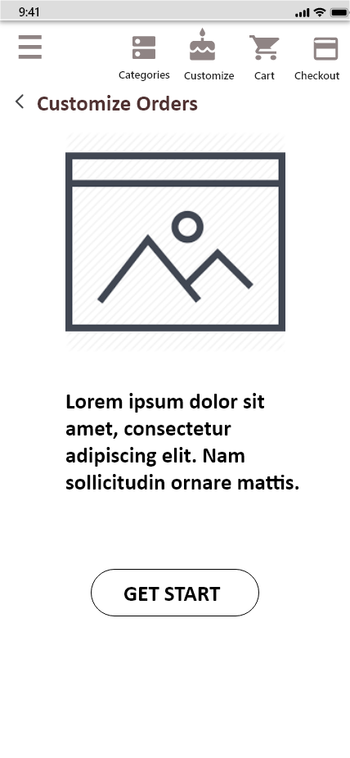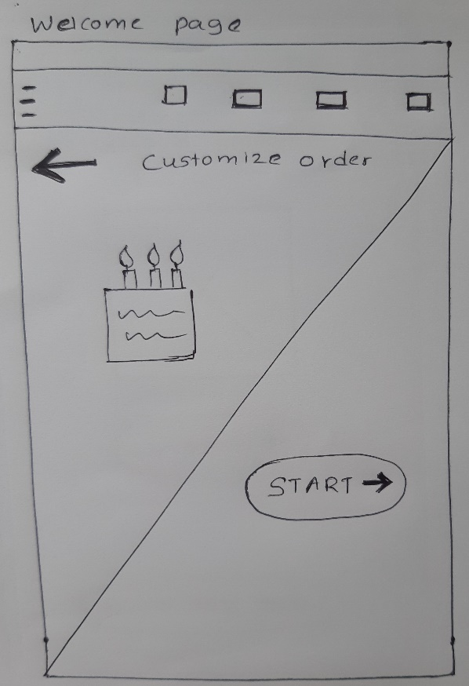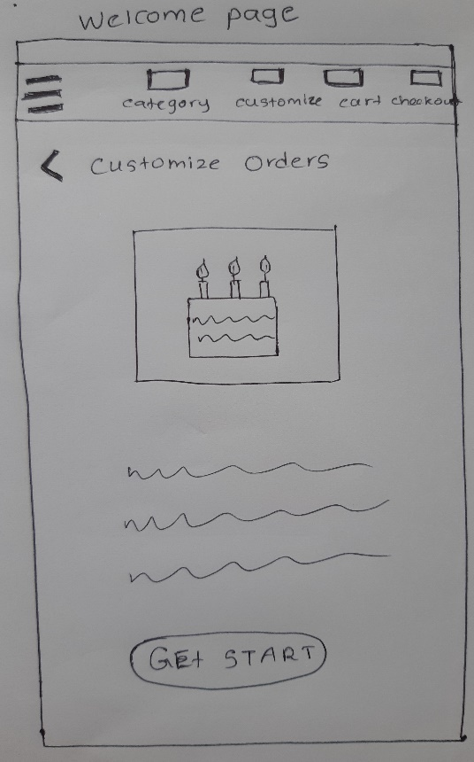

## **Interface 2 – Place Customized Cake Order**

**Design Suggestions**

|  |  |  |
| --- | --- | --- |
| Screenshot of the GUI | Proposed sketch | Proposed wireframe |
|  |  |  |
| Failure points of the UI:   * There is no customize cake function but fixed failure of their general form designs which is form fields are very small | Suggested solutions:   * According to user feedback they need to get a feature for customize their order. And form fields should be in appropriate size | |

**Sketches Wireframes**

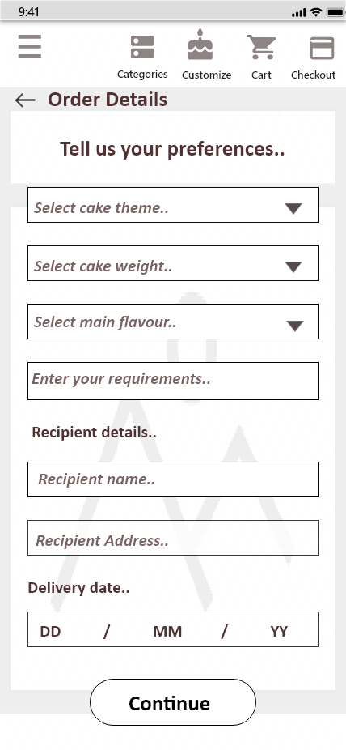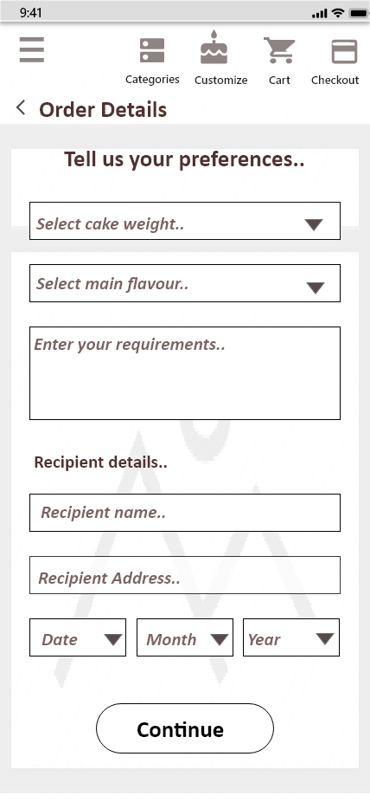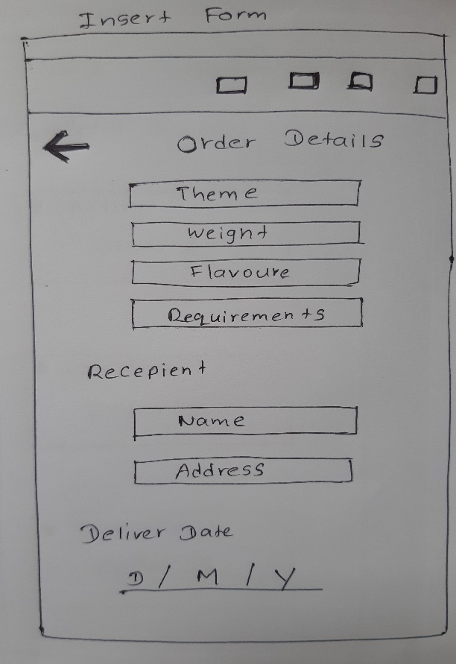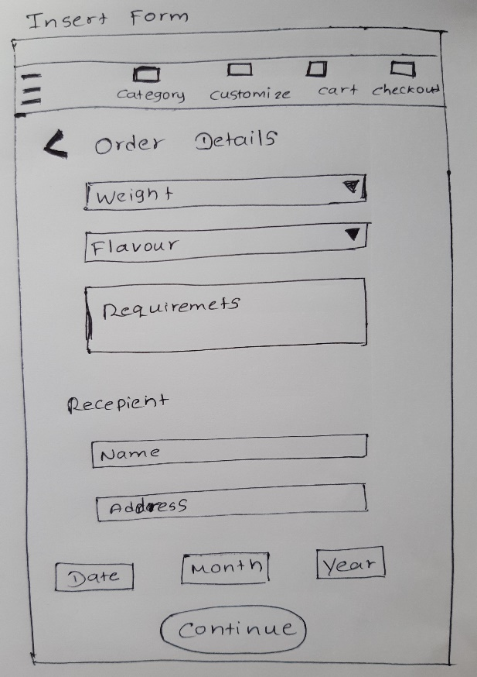

## **Interface 3 – Place Customized Cake Order – Upload Image**

**Design Suggestions**

**Sketches**

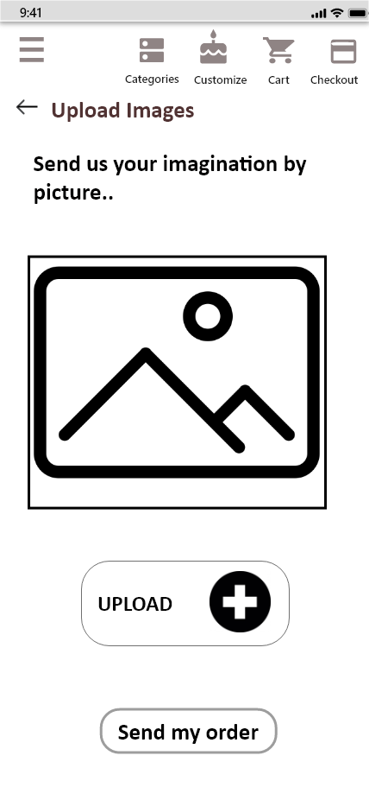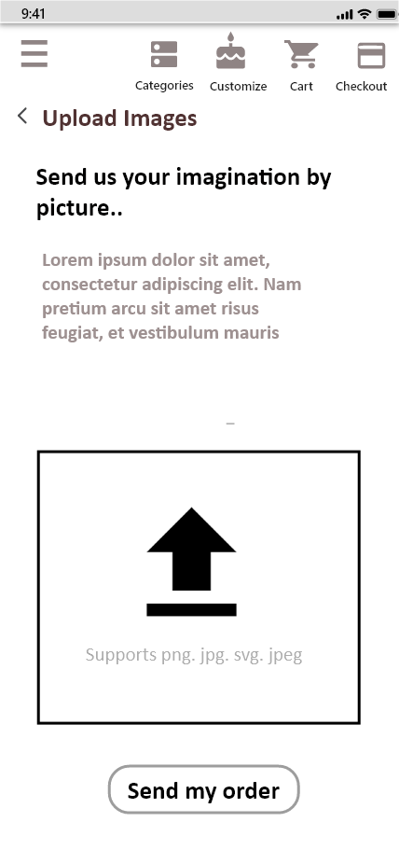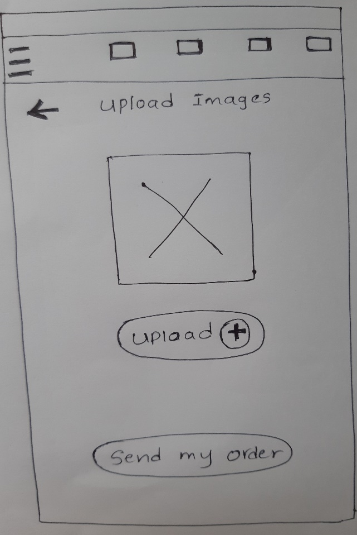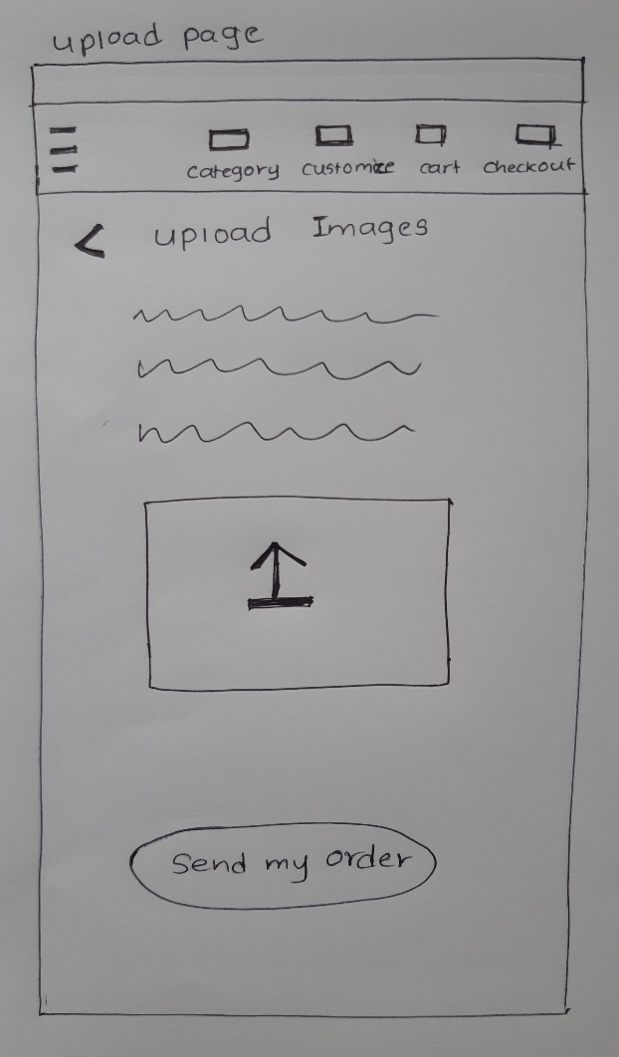

|  |  |  |
| --- | --- | --- |
| Screenshot of the GUI | Proposed sketch | Proposed wireframe |
|  |  |  |
| Failure points of the UI:   * There is no customize cake function but designed by fixing failure of their general interfaces which related to usage of faded colors small font size | Suggested solutions:   * According to user feedback they need to get a feature for customize their order. And used font size in appropriate way. And added file upload facility for better user experience | |

## **Interface 4 – Place Customized Cake Order Confirmation**

**Design Suggestions**

|  |  |  |
| --- | --- | --- |
| Screenshot of the GUI | Proposed sketch | Proposed wireframe |
|  |  |  |
| Failure points of the UI:   * There is no customize cake function but designed by fixing failure of their general interfaces which related to not giving confirmation messages after any process. | Suggested solutions:   * According to user feedback they need to get a feature for customize their order. And used font size in appropriate way. As well as navigation | |

**Sketches Wireframes**

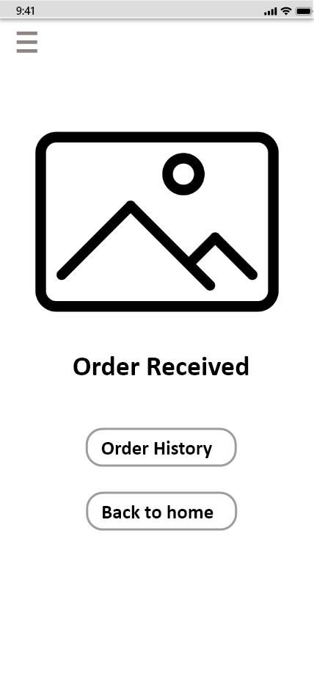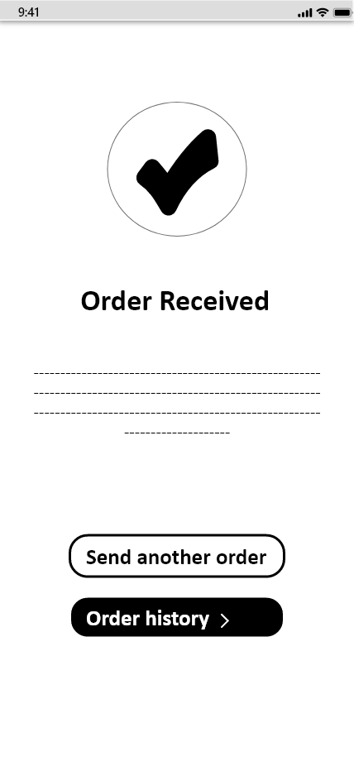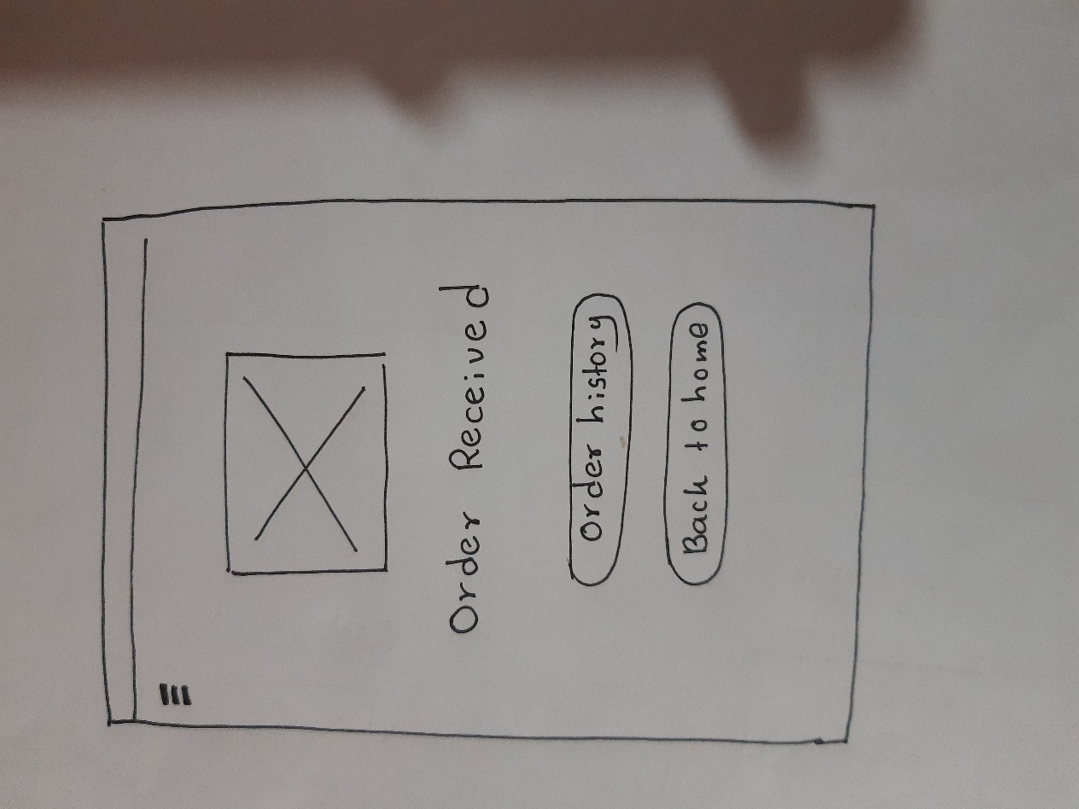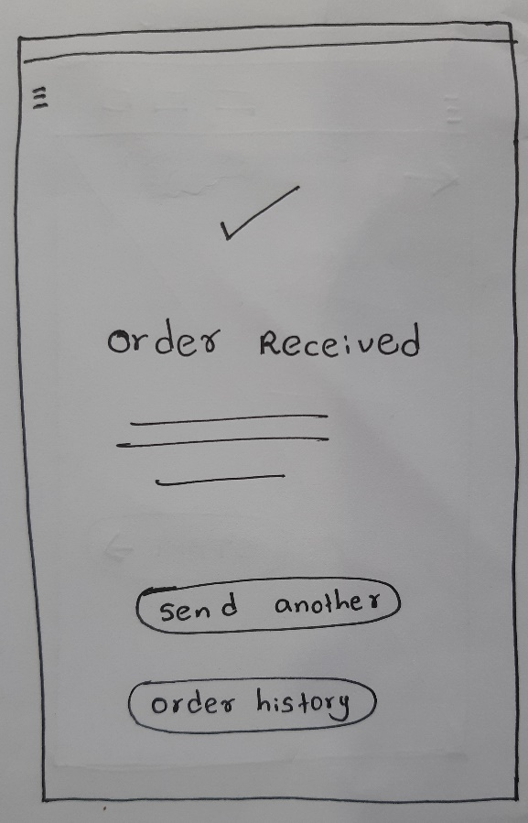

## **Interface 5 – Customized Cake Order History**

**Design Suggestions**

|  |  |  |
| --- | --- | --- |
| Screenshot of the GUI | Proposed sketch | Proposed wireframe |
|  |  |  |
| Failure points of the UI:   * There is no customize cake function but designed by fixing failure of their general interfaces which related to not having order history to see their previous order details and manage them | Suggested solutions:   * According to user feedback they need to get a feature for customize their order. And facilitated them to manage their order history by adding cancel orders edit order details in appropriate way. | |

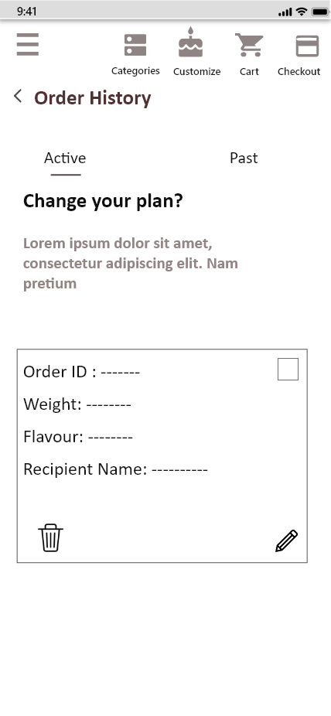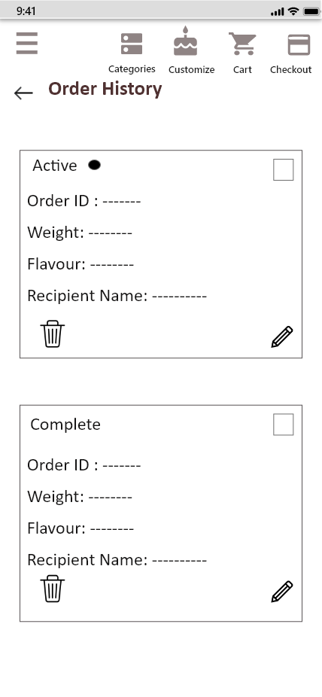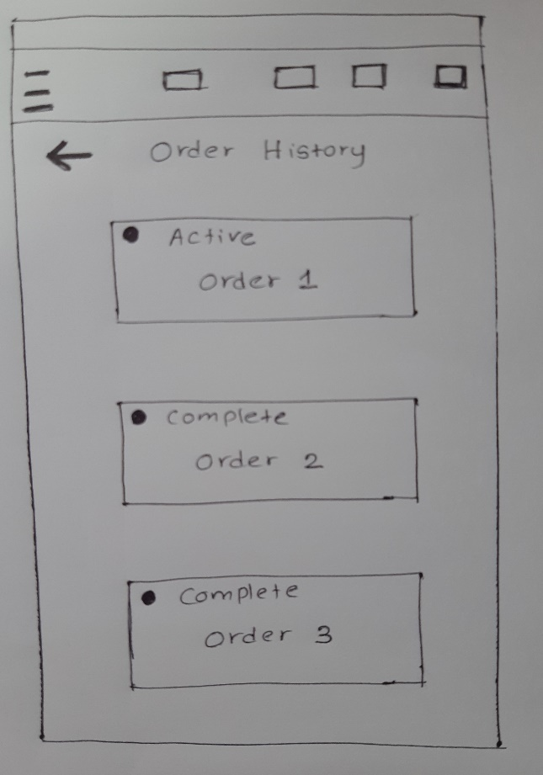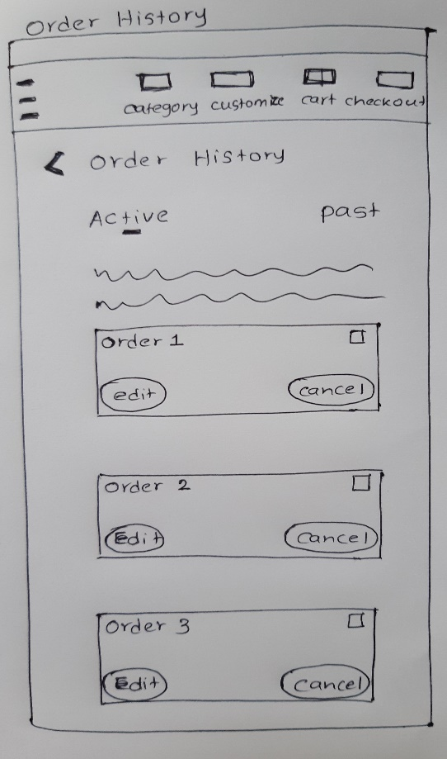**Sketches Wireframes**

**Connection Between UIs**









**Prototype Version 1**

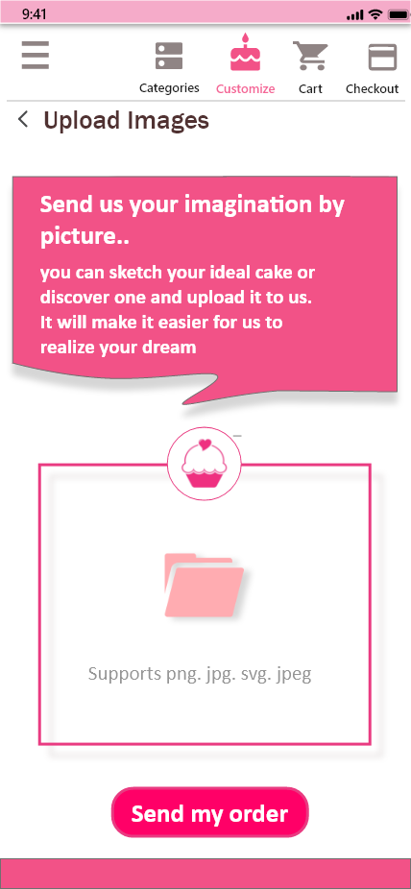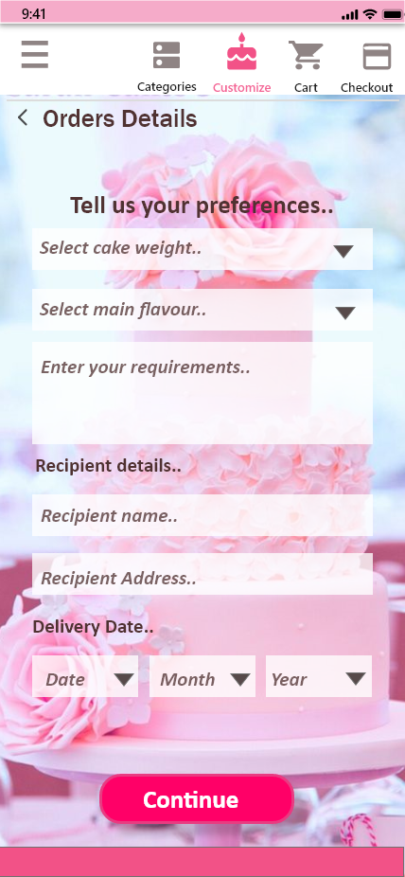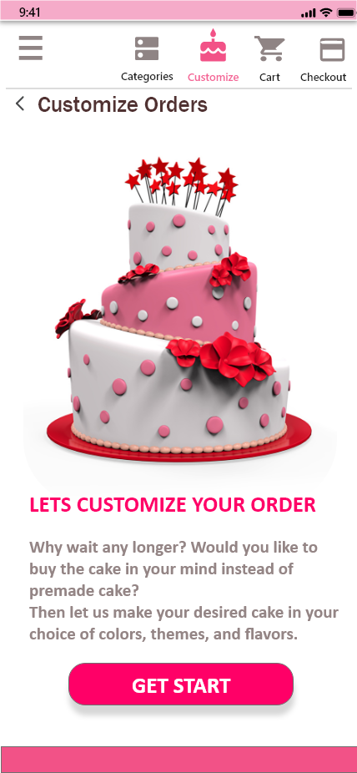

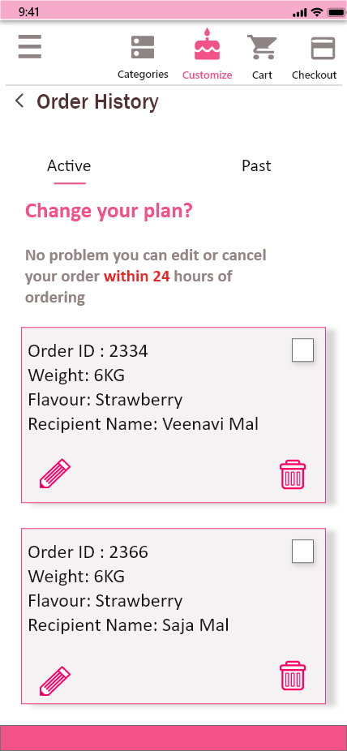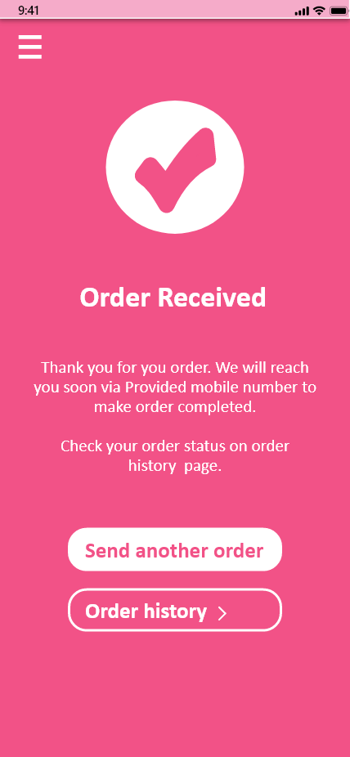

**Place Customized Cake Order Confirmation**

**Customized Cake Order History**

**Place Customized Cake Order – Upload Image**

**Place Customized Cake Order**

**Welcome Page - Customized Orders**

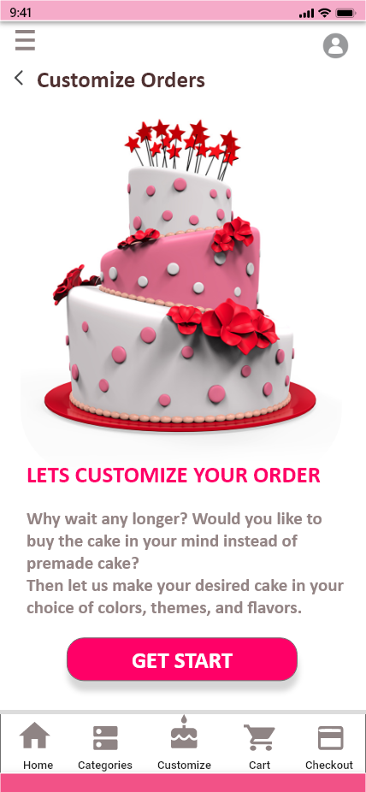**Prototype Version 2**

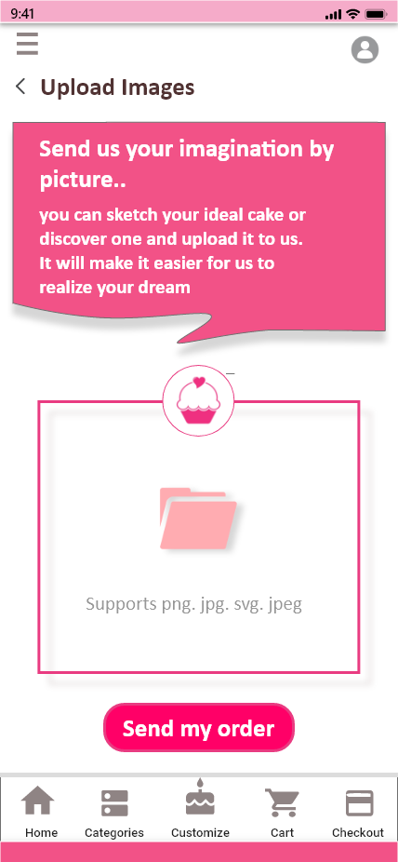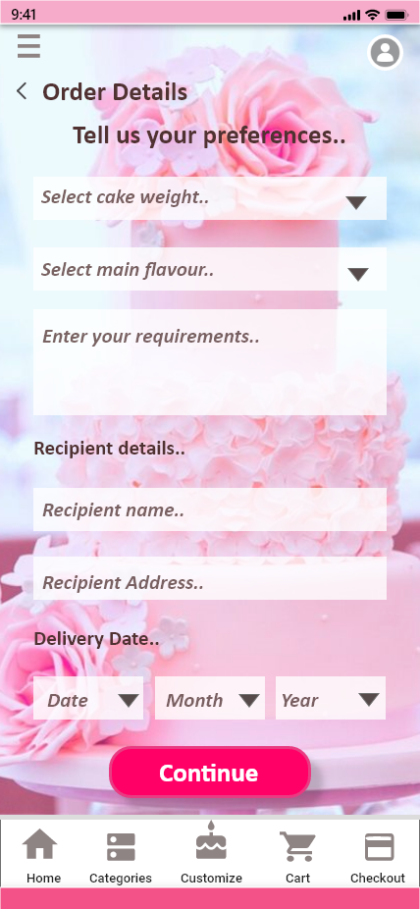

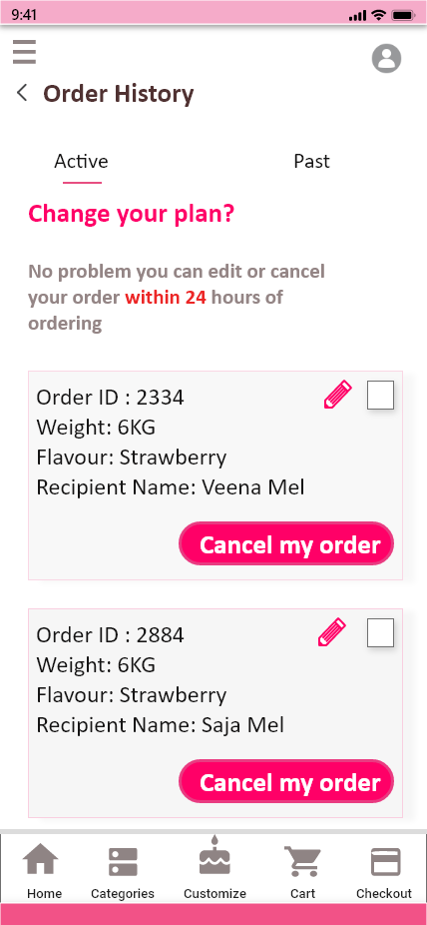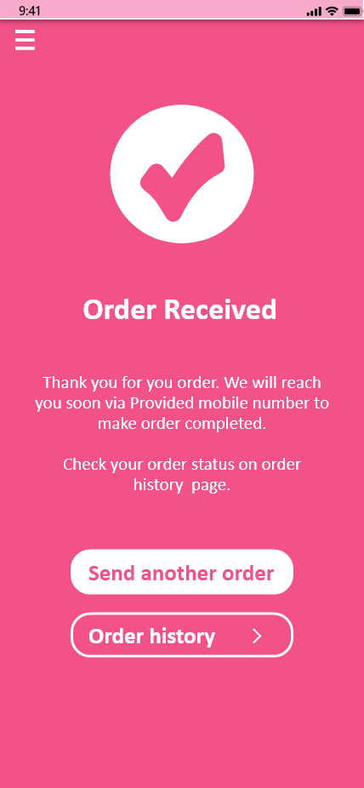

**Customized Cake Order History**

**Place Customized Cake Order Confirmation**

**Place Customized Cake Order – Upload Image**

**Place Customized Cake Order**

**Welcome Page - Customized Orders**

# **User Feedback for the Prototype**

Video reference link: <https://mysliit-my.sharepoint.com/:f:/g/personal/it19953984_my_sliit_lk/EpficZYvClpAmfFwBSQxS7cBxM9tuesL8ewo8OJYXcHq0w?e=MsVLR8>

**Script – Interview 1**

**K.A.S.S Rupasinghe**: Hi Mr. Shashi. So, it's us again. Today we are going to do a usability test. So, you may remember that last time we showed you this app and get your feedback. So, from your feedback, we were able to close the gap of this app. So according to your feedback we have implemented a prototype which is minimize the shortcomings that you have mentioned. So today we came to get feedback about our prototype. So, I will record this session as we did before. So, are you agree with it?

**Mr. Shashi**: Yes. I agree with it.

**K.A.S.S Rupasinghe:** OK, let's navigate to home page through the login and sign up and tell me about what do you think about the new appearance of this app.

**Mr. Shashi:** Actually, there is a big difference in this app over the previous one. It's very beautiful. It was very pleasing to the eye when using the app. In the previous the login and sign up were looks really like a card view. Now the form fields are in right size and it can be easy to fill and by clicking the sign up, it will navigate to the home page and the home page is really nice. It's nice to having these kind of item arrangements. Now we can maintain a wishlist also. Usage of eye-catching quality good picture is tempted to buy.

**K.A.S.S Rupasinghe:** Yeah, so it means the better than previous. Actually, we have used the quality pictures and the nice arrangements. I think than previous versions, right? So, this seems like the app is much better now than ever before. So, let's navigate to the cart by adding item and tell me about your opinions. Let's go back to the home and just add the item and go ahead.

**Mr. Shashi:** Actually, this is also very attractive and it's very clear and the fields that are used here is very easy to fill and the font sizes are very clear and there is option to increase the quantity and decrease the quantity and by adding, it will navigate to the cart and the shopping cart. In the previous version of the shopping cart is a very unclear because the picture of cake did not come to the cart so far. Now we can see pictures of the item on the cart, so it is very easy to recognize the item quantity and we can increase and decrease from here and the price also appears here, and if some user doesn't want to buy the item that added to the cart he can remove the item from the shopping cart easily.

**K.A.S.S Rupasinghe:** Yeah, the previous version, the items were without pictures. So now you have picture and you can clearly recognize what you have added the cart right? So, it's very easy to use I think yeah, so according to you, is there anything else that can be done to increase the user experience of this app.

**Mr. Shashi:** I think it's good to be navigation bar at the bottom of the interface because we use our phone most of the time we use the phone using our right hand and it's very easy and it's very easy to find and touch the navigation bar, if it's here and it will be easy for the navigation. When we come to the home page and this add to cart option I think it is too small and I think it would be nice to make it like a plus mark or an icon.

**K.A.S.S Rupasinghe:** Uh, OK, yeah there are minor shortcomings in there, right? Yeah OK Mr. Shashi. So, let's navigate to the payment option. So, what do you think about our brand-new payment option. We have done so many new arrangements of these payment options also.

**Mr. Shashi:** The payment function is really easy now because there were six or seven steps in the previous version and now there are a few steps to process the payment and form fields are in the right size so that the payment can be made without much hassle.

**K.A.S.S Rupasinghe:** Yeah, there were 7 or 8 steps to go through payment process, right? So yeah, we have done it from within two or three steps. So, Mr. Shashi according to you, this app can be used more efficiently than ever before, right? So, we added a brand-new feature to this app, which gives ability to order your own customized cake instead of pre-made cake. So, I would love to hear your thoughts on our new feature. So, let's navigate to the customized cake function and tell us your opinion.

**Mr. Shashi:** Yeah, I have mentioned this before, so I'm really happy about the customize cake page and it has been done very nicely and has a nice welcome page and also it's very user friendly and very pleasant and it allows user to fill those fields easy and it's very clear and it's allow user to add pics from Google and ask the cake makers to make the cakes like in that way and I can manage my orders very easily, so I am very happy about the feature.

**K.A.S.S Rupasinghe:** Yeah, you can manage your order by order history right so?

**Mr. Shashi:** Yeah, I can manage orders from order history.

**K.A.S.S Rupasinghe:** Yeah, so Mr. Shashi, what do you think about the overall app. Give me some brief explanation.

**Mr. Shashi:** Well, it is really much nicer than before. Very easy to use, very user friendly. It really made me to buy cake and I am happy with this app.

**K.A.S.S Rupasinghe:** OK, Mr. Shashi, so we really get good comments and thank you so much for giving us feedback and making time for us and we hope to improve this app by fixing those minor shortcomings that you have mentioned. So thank you for your participation.

**Mr. Shashi:** Thank you for inviting me.

**Script – Interview 2**

**K.A.S.S Rupasinghe:** Hi Mr. Janith, it's us again so today we are going to do a usability test again so you may remember that last time we showed you this app and get your feedback. So, from your feedback, we were able to close the gap of this app. So according to your feedback, we have implemented prototype which is minimize the shortcomings that you have mentioned earlier, so today we came to get feedback about the prototype from you. So, I will record this session as we did before. So, are you agree with it and ready?

**Mr. Janith:** Yes, that's OK and I'm ready, thanks.

**K.A.S.S Rupasinghe:** OK. Let's start, so let's navigate home page through the login and signup and tell me what do you think about the new appearance of this app.

**Mr. Janith:** Shall I take control?

**K.A.S.S Rupasinghe:** OK, you can get control of my screen.

**Mr. Janith:** All right, OK, so now I'm taking here I'm guessing this is the loading page and yeah. Going home and this is the sign in page. This this already is much better than it was before. I mean, this feels like a sign in page. That's what I mean. So, there are bigger fonts here. I can see the words clearly and this is much more user friendly. I really like it. Do I need to fill these fields now? I can just move on, right?

**K.A.S.S Rupasinghe:** Yeah, you can move on. Ok. Tell me something about home page.

**Mr. Janith:** Yeah, this is the home page alright, let me check.First off, the picture quality is much, much better than what it was before. And yeah, the overall theme and the colors and the add to cart button everything feels so different and really usable. I mean, this is quite attractive. You've done a great job.

**K.A.S.S Rupasinghe:** How do you feel about?

**Mr. Janith:** I really like this and I see there's also a search bar here. Yeah, this could really work out. This feels very professional. Yeah, this is a great upgrade that you've done here.

**K.A.S.S Rupasinghe:** Yeah OK, that seems like the app is much better now than ever before, right?

**Mr. Janith:** Yeah, definitely better than before.

**K.A.S.S Rupasinghe:** OK, so let's navigate for the cart by adding some item and tell me about your opinions about the add to cart function.

**Mr. Janith:** Alright, so I'm clicking here then. OK, that navigates me here alright, and again reflecting back on what it was before. This is much more usable. I mean, this is more comfortable than what it was before. First of the color scheme I just love the color scheme, which is really pleasant. And there's not that many fields also, right? So, it's very easy to add something to the cart, right? I like it, and if I click here this will be added to the cart right.

**K.A.S.S Rupasinghe:** Yeah, you can click. OK something about the cart. What do you feel about the new shopping cart?

**Mr. Janith:** OK, First off, difference I'm seeing here is that yeah, it there are pictures for the items which are already added to the cart right? So that's a massive upgrade from what it was because last version only had the letters, I mean the titles in the cart so you couldn't see what you already picked as the products were about purchase right so this I really like this, this is much better than it was and you could. You can clearly see the prices on everything we've added. And you can easily remove what's there on the path, so I really like this. This is much more than what is was before. This is very user friendly and much more usable.

**K.A.S.S Rupasinghe:** Yeah, you can clearly recognize that what you have added to the cart. Right?

**Mr. Janith:** Yeah, that's a great.

**K.A.S.S Rupasinghe:** Yeah, OK. So according to you, is there anything else that can be done to increase the user experience of this app? Anything elesaccording to your point of view.

**Mr. Janith:** Are there any more fields that you want me to show?

**K.A.S.S Rupasinghe:** No, let's give a brief explanation that if there are anything that increase the user experience of this app according to your point of view in the cart and homepage from anything.

**Mr. Janith:** I saw a two sort of buttons kind of things, then sort and filters somewhere. Can you get back to that place?

**K.A.S.S Rupasinghe:** Yeah, it's a home page I think.

**Mr. Janith:** Yeah. About these buttons, I think I icons much better than just having text on those on these buttons. What is the purpose of this buttons actually?

**K.A.S.S Rupasinghe:** Which means sort and filter. Yeah, it's actually it's a drop down, but I think, you cannot recognize at the first glance, right?

**Mr. Janith:** Yeah, I would have never guessed that it was a drop down. It doesn't work that we should have icons for those buttons.

**K.A.S.S Rupasinghe:** Yeah, according to your point of view, we have to increase our usage of icons, right? OK, instead of these two buttons. OK, so Mr. Janith the payment function is a troublesome one right in the previous version?

**Mr. Janith:** Yeah, there were so many pages in the previous.

**K.A.S.S Rupasinghe:** Yeah, there are so many steps also so I just wanted to know about your feelings about our brand-new checkout function so. Yeah, you can directly navigate through checkout, yeah?

**Mr. Janith:** I'm going. Alright OK. So, this I'm actually OK with this. I mean you could see what you can see clearly actually are purchasing and there are like not that many fields, but still enough of relevant information.Then like two payment details, right? So, this is what it should have been earlier, right? I mean, this is easy and this is this is just doable. I mean, you would want to purchase something from app like this, right? You don't want to go through multiple pages, right? Nobody, wants to go through 6 pages just to make a purchase, right? Yeah, that's my point all right.

**K.A.S.S Rupasinghe:** We have made it with 2 steps just two steps.

**Mr. Janith:** Yeah, alright, so if I click here. Yeah, it's a payment, successful message. OK, so you also give a payment successful message and that's really nice, OK so, if I click here. I'm getting it back to home, right?

**K.A.S.S Rupasinghe:** Yeah, so Mr. Janith, according to you, this app can be used more efficiently than ever before, right?

**Mr. Janith:** Yeah, I seriously believe that this is a big upgrade for that, and I think this is really user friendly and it was before it feels like a cake buying app.

**K.A.S.S Rupasinghe:** OK, so as you said, we added a brand-new feature to this app which gives you, ability to order your own customized cake instead of pre-made cake. So, I would love to hear your thoughts on our new feature. So let's navigate to the customized cake function and tell me about your feelings and tell me what you think about it.

**Mr. Janith:** OK, I believe it's the tab on the top of the page. OK, that's a really nice starting page. Yeah, quite user friendly. And if I click here, it navigates to you to this page. OK, I believe that you are letting the customer pick the cake he wants like click alright.

**K.A.S.S Rupasinghe:** Letting customize their own cake.

**Mr. Janith:** OK, alright, that's really smart and this page. Yeah, I'm really comfortable with this page. This is a good page nice, alright, I'll continue.

**K.A.S.S Rupasinghe:** Yeah, OK. And this facilitates to add some pictures from Google your device and you decide cake. Your imagination like that. Yeah you can sketch someone and add.

**Mr. Janith:** So, you can ask for a similar cake to the picture that's in here, right?

**K.A.S.S Rupasinghe:** To this because it gives bakers to the cake in your mind. They can get better idea about the cake.

**Mr. Janith:** Alright, I understand alright, so if I take here what would happen in my order? OK, send my order can click it and it will get confirmation message and you can navigate to this.So yeah, this is a really nice message that you can like. Give us a confirmation you said I really like this whole interface that you implemented here.

**K.A.S.S Rupasinghe:** Yeah. Do you love the used colors and the color blend? Yeah, because previous one has so faded colors they have used.

**Mr. Janith:** Yeah, yeah.

**K.A.S.S Rupasinghe:** OK, you can navigate to the order history and go.

**Mr. Janith:** Alright, let's see. Alright, I'm clicking here, yeah?

**K.A.S.S Rupasinghe:** So, what do you think about the order history management?

**Mr. Janith:** Looking at it normally it feels quite fine, but what does this dustbin icons do here.

**K.A.S.S Rupasinghe:** Ah, it's for cancel your order.

**Mr. Janith:** I believe a cancel order button which spells out the word cancel order would be much better than, dustbin icon, and these are the orders I believe. Yeah, I mean, they're pretty decent and brief. Yeah, I like it that way. And these should be proper buttons instead of just icons, right? That's the only concern I have with this.

**K.A.S.S Rupasinghe:** OK, you're telling that the trash icon should be removed, and there's some kind of a button should be added, right? OK. Mr. Janith, So what do you think about the overall app? I think you have missed some pages in home and categories.

**Mr. Janith:** Or you could wait till we get to home page from. The yeah, that's also a new feature, right? Yeah, I like that I like that you can do that before.

**K.A.S.S Rupasinghe:** You have to go through all the steps to navigate the home page in previous version, right? That's good because your journey this have made so troublesome with this homepage navigation I have.

**Mr. Janith:** Yeah, I remember yes. Yeah, so if I click here. OK, so categories I remember doing a drop-down list and I believe this is a way better representation of categories. Yeah, you can see the nice pictures and everything so.

**K.A.S.S Rupasinghe:** So, what do you think about the overall app? What you can tell?

**Mr. Janith:** So, I think it is way better than what it was before. I would really love to use this app after implemented properly and completed. And yeah, this is a better user experience than what was in the first step. Yeah, I really like this.

**K.A.S.S Rupasinghe:** OK. Mr. Janith, we really got good comments and thank you so much for giving us feedbacks and making time for us. Actually, because you are instead even you are a very busy person.

**Mr. Janith:** I'm sorry about the call in the middle of the meeting.

**K.A.S.S Rupasinghe:** It's totally OK and we hope to improve this app by fixing those minor shortcomings that you have mentioned to us. So, thank you so much for your participation.

**Mr. Janith:** Alright, thank you very welcome and thank you for having me.

**K.A.S.S Rupasinghe:** Thank you so much and goodnight Mr. Janith.

**Mr. Janith**: Goodnight.

**Features that need to be further developed according to user feedbacks**

* Better have a filter icon and sort icon instead of version 1 design in home page. Because, it seems like two buttons.
* Better to have a delete button instead of trash icon in customized order history
* Better to have a ' + ' icon instead of 'add to cart' button. Because it takes too much space in cake list view
* Better to add a ‘reset’ buttons to forms
* Better to add the navigation bar to bottom of the UI.